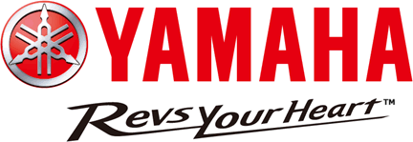
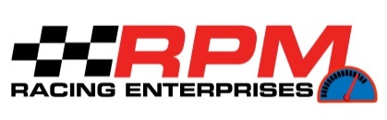

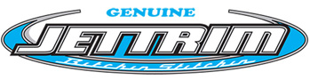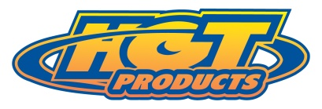
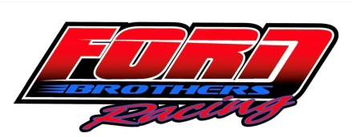

19th Annual Yamaha
Mark Hahn Memorial - Havasu 300

Presented by

Hot Products, Jettrim, Impros,

Riva, Ford Bros. Racing

Saturday - February 25, 2023
Lake Havasu City, Arizona

2023 DATE & LOCATION ANNOUNCED FOR THE IJSBA TEAM ENDURANCE CHAMPIONSHIP

Redondo Beach, CA – January 2023, the 19th Annual “World’s Longest Continuous PWC Race announced today by the new event Producer Ross Wallach, owner RPM Racing Enterprises, and Executive producer Mike Follmer. The 2023 Yamaha IJSBA Mark Hahn Memorial Havasu 300 Mile Team Endurance Race Is Back for a 19th year - Presented by Hot Products, JETTRIM, IMPROS, Riva & Ford Bros. Racing is all set to launch on Saturday - February 25, 2023 from Lake Havasu State Park, Point Beach. The 2023 event will once again be sanctioned by the International Jet Sports Boating Association (IJSBA), and it is expected to draw a record number of teams from around the globe as well as all the top PWC racers from the USA. The Teams will be competing against each other while trying to break the 300 mile record of 4 hour 46 minute and 13 seconds set by the 2016 Mark Hahn Memorial Overall winners Jean Bruno Pastorello and Jean Baptiste Botti of Team Kawasaki France.

For nineteen consecutive years the race is being held again in the memory of endurance racer Mark Hahn who was instrumental in providing the momentum to keep endurance racing going strong and growing across the country before his untimely death during a PWC race in 2004. The “Team” format features two riders for runabout (sit down) boat teams and up to three
riders for a stand-up craft. Solo riders are also welcome to “Ironman” the race on either style of PWC, a real test of skill and stamina reserved for only the true endurance racers and the 10-mile course will pit all the teams against the wind, rough water and long runs that this event has become synonymous with. In addition to all the weather and water conditions all the teams must contend with, they will also be required to make fuel stops, without spilling fuel, and make rider changes several times during the race, while modifying their race strategies as the race progresses. There will be 8 different classes competing on the racecourse simultaneously, with all the racers competing for the overall title. After the race, each class winning team will be crowned the IJSBA Team Endurance Champion for their respective class. A first-class awards program will feature a sit-down dinner and will once again be held at the Aquatic Center - Rods and Relics room.

“The event has become the gold standard for endurance racing in the world of PWC Racing and I hope to keep this great event alive for years to come” said Wallach. “The racers have a true test of man vs. machine vs. the elements with this race and in the past, we’ve seen what Mother Nature can throw at them.” Wallach added. We have on the water still photography and magazine coverage to chronicle the event for the riders. The awards banquet will feature a sit-down dinner for over 300 plus people and over 60 award trophies to be presented to overall and class winners with a host of special awards that will once again surprise their worthy recipients.”

We are very fortunate to have Yamaha Motor Corp USA as our title sponsor for the 2023 event and Presenting sponsors Hot Products, Riva, Jettrim, Impros & our newest sponsor Ford Bros. Racing from Texas and all our many other great sponsors that have helped support this exciting event for the past 18 years. All of the pre-race attention and planning for the 2023 19th annual IJSBA Yamaha Mark Hahn Memorial Havasu 300 - Presented by Hot Products, Riva, Jettrim, Impros & Ford Bros. Racing will guarantee that it will surpass the previous 18 years which have been heralded by many as the “Best PWC race on the planet”! Get your teams together and your entry in early to make sure you do not miss out on this 2023 great experience.

Racers, like last year, we need you to pre-register to insure the event continues. Last day to pre-register before late fee’s are added is Monday, January 23rd. Online entry form is available at https://form.jotform.com/223445008133143, race information, updates will be posted on the Mark Hahn Facebook page and web site at: www.markhahn300.com
.

