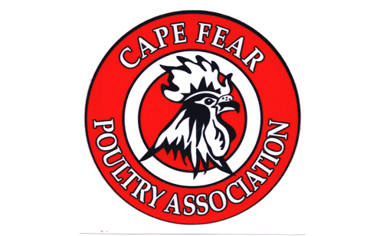
CAPE FEAR POULTRY ASSOCIATION

MEMBERSHIP FORM
DATE__________________________________

FIRST NAME__________________________________________LAST NAME______________________________________

ADDDRESS: ____________________________________________________________________________________________

CITY: ______________________________________________________ STATE: _______________ ZIP: ____________

HOME PHONE: ___________-____________-_______________ CELL: ___________-____________-__________

E-MAIL:_________________________________________________________________________

** PERMISSION TO SHARE E-MAIL AND/OR PHONE #'S WITH OTHER MEMBERS,
SHOW EXHIBITORS AND POST CLUB PICTURES ON WEBSITE

** SIGNATURE: _____________________________________________________________________________

SPONSORED BY: ______________________________________________________________________________________

SPOUSE'S NAME (IF APPLICABLE) _____________________________________________________________________

CHILDREN’S NAME AND AGES (Under the age of 18) ______________________________________________________

_____________________________________________________________________________________________________

WHAT TYPE/BREEDS OF POULTRY DO YOU HAVE NOW? ________________________________________________

_____________________________________________________________________________________________________

_____________________________________________________________________________________________________

WHAT TYPE/BREEDS DO YOU WANT IN THE FUTURE? __________________________________________________

_____________________________________________________________________________________________________

MEMBERSHIP DUES ARE: $20.00 PER YEAR FOR FAMILYAND $12.00 FOR INDIVIDUALS.
JUNIOR (NOT IN A FAMILY MEMBERSHIP) DUES ARE $8.00 PER YEAR UNTIL AGE OF 18.
ALL MEMBERSHIPS ARE RENEWABLE JANUARY 1ST EACH YEAR

PLEASE MAKE CHECK OR MONEY ORDER PAYABLE TO CFPA
MAIL TO: CFPA c/o Donna Worthington, 118 Kincalf Lane, Macclesfield, NC 27852

