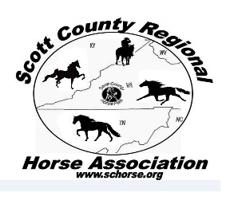
Scott County Regional Horse Association
2019 Membership Application
Please check the appropriate membership option(s):
JUNIOR_______ SENIOR_________ FAMILY__________
$8.00 (17 & under) $10 (18 & over) $25*
Individual Individual

Family membership includes parent or parents and their children 17 & under.
Family DOES NOT Include adult children 18 and over or other adult family members living at the same address. Any adult age children or adults living at the same address (home) must apply and pay for a SENIOR membership.

Applicant Name(s) Age(s)
______________________________ __________
SCRHA asks for this information to use
As data on the demographics of the
Association when completing reports and grants. It is much appreciated

______________________________ __________
______________________________ __________
______________________________ __________
______________________________ __________
Mailing Address: (MUST have complete mailing address-please use PO Box or 911 address and include the zip code)
______________________________________________________________________
______________________________________________________________________
Phone Number: _____________________________________________
E-mail _____________________________________________________
Check all that apply: Do you prefer to: SHOW ________TRAIL RIDE________STRAIGHT AWAY EVENT_______
OTHER______________________________
Authorizing Signature:
__________________________________________________Date:_________________
Dues are a contribution toward the operation of the association and are tax deductible under the IRS 501©3 guidelines.
Please return completed application and membership fee to:
Scott County Regional Horse Association Make Checks Payable to SCRHA
Carla Osborne
2664 River Bluff Rd.
Fort Blackmore, VA 24250

