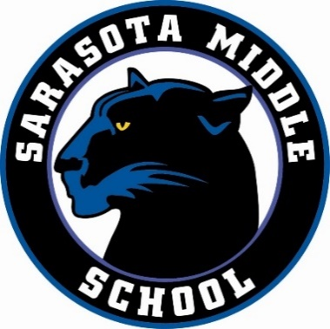
Parent/Guardian Contact Information Form
Sarasota Middle School
2016 – 2017

Welcome to Sarasota Middle School!

Our main form of communication with our families is through email. We will only send school, PTSO (Parent Teacher Student Organization), and volunteer based emails to the address you provide.

Please provide all information requested below in order to receive important notifications including PTSO meeting reminders, updates, upcoming events, volunteer opportunities, and donation item requests. Your name and email address will be entered into SignUpGenius by Cher Palmer, SMS Volunteer Coordinator. A copy of this form will also be given to the Team Leader assigned to your child’s team in order that he/she may provide you with important information regarding team activities and events.

If you have any questions or concerns, please contact Cher at smsptsovol@yahoo.com.

We are glad you are here and look forward to getting to know you more.

Thank you!

Please Print All Information Clearly
~ Only one (1) form per family necessary ~

Parent/Guardian Name: ____________________________________________________________

Email: ____________________________________________ Phone #: ______________________

Child’s Name: ______________________________ Grade: _____ Team: ____________________

Child’s Name: ______________________________ Grade: _____ Team: ____________________

Child’s Name: ______________________________ Grade: _____ Team: ____________________

_____ My child/children have not yet been assigned a team

Please return to your child’s teacher or the front office. Thank you!
(Teachers/Front Office: Please return to the PTSO mailbox. Thank you!)

