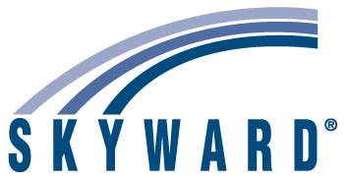

2017 Fall Tennessee Data & Attendance Supervisors Conference

Room Location: Cambridge AB

Attendees: Travis Colby Student Management Product Specialist
Caitlin Lundquist State/Federal Reporting Specialist
Jennifer Prideaux State/Federal Reporting Team Manager
Jordan Roberts Industry Specialist

Agenda:

Wednesday 9/13

8:00-9:00 am Open Q/A period with Skyward Team
9:00-10:00 am Online Registration - Lisa Berry, Alcoa City
10:00-11:00 am Attendance Letters – Travis Colby, Skyward
11:00-12:00 am Communication Options and Scheduled Tasks – Travis Colby, Skyward
12:00-1:00 pm Break for Lunch
1:00-2:00 pm New Gradebook Options – Travis Colby, Skyward
2:00-3:00 pm Custom Forms - Jennifer Connor, Oak Ridge
3:00-4:00 pm Troubleshooting EIS Errors – Jennifer Prideaux & Caitlin Lundquist, Skyward
4:00-5:00 pm EIS Recent Updates – Jennifer Prideaux & Caitlin Lundquist, Skyward

Thursday 9/14

8:00-4:15 pm Skyward staff available as needed
4:15-5:30 pm Frequent Ed-Fi Issues - Jennifer Prideaux & Caitlin Lundquist, Skyward

