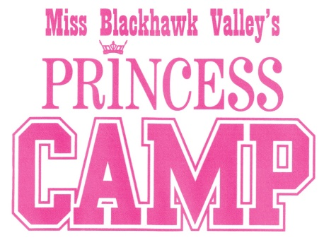
Princess Camp Opportunities for 2020

Participants in the 2020 Princess Program will have opportunities to build relationships with the Miss and Outstanding Teen BHV titleholders while developing speaking and performance skills through service-based appearances. Listed below are just some of the activities that are already being planned:

Performance opportunities (will include a princess group dance as well as chances for individual performances):
Miss BHV Competition January 4, 2020
Miss BHV Send-off to Miss Illinois May 2020
Bix Run, Davenport July, 2020
Halloween Parade Float October, 2020
Festival of Trees CenterStage November 27, 2020

Mentoring Events:
Fitness Day & Miss BHV Competition First Quarter, 2020
Community Service Day Second Quarter, 2020
Etiquette and Manners event Third Quarter, 2020
To be determined Fourth Quarter, 2020

Miss Illinois Princess Program
Opportunity to represent Miss Blackhawk Valley at the Miss Illinois Pageant June 20, 2020.

Miss Blackhawk Valley Princesses will be admitted to all Miss Blackhawk Valley functions during the pageant year 2020.

Each participant in the Princess Camp will receive:
- Tiara
- Sash
- Miss Blackhawk Valley Princess T-shirt

Revised 9/2019

