RSAI 2023 Position Paper:
School Choice and the Priority of Public Schools

Current Reality: Iowa has a wide range of school choice options for parents and students, including:
- Within District Transfer: A neighborhood public school or a public school in another neighborhood within the school district (transfers regulated by the local school board).
- Open enrollment to public school in another district: 36,412 students exercised this option in the 2021-22 school year. This total includes: 1) Open enrollment to another district or open enrollment to an Iowa public virtual academy online program. Note: Legislation in 2022 removed the requirement to meet a March 1 deadline, so students can now open enroll to another public school district at any time.
- Charter Schools: HF 813 and HF 847, effective July 1, 2021, created new charter school options for school boards or independent founding groups.
- Strong nonpublic schools: with 36,636 students enrolled in 2021-22. Millions of state tax dollars support private schools and parents for school tuition organization scholarships, tuition and textbook tax credits, transportation/textbook funds to private schools, public school and AEA support for special education in private schools, and public/private partnerships for private preschool tuition in the statewide voluntary preschool program.
- Home School Options: competent private instruction or independent private instruction. HF 847 in 2021 applied the tuition and textbook tax credit to home school for the first time.
- Public funding for private education: In 2018, over $66 million of state dollars supported education of Iowa students in private and home schools, according to the Iowa Fiscal Policy Project Analysis Nov. 2018. The additional fiscal impact of HF 847 expanding tax credits to home school would raise that total to $91 million.
- Recent Iowa Expansion of Private School Support: In the 2021 session, School Flexibility and Choice, HF 847, accelerated the prior year’s increase of the annual cap for School Tuition Organization (STO) Tax Credits to $20.0 million from CY 2025 to CY 2022 and the credit was expanded from 65% to 75% of the contribution. These scholarships support private school tuition for students from families below 400% of the federal poverty level ($111,000 income for a family of 4). The bill also doubled the Tuition and Textbook Tax Credit to 25% of $2,000 spent and applied it to home school for the first time in CY 2021.
The Heritage Foundation’s Education Freedom Report Card shows Iowa ranked 9th in the nation in school choice: this ranking predated the expansion of charter schools, tax credits for home school and elimination of an open enrollment deadline.
Vouchers or Education Savings Accounts Costs Outweigh Benefits: Increasing Iowa’s public investment in private schools will not add benefits and will negatively impact public school students:
- Iowa has competition to pressure schools to perform (if the assumption is that competition provides positive pressure). According to the Economic Policy Institute Report, Feb. 28, 2017, “Research does not show that vouchers significantly improve student achievement.”
- That report concludes there are more effective ways to increase graduation and college attendance rates, that voucher/ESA programs have hidden costs including shrinking the pipeline into teaching, and that support for privatization detracts from more proven methods of improving student learning. Rural schools already find it hard to compete for employees and are concerned that increased demand for teachers in private schools, even if just in urban areas, will make is harder for rural schools to find teachers, already in short supply.
- Diverting funds to private education further stresses public school resources. From State Tax Subsidies for Private K-12 Education, Oct. 2016; “30 neovouchers across 20 states are draining over $1 billion in public revenues from state coffers every year. Every dollar of revenue diverted toward private schools is revenue that cannot be invested in the public education system.”
- Programs Start Small but Expand: school choice programs in other states tend to start small, often with eligibility available to low-income or students with disabilities. Though, over time, eligibility expands to include all students. For example, Ohio’s private school vouchers began as a pilot program, but has grown from $42 million a year in 2008 to $350 million in the 20-21 school year. With Iowa’s historic income tax cuts hitting the balance sheet with an anticipated $1.8 billion revenue reduction, the commitment to increase state support for private school will bump up against budget cuts in just a few short years.
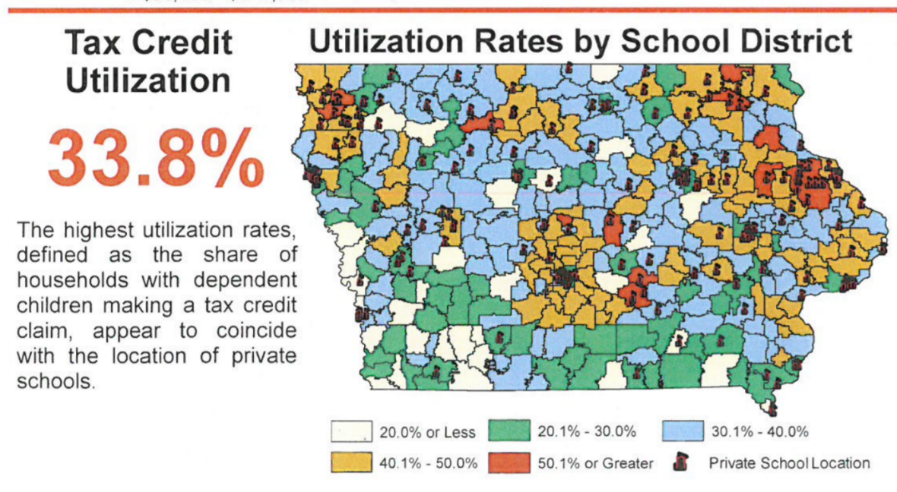
- Few Rural Private Schools: the survival of rural schools and variety of educational options for students depend on adequate state funding. There are few private schools available for rural parents to exercise choice, as this map from Iowa’s Department of Revenue presentation to the Tax Expenditure Committee measuring participation in tax credits, Jan. 2019, shows. According to the National Rural Education Association, education savings accounts reduce resources to rural schools and save money for parents in urban centers. Meanwhile, student poverty and minority concentration are exacerbated when families with means are encouraged to leave the public school for a private school program.
- No Oversight: The Economic Policy Institute also finds insufficient budgetary oversight of voucher programs. There is no publicly elected school board or Department of Education regulation of allowable expenditures. The public does not have access to records or public meetings. Good stewardship of tax dollars requires transparency and clearly articulated expectations.
- Level the Playing field: Public schools are accountable to taxpayers, parents, communities (the public), and serve all students. Unlike public schools, private schools can refuse to enroll or later expel students not meeting expectations or refuse enrollment based on specific student needs, such as students with disabilities, non-English-speaking, minority, low income or transgender students. If additional state dollars are used to fund ESAs, the private schools receiving those tax dollars should also be required to comply with testing, reporting, enrollment and service requirements.

Public School Priority: Public schools must be adequately funded and supported by the State. Investments in education savings accounts, voucher programs, school tuition organizations or home school, whether by tax credit or direct appropriation, remove resources from public schools in three ways;

- Iowa’s funding formula is enrollment based. Fewer students in public schools results in fewer resources for staff, programs and courses for the vast majority of students remaining in the public school. For rural schools in particular, the loss of students further stresses an already tight economy of scale.
- Carving Iowa’s education funding pie into more pieces means a smaller piece of the pie for Iowa’s public school students. Rural school leaders, looking ahead to the implementation of the 2022 historic tax cuts, already fear the inability of the state to adequately fund public schools, let alone take on the commitment of a second educational delivery system.
- School choice programs typically start small but quickly expand eligibility criteria (increased income eligibility, support for home school, or even eventual public support of private tuition for any student at any private school that will take them). Many rural school districts do not have a private school in their community today. In the future, private online academies, the pressure for the state to support homeschooling, and the profit motive to expand private schools without the corresponding costs of oversight and compliance, will create lower economies of scale and the inability for small rural schools to survive increased rigorous state accreditation compliance.
RSAI is opposed to all forms of education savings accounts/voucher programs/additional public funds appropriated for private or home school. Such programs traditionally do not include accountability for tax expenditures, are not required to educate and assess all children or provide special education services, and are hidden from the public oversight that accompanies public funding.
With recent expansions to unlimited open enrollment to any public school in Iowa, combined with Iowa’s current public investment in private religious schools and home school exceeding $80 million, even small demonstration programs or pilot projects should be resisted; the camel’s nose under the tent is soon followed by the humps.

