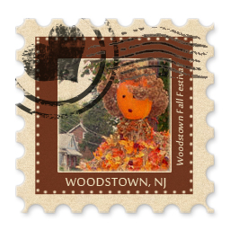
2017 Scarecrow Contest
September 30, 2017
www.woodstownfallfestival.com
Participate in a great Woodstown tradition and show your community spirit by entering the Woodstown Fall Festival Scarecrow competition. All businesses, groups, and individuals are encouraged to decorate a scarecrow that will be displayed throughout Woodstown during the fall season. We have over 100 scarecrow frames for decorating.
Scarecrow Competition and Display September 29 – October 31
The frames are approximately six feet tall. All frames and lamppost locations will be given out on a first-come, first -serve basis. Set up is Friday, September 29 at 5:00pm.
Please contact Tom or April Hollinger at
769-1558 or 609-420-7177 or THHOLLINGER@COMCAST.NET for additional information.

CATEGORIES
Youth
Individual / Family
Business
Nonprofit/Club

PRIZES
Best of Show $200
First $100
Second $50
Third gift
Most Original gift
Harvest gift
Mayor’s Choice gift

WOODSTOWN FALL FESTIVAL SCARECROW CONTEST

Contact Name: ___________________________

Address: _____________________________________________________

Phone: ___________________________email: ___________________________

Scarecrow Category: ___________________________

Title of Entry: ____________________________

email information to THHOLLINGER@COMCAST.NET

