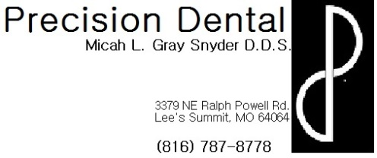
Proper Bleach tray care and use instructions
- Any time that custom trays are not in your mouth ensure that they are protected in a sealed container with a small amount of cool/warm water
- Only place a small dot of the provided bleach on the facial (or side closest to your lips/cheeks) surfaces of the inside of your bleach tray. Too much material can cause burning of gums.
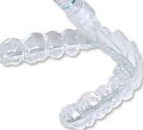
- DO NOT place bleach in any areas that contain porcelain restorations, if you desire we can place a small hole in the facial surface of your tray to remind you not to place bleach in those areas.
- Occasionally bleaching causes sensitivity it is recommended that you begin using a sensitivity toothpaste 2 times a day at least 2 weeks prior to bleaching and continue it’s use through the duration of your bleaching, and for any additional time that sensitivity persists.
- Brush and floss your teeth then place loaded tray in your mouth for _____ min, ______ times a day until desired shade is achieved.
- Press the trays against your teeth to disperse the material , wipe any excess away with your finger, and wash hands
- After allotted time, remove trays, rinse mouth with water and gently brush off any excess material with a soft, wet toothbrush.
- If you notice that your teeth are still very sensitive reduce the amount of time and/or frequency of use.
- Avoid things that might stain your teeth (red wine, coffee, tea, etc) to prolong the whitening effect of your bleaching.
- Please contact the office with any questions or concerns.
- If you would like to purchase additional bleach please contact the office.

