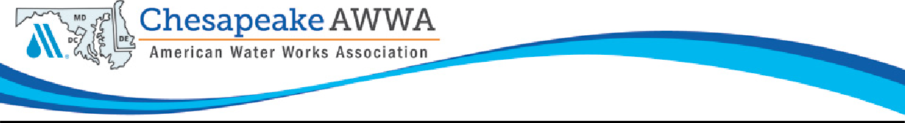

2022 CSAWWA Operator of the Year Award Application

The Chesapeake Section of the American Water Works Association, Inc. (CSAWWA) is accepting applications for its annual Operator of the Year Award. Eligible candidates must have made an outstanding contribution to the water industry over the past year.

Completed applications must be returned by July 22, 2022 to Rob Swann at
Pwswan24@aacounty.org

- Nominee's Name: Title: Company Name: Address: CSAWWA Membership #:

- Nominated By: Address: Phone No.: Email:

Brief employment history:

- Please note accomplishments which you feel help justify the nominee receiving this award:

Examples of noteworthy accomplishments include:
  - Continuous compliance with public health standards in finished water.
  - Consistent and outstanding contribution to plant maintenance thereby prolonging the useful lives of equipment.
  - The development of new and/or modified equipment or significant process modifications to provide for a more efficient or effective treatment.
  - Special efforts in the training of treatment plant operators.
  - Special acts not directly related to water treatment, but which demonstrate dedication to the public beyond the normal operating responsibilities.
  - Consistent and outstanding contribution to operation and/or maintenance of distribution system(s), pump stations, and/or reservoirs.

Citation- Please provide recommended citation of 50 words or less:

- Year nominee became an AWWA member:

- List any offices held and/or committees the nominee has served on:

- List any Professional organization memberships or civic organization memberships (Lions, Kiwanis, school board, etc.) held by the nominee:

- List any Professional awards/honors received. Provide year and identify awarding organization:

- Educational Experience:
- Degree(s) Earned:
- Year(s):

