REGULAR MEETING
JANUARY 19, 2023

The Regular Meeting of the Town Board of the Town of Hampton, County of Washington and the State of New York was held at the Town Hall, 2629 State Route 22A, Hampton, New York, on the 19th day of January 2023.

PRESENT: David K. O’Brien------------Supervisor
Donald Sady----------------- Councilman
Tamme Taran----------------Councilwoman
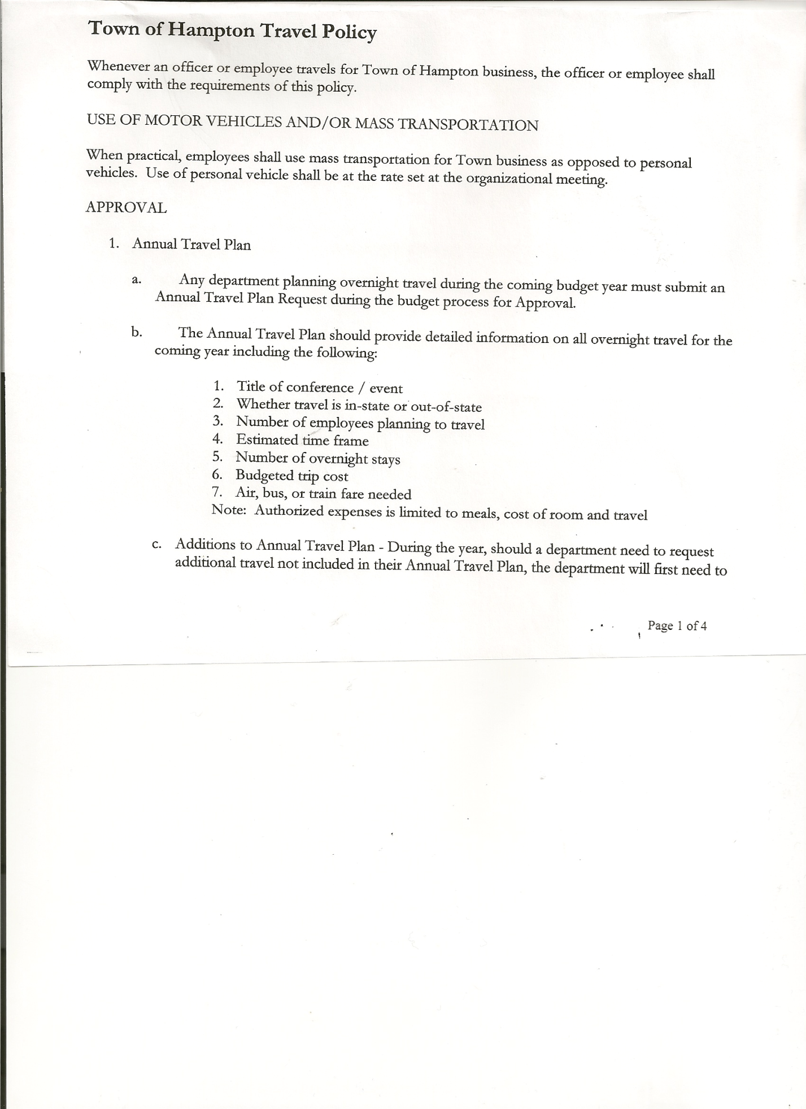
Michael Pietryka------------Councilman
Andrea Kugler---------------Councilwoman
Rebecca Jones---------------Town Clerk
Camilla Shaw----------------Deputy Town Clerk
Tyler McClure---------------Highway Superintendent

Planning Board Member (s):…Matthew Pratt and Richard Cole
Others present at the Town Hall: see attached sheet

The Regular Meeting was called to order by Supervisor O’Brien at 7:30pm, followed by the Pledge of Allegiance. Location of Fire Exits were given. Quorum of board members present.

RESOLUTION NO. 9-2023
APPROVAL OF THE MINUTES
On a motion of Councilman Sady, seconded by Councilman Pietryka, the following resolution was ADOPTED: AYES 5 O’Brien, Sady, Taran, Pietryka, Kugler
NAYS 0
RESOLVED, that the Regular Town Board Meeting Minutes for December 15th, 2022; the Special Town Board Meeting Minutes for December 30th, 2022 and the Special Town Board Meeting Minutes for January 2nd, 2023 are approved.

PERMITS/SUBDIVISION
Bruce Jones, 2338 County Route 18 came before the Board to amend his previously filed subdivision. The amended Mylar Map now shows the .7 acre lot to 1 acre; another lot is 54.69 acres and a third lot with 6.92 acres.
RESOLUTION NO. 10-2023
JONES-AMENDED - SHORT ENVIRONMENTAL ASSESSMENT FORM/NEGATIVE DECLARATION
On a motion of Councilman Sady, seconded by Councilwoman Kugler, the following resolution was ADOPTED: AYES 5 O’Brien, Sady, Taran, Pietryka, Kugler
NAYS 0
RESOLVED, that the Amended Short Environmental Assessment Form for Bruce Jones is complete and to adopt a negative declaration and finding that there will be no adverse environmental impacts and to consider it a minor subdivision, therefore waving the public hearing.

TOWN BOARD MEETING
JANUARY 19, 2023 PAGE 2

RESOLUTION NO. 11-2023
APPROVAL OF SUBDIVISION
On a motion of Councilman Sady, seconded by Councilwoman Taran, the following resolution was ADOPTED: AYES 5 O’Brien, Sady, Taran, Pietryka, Kugler
NAYS 0
RESOLVED, to approve Bruce Jones ‘subdivision

Richard Cole, Dog Control Officer gave his report…
- William Jones, Low Hampton….licensed one dog. He has another dog, which is not licensed.
- Complaint on County Route 21, dog running loose, not licensed. Having a hard time trying to deliver complaint to homeowner, not able to find them at home.

Supervisor O’Brien suggested doing another Dog Enumeration, as many dogs in Town are not licensed. Voluntary licensing will not have a fine, but there would be a fine for not licensing. This would be a mailing. The last Dog Enumeration was done in 2017. The following resolution was then introduced:
RESOLUTION NO. 12-2023
DOG ENUMERATION
On a motion of Councilman Pietryka, seconded by Councilman Sady, the following resolution was ADOPTED: AYES 5 O’Brien, Sady, Taran, Pietryka, Kugler
NAYS 0
RESOLVED, to do another Dog Enumeration via a mailing.

Annual Shelter Service Agreement received from Animal Safe-Home and Rehabilitation, LLC. The following resolution was introduced authorizing Supervisor O’Brien to sign the Shelter Service Agreement.
RESOLUTION NO. 13-2023
DOG SHELTER AGREEMENT
On a motion of Councilman Sady, seconded by Councilman Pietryka, the following resolution was ADOPTED: AYES 5 O’Brien, Sady, Taran, Pietryka, Kugler
NAYS 0
RESOLVED, to authorize Supervisor O’Brien to sign the Shelter Service Agreement.

Tax Collector….. has started collecting 2023 Town/County taxes. Two payments to Supervisor O’Brien so far.

Planning Board…copy of the minutes of their meeting held January 11th, 2023 are attached. Next Planning Board meeting is planned for February 8th, 2023.

Tyler McClure, Highway Superintendent submitted his report, copy of which, is attached.

TOWN BOARD MEETING
JANUARY 19, 2023 PAGE 3

SUPERVISOR’S REPORT/ COUNTY UPDATES/ COMMUNICATIONS
Supervisor’s Report for December 2022….will table approving until February meeting. Board would like further explanation of numbers on the side of report.

NEW BUSINESS
2022 ANNUAL AUDITS

RESOLUTION NO. 14-2023
END OF YEAR COURT AUDIT
On a motion of Councilwoman Taran, seconded by Councilwoman Kugler, the following resolution was ADOPTED: AYES 4 O’Brien, Taran, Pietryka, Kugler
NAYS 0
ABSTAIN 1 Sady
RESOLVED, to accept the Court Audit for 2022.

RESOLUTION NO. 15-2023
END OF YEAR AUDITS FOR TOWN CLERK AND TAX COLLECTOR
On a motion of Councilman Pietryka, seconded by Councilman Sady, the following resolution was ADOPTED: AYES 5 O’Brien, Sady, Taran, Pietryka, Kugler
NAYS 0
RESOLVED, to accept the Town Clerk and Tax Collector Audits for 2022.

Following a discussion regarding Partial Real Property Tax Exemption for Volunteer Firefighters and Volunteer Ambulance Workers, the following resolution was introduced:
RESOLUTION NO. 16-2023
MOTION BY: Councilman Donald Sady
SECONDED BY: Councilman Michael Pietryka

RESOLUTION INTRODUCING PROPOSED LOCAL LAW PROVIDING FOR A PARTIAL REAL PROPERTY TAX EXEMPTION FOR INCORPORATED VOLUNTEER FIRE COMPANY, FIRE DEPARTMENT OR INCORPORATED VOLUNTEER AMBULANCE SERVICE MEMBERS AND THEIR SPOUSES

WHEREAS, the State of New York legislature enacted Real Property Tax Law Section 466-a which permits a municipality to adopt a local law providing for a partial tax exemption for enrolled members of an incorporated volunteer fire company, fire department or incorporated voluntary ambulance service, and their spouses; and

WHEREAS, the Town Board has reviewed the options allowed under Real Property Tax Law Section 466-a and a local law has been drafted and the Town Board wishes to proceed with the introduction of, and the holding of a public hearing on said local law for the adoption thereof.

TOWN BOARD MEETING
JANUARY 19, 2023 PAGE 4

NOW, THEREFORE BE IT

RESOLVED, that a public hearing shall be scheduled for the consideration of said local law to be held by the Town Board on February 16th, 2023 at 7:15 p.m. at the Town Hall located at 2629 State 22A, Hampton, NY 12837 and be it further

RESOLVED, that the Town Clerk is directed to post and publish a notice of said public hearing in the Manchester Newspapers (The Granville Sentinel/The Whitehall Times) at least five (5) days before the public hearing.

RESOLVED, that this resolution shall take effect immediately.

DATED: January 19, 2023 Supervisor O’Brien AYE
Councilman Sady AYE
Councilwoman Taran AYE
Councilman Pietryka AYE
Councilwoman Kugler AYE

RESOLUTION NO. 17-2023
AUDIT OF CLAIMS
On a motion of Councilman Sady, seconded by Councilman Pietryka, the following resolution was ADOPTED: AYES 5 O’Brien, Sady, Taran, Pietryka, Kugler
NAYS 0
RESOLVED that the bills have been reviewed by the Town Board and are authorized for payment in the following amounts.
General Fund No. 1 through No. 9 $ 2,491.63
Highway Fund No. 1 through No. 7 $ 4,725.62
Total both funds $ 7,217.25

The Town Clerk’s report for December 2022 was submitted to the Board. The Town Clerk had Board Members review and sign bank reconciliation statements for the Town Clerk Account and Special Clerk Account dated December 31st, 2022.

RESOLUTION NO. 18-2023
MEETING ADJOURNED
On a motion of Councilwoman Taran, seconded by Councilman Sady, the following resolution was ADOPTED: AYES 5 O’Brien, Sady, Taran, Pietryka, Kugler
NAYS 0
RESOLVED that the meeting adjourned at 8:53pm.

Respectfully submitted,

Rebecca S. Jones, RMC
Town Clerk

