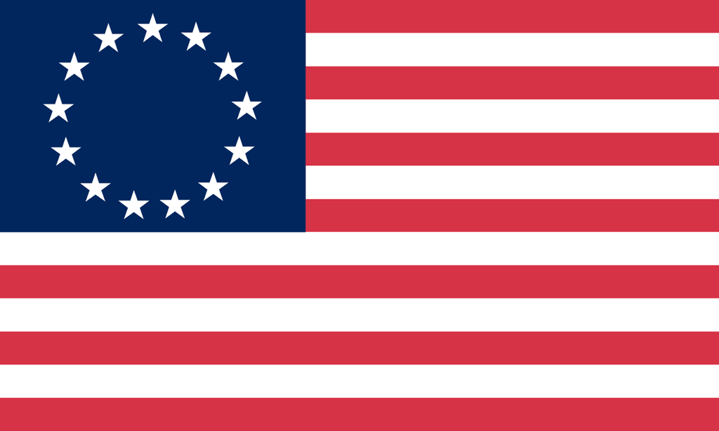U.S. History with Mr. Brown Name _______________________________ Period _____
George Washington French and Indian War

Directions: Read the article below and answer the questions that follow.

The Bullet Proof President
http://www.garymcleod.org/bullet.htm
From America's Godly Heritage
by David Barton
Wallbuilders.com

This story of George Washington once appeared in virtually every student text in America, but hasn't been seen in the last forty years. This story deals with George Washington when he was involved in the French and Indian War as a young man only twenty-three years of age.

The French and Indian War occurred twenty years before the American Revolution. It was the British against the French; the Americans sided with the British; and most of the Indians sided with the French. Both Great Britain and France disputed each others' claims of territorial ownership along the Ohio and Mississippi rivers; both of them claimed the same land.

Unable to settle the dispute diplomatically, Great Britain sent 2300 hand-picked, veteran British troops to America under General Edward Braddock to rout the French.

The British troops arrived in Virginia, where George Washington (colonel of the Virginia militia) and 100 Virginia buckskins joined General Braddock. They divided their force; and General Braddock, George Washington, and 1300 troops marched north to expel the French from Fort Duquesne --- now the city of Pittsburgh. On July 9, 1755 --- only seven miles from the fort --- while marching through a wooded ravine, they walked right into an ambush; the French and Indians opened fire on them from both sides.

But these were British veterans; they knew exactly what to do. The problem was, they were veterans of European wars. European warfare was all in the open. One army lined up at one end of an open field, the other army lined up at the other end, they looked at each other, took aim, and fired. No running, no hiding, But here they were in the Pennsylvania woods with the French and Indians firing at them from the tops of trees, from behind rocks, and from under logs.

When they came under fire, the British troops did exactly what they had been taught; they lined up shoulder-to-shoulder in the bottom of that ravine -- and were slaughtered. At the end of two hours, 714 of the 1300 British and American troops had been shot down; only 30 of the French and Indians had been shot.

There were 86 British and American officers involved in that battle; at the end of the battle, George Washington was the only officer who had not been shot.

Following this resounding defeat, Washington gathered the remaining troops and retreated back to Fort Cumberland in western Maryland, arriving there on July 17, 1755.

The next day, Washington wrote a letter to his family explaining that after the battle was over, he had taken off his jacket and had found four bullet holes through it, yet not a single bullet had touched him; several horses had been shot from under him, but he had not been harmed. He told them:

By the all powerful dispensations of Providence, I have been protected beyond all human probability or expectation.

Washington believed that God's hand was upon him, that God had protected him and kept him through that battle.

However, the story does not stop here. Fifteen years later, in 1770 -- now a time of peace -- George Washington and a close personal friend, Dr. James Craik, returned to those same Pennsylvania woods. An old Indian chief from far away, having heard that Washington had come back to those woods, traveled a long way just to meet with him.

He sat down with Washington, and face-to-face over a council fire, the chief told Washington that he had been a leader in that battle fifteen years earlier, and that he had instructed his braves to single out all the officers and shoot them down. Washington had been singled out, and the chief explained that he personally had shot at Washington seventeen different times, but without effect. Believing Washington to be under the care of the Great Spirit, the chief instructed his braves to cease firing at him. He then told Washington:

I have traveled a long and weary path that I might see the young warrior of the great battle....I am come to pay homage to the man who is the particular favorite of Heaven, and who can never die in battle.

1) Who was the British General sent to help Washington and the Colonists fight the French and Indians?

2) What present day city is at the site of Fort Duqense?

3) How many bullet holes did George Washington have in his coat?

4) Was that a pretty neat story?

