

Report Week 1

Singles League

2nd November 2013

Welcome to the new season and the wonderful weather we are going to have to get used to.

Current Winter League champion (who won 9 out of 9 last winter) Matt Ryan lost to inform Keith Pinel the second time in consecutive seasons Keith has beat Matt.

Current Summer Singles champion Ross Payne escaped defeat by the skin of his teeth beating Callum Stewart 13 – 12 to gain a draw. David Ibitson and Jake Romeril both relegated in the summer could both struggle again in the top flight, drawing against each other. Alan Oliveira and Toby yet to play with Andrew Bellamy on a bye.

Division 1 will be a close fought affair this winter, two players relegated last Winter Brian Harris and Alice Ibitson both won with Alice beating Chris Romeril who was undefeated in the summer. Another person undefeated in the summer was joint player of the Season John McGaw but he also lost, to Stefan Riccio. Joint player of the season Richard Potrzeba became the ninth person in 11 matches to draw against Paul Le Moine. Ian Foster on a bye.

Division 2 saw three winners with Matt Buesnel beating Tracy Beverley, Jake Day beating Cassie Stewart and Carol Kerr tops the table after a win over Alex Stewart. Nathan, Brendan and Celine all still to play.

Please don’t forget entries to the melee’s, they will not only be individual competitions which will give you opportunities to play with different people but results from all the seasons melee’s (not Christmas & Valentine’s competitions) will be added together in a separate league table to find the best male and female melee player.

Kind Regards

Toby

Report Week 2

Doubles League

9th November 2013

The first Doubles week saw many new partnerships enter the fray.

The Premier League had five new teams from last Winter but none of them could manage a win.

Brendan Jones & Jamie Benson took on one half of the Summer Doubles champions Ross Payne & new partner for the Winter Jake Romeril with both teams playing well for a good draw. Newly promoted teams Paul Le Moine & Celine Gimenez and Colin Myers & Steve Simpkin also drawing a very close game. New boys John & Richard though lost to experienced duo Alice & Brigitte Ibitson with one game to 13 – 12.

Two potential title contenders played each other in the first match of the season but a convincing win for Toby & Andrew Le Breton over Callum & Andrew Bellamy to top the table early on, but current Winter champions Matt Ryan & David Ibitson still to play with their match against the first ever Winter league champions Alan Oliveira & Craig Kelly postponed for another day.

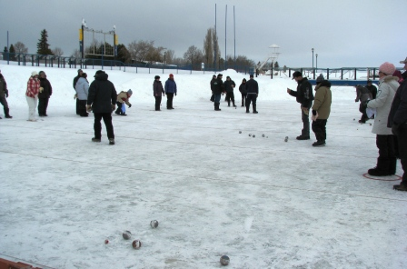

(Pictured Above)

10th edition of the petanque tournament of ice held the first week end in March on the Lac St-Jean in Roberval in Canada

Division 1 saw another new partnership in Brian Harris & Stefan Riccio play together for the very first time but after losing the first game to Cassie & Alex Stewart got into their rhythm winning the second game 13 – 1 for what could turn out to be a good partnership going forward.

Another new but very experienced partnership is Keith Pinel current leader in the Singles Premier league partnered by Rosie Boleat but with an early start time got caught by the rain and Dawn Buckley & Jo Logue as the match ended in another close draw.

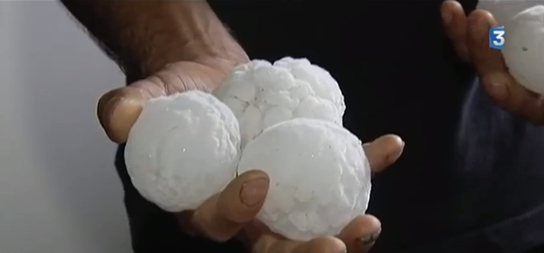

Next week is Singles League then on the 23rd November the clubs first ever melee. For those of you who don’t know what a melee is a brief explanation below.

There will hopefully be four rounds and for each round you will be drawn to play with a different person, with each round based on one game to 13. At the end of the four rounds the male and female players with the most wins and best + points difference will be the winners.

These competitions are more a bit of fun outside of the competitive leagues but also give you the opportunity to play with different people.

Kind Regards

Toby Northern

Chairman

Liberation Petanque Club

Report Week 3

Singles League

16th November 2013

Keith Pinel continues to set the pace in the top flight with a win over Jake Romeril who continues to struggle in the top flight as he also lost to Toby, but surprisingly is not in the relegation places. This is Matt Ryan and Andrew Bellamy’s places, at least for the moment as Matt has only played one match and Andrew is yet to play.

Callum Stewart and David Ibitson drew gain, this time against each other with one game going the distance to 13 – 12. Alan Oliveira gained a good draw against Toby, although after losing the first game was 10 nil up in the second game but Toby came back to 11 all before Alan settled his nerves to win 13 – 11 and get himself off the mark.

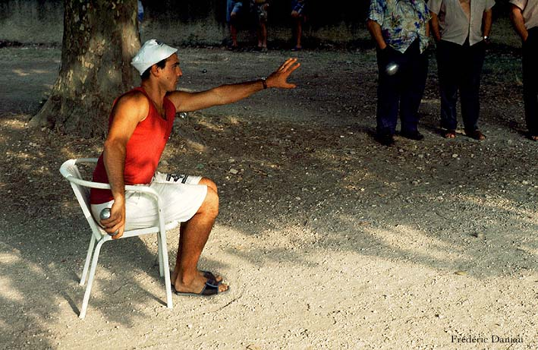

Why not take a seat!! And enjoy a game of petanque.

Division 1, see’s Brian Harris continue his 100% record this time beating new doubles partner Steffan Ricciou and with other potential title rivals dropping points will be hard to beat. One of those challengers Alice Ibitson dropped points against John McGaw with a game going to 13 – 12 in the longest match of the day in a very close match.

A somewhat surprising result considering the final table in the Division 1 Summer Singles league as one of the promotion favourites Ian Foster lost to Brigitte Ibitson in what could be a very close division.

Division 2 saw the closest possible match in a shared 13 – 12 between Alex Stewart and new league leader Matt Buesnel. Nathan Wheller was another player to miss out on a win losing the first game against Celine 13 – 12 before recovering to gain a point.

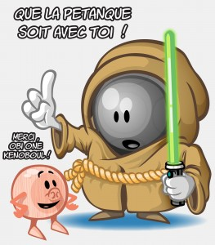

May the Petanque be with you.

Enjoy your week

Kind Regards

Toby

Report Week 4

Mixed Doubles Melee

23rd November 2013



Thank you to the 18 players who took part in the club’s first ever melee.

With every player taking part playing with a different partner in each of the 4 rounds, it was a good opportunity to play with new people of different levels and have a bit of fun.

The Melee’s are not only individual competitions but will also be entered into a league table with all the melee’s results for an overall champion.

The first ever melee winner is

Men Ladies

Brian Harris Cassie Stewart

Brian Harris won the competition overall winning all 4 matches with +19.

Full table below:

 |  | W / L | Points FOR | Points AGAINST | + / -
1 | Brian Harris | 4 | 52 | 33 | 19
2 | Keith Pinel | 4 | 52 | 39 | 13
3 | Ross Payne | 3 | 50 | 28 | 22
4 | Toby Northern | 3 | 48 | 34 | 14
5 | Cassie Stewart | 3 | 50 | 40 | 10
6 | Teresa Koradi | 3 | 44 | 41 | 3
7 | Alan Oliveira | 2 | 45 | 39 | 6
8 | Callum Stewart | 2 | 43 | 39 | 4
9 | Jake Day | 2 | 43 | 42 | 1
10 | Stefan Riccio | 2 | 43 | 44 | -1
11 | Elaine Paisnel | 2 | 41 | 45 | -4
12 | Dawn Buckley | 2 | 36 | 41 | -5
13 | Paul Le Moine | 1 | 35 | 39 | -4
14 | John McGaw | 1 | 40 | 50 | -10
15 | Cerys Thompson | 1 | 36 | 48 | -12
16 | Colin Myers | 0 | 35 | 52 | -17
17 | Martin Koradi | 0 | 30 | 52 | -22
18 | Andrew Bellamy | 0 | 0 | 52 | -52 | Withdrawn

This Weekend is not only Doubles week but a Double Fixture week

The 7th December is the Christmas Doubles competition for members and their partners or friends (no membership required for partners or friends).

There will be drinks, mince pies and other festive treats on the day, and if you wish to add your own festive touch you are more than welcome.

There will be 4 matches a semi-final and final starting at 9.30am

Please email me your entry by the 5th December

Kind Regards, Toby

Report Week 5

Doubles League

30th November 2013



Even giants sometimes have bad days.

This was the case for favourites to retain their Winter Doubles league title Matt Ryan & David Ibitson who were brought crashing to earth with a defeat against Premier League first timers Paul Le Moine & Celine Gimenez and it didn’t get much better in their 2nd match as they just scraped a draw against Brigitte & Alice Ibitson.

Two other big teams Ross Payne & Jake Romeril and Callum Stewart & Andrew Bellamy drew against each other with both these teams also without a win this season.

Brigitte & Alice also drew against Colin Myers & Steve Simpkin which means they top the table early on and undefeated in 3 matches.

Division 1 saw Brian Harris & Stefan Riccio storm to the top with two very convincing wins over Monika & Jamie and then Pat & Teresa, the latter match included a 13 – 0.

New partnership Rosie Boleat & Keith Pinel had a win and a draw as the experienced pair get used to playing together and now sit in 2nd place.

Ann Ellis & Ian Foster also won, but Alex & Cassie Stewart lost both matches.

Martin Koradi & Chris Hoegsburg won one and lost one with Matt Buesnel & Nathan Wheller now finding it tough going in the winter after their initial performances in the Summer sunshine.

Good Luck to the 12 teams playing on Saturday, hope you enjoy the day.

Polite notice – if you are planning on entering any of the competitions / melee’s please allow for a full days play.

CLUB KIT

The club has designed as some of you are aware a club kit with logo on it, this is only available in mens sizes at a cost of £25.

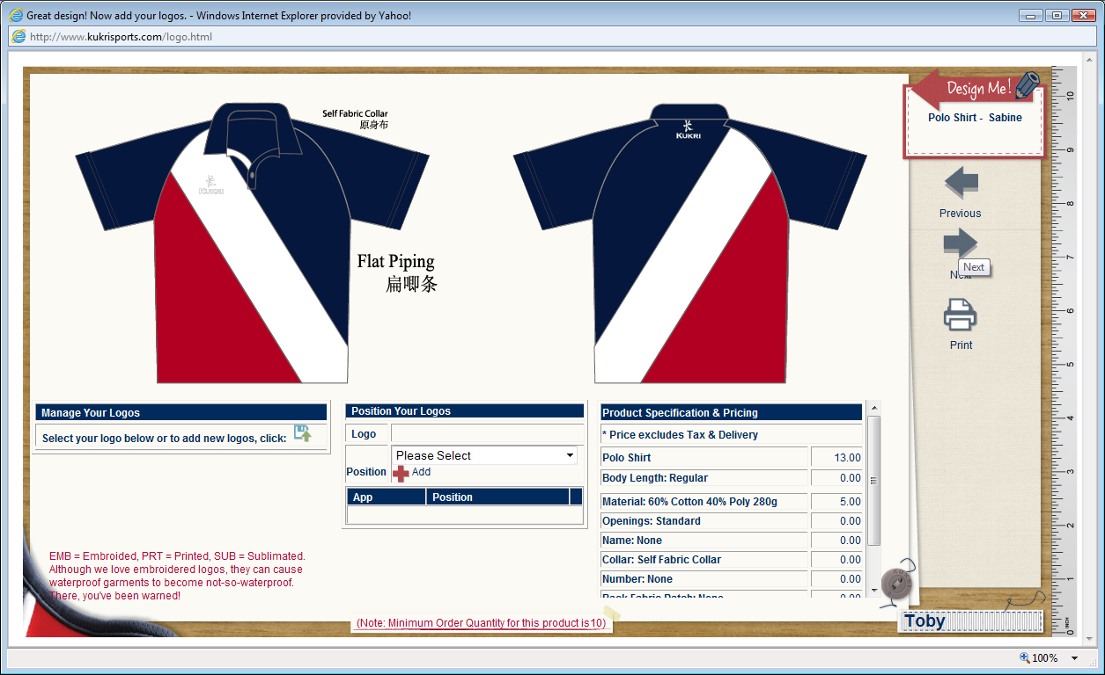

Sizes

2XS34
XS36
S38
M40
L42
XL44
2XL46
3XL48
4XL50
5XL52
6XL54
7XL56
8XL58
9XL60

Please email me your order with your size please if you would like to purchase one.

We need a minimum of 10 orders to purchase them and it takes approx 6-8 weeks for delivery.

Payments Liberation Petanque Club sent to Matt Ryan please.

Kind Regards

Toby

Report Week 6

7th December 2013
Christmas Competition 2013

A nice morning was enjoyed by all for the second annual Liberation Christmas Melee, organized by Callum all teams turning up on time apart from John McGraw, who just about made the cut off point, and only losing 1 point, as Keith and Rosie were very nice.
In the first round, Ross and Cassie beat Callum and Brendan conformably 13 8, John and Dawn managed to win 13 – 8 starting with a one point deduction. However the score of the round was Jake and Alannah winning 13 1 against Martin and Teresa.
Round 2 saw John and Dawn win again 13 7 against married couple Ian and Penny, while Keith and Sue beat Steve and Alex 13 12 and Bells and his finance getting a win against an unfortunate Martin and Teresa again.
After 2 rounds John and Dawn and Keith and Sue were both in the lead with 2 wins
Round 3 saw a very close game between Ian and Penny who were beaten 13 12 against Steve and Alex, Currently unbeaten John and Dawn lost against Ross and Cassie, who both were on 2 wins now and Keith and Sue got 3 wins out of 3 by beating Jake and Alannah 13 3.
Round 4 saw Ross and Cassie beat Ian and Penny to get 3 wins out of 4, however with Steve and Alex, Keith and Rosie and Brian and Paul all getting 3 wins Ross and Brian’s teams were the unlucky losing by not finishing on enough points difference.
Well done to Keith and Sue who won all 4 games.
Now the tricky bit, Steve and Alex and Rosie and Keith both finished on plus 15, with a hungover competitions officer, it was decided that they would have 1 end, (whoever let him do this, well, I dunno) whoever lost would play Keith and sue, unlucky for Steve and Alex it was them.
With it being close in the group, Steve and Alex thought they had a good chance, however with Sue’s placing spot on we saw the first and only fanny of the day with it being 13 nil to Keith and Sue
Another game which we saw in the group, John and dawn won 13 10 against Keith and Rosie to play in the final.
3rd and 4th place was 13 6 to Steve & Alex against John & Dawn
Final was 13 5 to Keith & Sue v Rosie & Keith
Well Done to everyone.

Report Week 7

Singles League

14th December 2013

As we enter the Christmas break there are no real outright leaders in any of the leagues.

Top two in the Premier league drew which means Keith Pinel remains top, with both the top two the only players unbeaten.

But its wins that count as Andrew Bellamy showed with wins over David Ibitson and Callum Stewart moved him to joint second place and within touching distance of that coveted top spot.

Alan Oliveira continues to improve with a convincing win over Ross Payne. Callum drew with Jake Romeril who also lost to Toby. Jake is now without a win in 15 Premier League matches counting last summer’s results. We all know what Jakes New Year’s resolution will be!

David Ibitson moves into contention with a win over Alan, but last winters champion is bottom of the table (Matt Ryan) yet to win.

Division 1, top 2 also played each other, playing out a draw, but Brian Harris will be much the happier handing Alice Ibitson a 13 – 0 defeat, Alice though recovered to beat Ian Foster and with Brian run very close by John McGaw it’s that 13 – 0 win which keeps Brian top.

Alice did recover though to beat Ian Foster who in turn beat Stefan Riccio for his first points of the season. Brigitte had a good day picking up 4 points but couldn’t beat Richard Potrzeba who has a 100% record (draws that is).

One surprise though is Chris Romeril, the Islands top ranked player in the relegation zone in Division 1 without a win!

Division 2 see’s Carol Kerr returning to the singles league this season and tops the league unbeaten.

Also unbeaten is Matt Buesnel who drew both matches, with Carol and doubles partner Nathan but keeps 2nd place over Tracey Beverley on points difference.

Despite being the best performing female player in the recent melee, Cassie Stewart is unable to convert this into league points as surprisingly is bottom of the table, with Celine and Nathan also without wins.

Doubles

The Premier league has seen some surprising results with Matt & David struggling, Ross and Jake still getting used to each others style of play and Callum and Andrew still not converting potential into points.

This has allowed new comers Colin & Steve and Jamie & Brendan to move up the table and myself and Andrew getting dizzy from the lack of oxygen at the top of the table.

Division 1 see’s two new doubles teams top the table with Ann Ellis & Ian Foster and Brian Harris & Stefan Riccio leading the way on 7 points and both unbeaten.

With a lot of new teams / partner ships and changes to the leagues we have seen quite a few 13 – 0 already, hope your looking forward to picking up your certificates at the end of the season.

Dates / to watch out for in 2014

11th January Melee (Random triples)

25th January Melee (Random Doubles)

Please email me tjamesnorthern@yahoo.co.uk if you want to play

End of Feb/Beginning of March will be the Clubs AGM (date tbc)

If your interested in helping run the club and would like to know more about the current positions please email me.

Club’s Open tournaments 5th April Singles

7th June Doubles

We have already started to receive entries from external players and as spaces are limited please don’t leave your entries till late as you may miss out.

Don’t forget orders for the club kit ready for the Summer Season.

On behalf of the club and myself I hope everyone has a great Christmas and wish you all a happy new year.

Don’t forget Magic Touch have lots of Petanque equipment if anyone wants to buy me (sorry partners friends etc) Christmas presents.

Kind Regards

Toby

Chairman

Liberation Petanque club

Report Week 8 & 9

Free Weeks ( Christmas Period )

Report Week 10

Doubles League

4th January 2014

A New Year and new league leaders as Brigitte & Alice Ibitson take over top spot with a draw against Toby & Andrew and a win over Alan Oliveira & Craig Kelly with Craig under the weather in more ways than one.

Also into contention are Premier League new boys Brendan Jones & Jamie Benson who drew with Matt Ryan & David Ibitson before thrashing Toby & Andrew as the rain poured down for the performance of the week.

Callum Stewart & Andrew Bellamy continued to turn the table upside down with two wins and a draw moving from relegation places to title challengers. Their draw though was a very well earned point although they did make it hard on themselves coming back from 12-1 down in the first game to just lose 13 – 12 and then won the second game from 11-1 down.

Colin & Steve gave a good account of themselves with 2 draws one of which was against Richard & John yet to win but are proving hard to beat in a very competitive league.

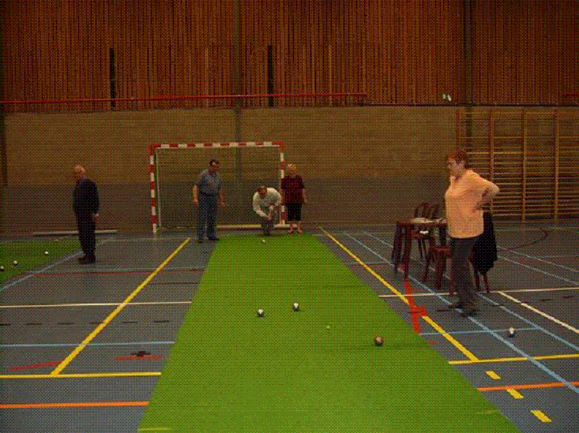

Above could indoor petanque be coming to Fort Regent?

Ann Ellis & Ian Foster remain unbeaten and now top the league with a win and draw, however its Brian Harris & Stefan Riccio who seem to be the ones to beat only conceding an average of 5 points per game so far.

Martin and Teresa Koradi on different teams but contesting a promotion place currently just separated by points difference.

Keith Pinel and Rosie Boleat still unbeaten but finding wins hard to come by.

Hope all those playing in the melee have a good time.

Kind Regards

Toby

Report Week 11

Melee 2 Random Doubles

11th January 2014

The clubs second melee was played in glorious sunshine, with a record 20 players registered, meant the format was changed from Triples to random doubles.

It was great to see everyone enjoying playing with different people and it brought some surprising results.

Round 1 saw Colin Myers & Jake Day beat Brendan Jones & Paul Le Moine 13 – 0 (Certificate on its way), well done to both as neither of them won a match in the first melee.

Round 1 also saw comeback of the day as Teresa Koradi & Toby Northern who from 11 – 1 down beat Steve Simpkin & Keith Pinel.

Andrew Bellamy must be tired of playing against Ross Payne who along with partner Alex Stewart beat him and Elaine 13 – 0 in round 2, the second melee in a row that Ross has handed that score line out to Andrew.

There was also what is known as a technical f----y as Jake Day & Toby Northern came back from 6 – 0 down to beat Cassie & Callum Stewart 13 – 6.

Round 3 kept up the remarkable results as in just 3 ends (The lowest amount possible) Jake Day & Paul Le Moine lost 13 – 0 to Ross Payne & Callum Stewart (I’m not aware of a name for being beaten in three ends, answers/suggestions on a postcard).

After three rounds only 2 players had won all 3 games Toby Northern and no surprises in Ross Payne. It just so happened that they played each other. Ross with Colin Myers and Toby with Andrew Bellamy. Toby and Andrew went 6 – 1 up before a six on the next end turned it around and it went to 11 all before Ross & Colin sealed the win.

So the overall winner was:

Ross Payne

And best female player was

Pat Cooper.

Ross now also leads the overall melee table with Cassie Stewart still the best female player, full combined table below.

Next Melee is January 25th depending on entries this may be a triples or doubles. Please let me know ASAP if you wish to play.

Also don’t forget our OPEN COMPETITIONS,

SINGLES OPEN Saturday 5th

Early entry would be very much appreciated as we are using new competition software and need numbers early to be able to test it out.

Also don’t forget your kit orders!

Kind Regards

Toby Northern

Chairman

Liberation Petanque Club

 |  | W / L | Points FOR | Points AGAINST | + / -
1 | Ross Payne | 7 | 102 | 45 | 57
2 | Toby Northern | 6 | 98 | 70 | 28
3 | Brian Harris | 6 | 93 | 73 | 20
4 | Keith Pinel | 6 | 92 | 76 | 16
5 | Stefan Riccio | 5 | 87 | 64 | 23
6 | Cassie Stewart | 5 | 88 | 78 | 10
7 | Callum Stewart | 4 | 83 | 66 | 17
8 | Elaine Paisnel | 4 | 74 | 79 | -5
9 | Teresa Koradi | 4 | 70 | 91 | -21
10 | Jake Day | 3 | 82 | 64 | 18
11 | Ian Foster | 3 | 41 | 28 | 13
12 | Brendan Jones | 3 | 39 | 28 | 11
13 | Colin Myers | 3 | 80 | 81 | -1
14 | Alan Oliveira | 2 | 45 | 39 | 6
15 | Pat Cooper | 2 | 39 | 36 | 3
16 | Steve Simpkin | 2 | 40 | 43 | -3
17 | Dawn Buckley | 2 | 36 | 41 | -5
18 | Cerys Thompson | 2 | 67 | 95 | -28
19 | John McGaw | 1 | 40 | 50 | -10
20 | Alex Stewart | 1 | 26 | 39 | -13
21 | Andrew Bellamy | 1 | 30 | 45 | -15
22 | Paul Le Moine | 1 | 49 | 91 | -42
23 | Martin Koradi | 0 | 43 | 104 | -61

Report Week 12

Singles League

18th January 2014

The Premier league’s top two faced off and very close game between Ross Payne and Keith Pinel with the latter winning the first game with a carreaux right after Ross had done the same shot. Ross though recovered for a draw. Keith then drew another close game with David Ibitson 13 – 11, 12 – 13.

Ross however won his second match coming back from 12 – 4 in the first game to beat Toby Northern. Elsewhere, Matt Ryan beat doubles partner David Ibitson and drew with Callum Stewart to move off the bottom of the table. Callum got his second draw of the day against Alan Oliveira.

Advantage must be to Andrew Bellamy now though with two matches in hand and only three points off top spot.

Division one saw the top three players all drop points, with Brian Harris drawing with Chris Romeril, Alice Ibitson lost to Paul Le Moine and Brigitte lost to Chris Romeril (including a 13 – 0).

Paul Le Moine also drew with John McGaw and Stefan gained three points against Richard, but a number of games still to play it’s all in the balance as it stands at the moment.

Division two saw Matt Buesnel make up ground on league leader Carol Kerr, but Brendan Jones has a game in hand and could move up to first place with a win over Jake Day in an outstanding match.

Despite being the best female player in the melee’s, Cassie Stewart looks certain for relegation with only one point from 5 matches, but this was in her last match over Nathan Weller (13 – 3) in her last game, to give a little hope.

Regards

Toby

Report Week 13

Melee 3 Random Triples

25th January 2014

The penultimate melee of the season saw 18 members play 4 rounds of triples matches. With only two boules and two strangers to play with mean’t communication was the key to winning a match, well that and getting your boule close to the coche.

Round one saw melee leader Ross Payne lose with Cery’s and Paul to Stefan, Carol and Toby. There were some very close matches and for the first time no 13 – 0’s.

Leading after three rounds were Ian Foster and Keith Pinel, Ian was playing with Cery’s and Pat against John, Paul and Elaine and won resoundingly 13 – 3.

Keith playing with Brian and Stefan faced Ross, Toby and Martin and were losing 10 – 5 before a perfect 6 put them in front, but Martin’s excellent placing at the end sealed the win for Ross, Toby and Martin. This was a good day for Martin Koradi who won three matches, having been unfortunate in the last two melee’s, not winning any matches but finished fifth this time.

Several people won three matches Cery’s +20, Keith + 18, Pat +5, Martin +3 and Ross +1.

Winners

Ian Foster. 4 wins + 30

Ladies

Cery’s 3 wins + 20

The final melee (although not actually a melee) is on the 8th March. Super Sevens is a New different competition where in all matches (7 Matches) you play seven ends with no limits on the scores.

Results from all the melee’s and combined table below.

Melee 3 (25.01.14)

 |  | W / L | Points FOR | Points AGAINST | + / -
Ian Foster |  | 4 | 52 | 22 | 30
Cerys Thompson |  | 3 | 45 | 25 | 20
Keith Pinel |  | 3 | 50 | 32 | 18
Pat Cooper |  | 3 | 43 | 38 | 5
Martin Koradi |  | 3 | 43 | 40 | 3
Ross Payne |  | 3 | 45 | 44 | 1
Teresa Koradi |  | 2 | 48 | 41 | 7
Carol Kerr |  | 2 | 47 | 41 | 6
Jake Romeril |  | 2 | 47 | 41 | 6
Brian Harris |  | 2 | 46 | 42 | 4
Cassie Stewart |  | 2 | 46 | 42 | 4
Toby Northern |  | 2 | 40 | 43 | -3
Chris Romeril |  | 2 | 35 | 47 | -12
Stefan Riccio |  | 1 | 38 | 45 | -7
Elaine Paisnel |  | 1 | 32 | 43 | -11
John McGaw |  | 1 | 26 | 48 | -22
Matt Buesnel |  | 0 | 31 | 52 | -21
Paul Le Moine |  | 0 | 24 | 52 | -28

Melee 2 (11.01.14)

 |  |  | TOTALS
 |  |  | W / L | Points FOR | Points AGAINST | + / -
1 | Ross Payne |  | 4 | 52 | 17 | 35
2 | Stefan Riccio |  | 3 | 44 | 20 | 24
3 | Jake Day |  | 3 | 39 | 22 | 17
4 | Colin Myers |  | 3 | 45 | 29 | 16
5 | Toby Northern |  | 3 | 50 | 36 | 14
6 | Ian Foster |  | 3 | 41 | 28 | 13
7 | Brendan Jones |  | 3 | 39 | 28 | 11
8 | Callum Stewart |  | 2 | 40 | 27 | 13
9 | Pat Cooper |  | 2 | 39 | 31 | 8
10 | Keith Pinel |  | 2 | 40 | 37 | 3
11 | Brian Harris |  | 2 | 41 | 40 | 1
12 | Cassie Stewart |  | 2 | 38 | 38 | 0
13 | Elaine Paisnel |  | 2 | 32 | 34 | -2
14 | Steve Simpkin |  | 2 | 40 | 43 | -3
15 | Alex Stewart |  | 1 | 26 | 39 | -13
16 | Andrew Bellamy |  | 1 | 30 | 45 | -15
17 | Cerys Thompson |  | 1 | 31 | 47 | -16
18 | Teresa Koradi |  | 1 | 26 | 50 | -24
19 | Paul Le Moine |  | 0 | 14 | 52 | -38
20 | Martin Koradi |  | 0 | 13 | 52 | -39

Melee 1 (23.11.13)

 |  |  | TOTALS
 |  |  | W / L | Points FOR | Points AGAINST | + / -
1 | Brian Harris |  | 4 | 52 | 33 | 19
2 | Keith Pinel |  | 4 | 52 | 39 | 13
3 | Ross Payne |  | 3 | 50 | 28 | 22
4 | Toby Northern |  | 3 | 48 | 34 | 14
5 | Cassie Stewart |  | 3 | 50 | 40 | 10
6 | Teresa Koradi |  | 3 | 44 | 41 | 3
7 | Alan Oliveira |  | 2 | 45 | 39 | 6
8 | Callum Stewart |  | 2 | 43 | 39 | 4
9 | Jake Day |  | 2 | 43 | 42 | 1
10 | Stefan Riccio |  | 2 | 43 | 44 | -1
11 | Elaine Paisnel |  | 2 | 41 | 45 | -4
12 | Dawn Buckley |  | 2 | 36 | 41 | -5
13 | Paul Le Moine |  | 1 | 35 | 39 | -4
14 | John McGaw |  | 1 | 40 | 50 | -10
15 | Cerys Thompson |  | 1 | 36 | 48 | -12
16 | Andrew Bellamy |  | 1 | 26 | 48 | -22
17 | Colin Myers |  | 0 | 35 | 52 | -17
18 | Martin Koradi |  | 0 | 30 | 52 | -22

COMBINED TABLE

 |  |  | TOTALS
 |  |  | W / L | Points FOR | Points AGAINST | + / -
1 | Ross Payne |  | 10 | 147 | 89 | 58
2 | Keith Pinel |  | 9 | 142 | 108 | 34
3 | Toby Northern |  | 8 | 138 | 113 | 25
4 | Brian Harris |  | 8 | 139 | 115 | 24
5 | Ian Foster |  | 7 | 93 | 50 | 43
6 | Cassie Stewart |  | 7 | 135 | 120 | 15
7 | Stefan Riccio |  | 6 | 125 | 111 | 14
8 | Teresa Koradi |  | 6 | 118 | 132 | -14
9 | Jake Day |  | 5 | 82 | 64 | 18
10 | Pat Cooper |  | 5 | 82 | 69 | 13
11 | Cerys Thompson |  | 5 | 112 | 120 | -8
12 | Elaine Paisnel |  | 5 | 105 | 122 | -17
13 | Callum Stewart |  | 4 | 83 | 66 | 17
14 | Brendan Jones |  | 3 | 39 | 28 | 11
15 | Colin Myers |  | 3 | 80 | 81 | -1
16 | Martin Koradi |  | 3 | 86 | 144 | -58
17 | Alan Oliveira |  | 2 | 45 | 39 | 6
18 | Carol Kerr |  | 2 | 47 | 41 | 6
19 | Jake Romeril |  | 2 | 47 | 41 | 6
20 | Dawn Buckley |  | 2 | 36 | 41 | -5
21 | Chris Romeril |  | 2 | 35 | 47 | -12
22 | John McGaw |  | 2 | 66 | 98 | -32
23 | Andrew Bellamy |  | 2 | 56 | 93 | -37
24 | Alex Stewart |  | 1 | 26 | 39 | -13
25 | Paul Le Moine |  | 1 | 73 | 143 | -70
26 | Matt Buesnel |  | 0 | 31 | 52 | -21

1 | Cassie Stewart |  | 7 | 135 | 120 | 15
2 | Teresa Koradi |  | 6 | 118 | 132 | -14
3 | Pat Cooper |  | 5 | 82 | 69 | 13
4 | Cerys Thompson |  | 5 | 112 | 120 | -8
5 | Elaine Paisnel |  | 5 | 105 | 122 | -17
6 | Carol Kerr |  | 2 | 47 | 41 | 6
7 | Dawn Buckley |  | 2 | 36 | 41 | -5

Report Week 14

Doubles League

1st February 2014

Despite the onset of colder weather the pressure is heating up at the top of the Premier League.

Callum Stewart & Andrew Bellamy took on league leaders Alice & Brigitte Ibitson (who were undefeated before the days play) knowing a win could move them top however it was the two ladies who triumphed over the two Island players. The title is now in the ladies hands although they have to play 2nd place Ross Payne & Jake Romeril in the final match of the season.

Two other teams vying for the title Ross Payne & Jake Romeril took on Toby Northern & Andrew Le Breton and despite a close first game Ross & Jake won 13 – 8, the two victors then chose a different terrain for the next game, but this proved their undoing as Toby & Andrew won the game 13 – 1 for a good draw.

Toby & Andrew then won an incredibly close match against Richard Potrzeba & John McGaw 13 – 12, 13 – 9.

Matt Ryan & David Ibitson and also Colin Myers & Steve Simpkin did not play so temporarily lose the chance to move up the table with Colin & Steve still undefeated have a chance for the title as do Brendan Jones & Jamie Benson who play Brigitte & Alice next as six teams are still in with a chance of the title.



Does anyone know where you would find this Statue? I’ll give you a clue, its in Europe! In fact, surprisingly very close to my birth home.

Division 1 is even closer than the Premier League with Brian Harris & Stefan Riccio leading the way with 14 points +77 over Ian Foster & Ann Ellis 14 points + 67 and Teresa Koradi & Pat Koradi 14 points +53 with just Martin Koradi & Chris Hoegsburg able to crash the party 3 points off the pace.

Marine & Tulia continue to improve running Ian & Ann close just losing 13 – 12 & 13 – 10, but Monika & Jamie continue to struggle at the bottom of the table, you know what they say, practice makes perfect.

Singles catch up match in the Premier league saw newly installed title favourite Andrew Bellamy get fa**d 13 – 0 by bottom placed Jake Romeril, his third such loss this season (could be a new record!!!), although two of these were in the melee’s, but Andrew did recover for a draw.

Notices

Please also remember it is your responsibility to know who you are playing and when, not turning up for a fixture is disrespectful to other club members and will not be tolerated.

15th of February is the Valentines Competition, members and your partners (husbands, wifes, girlfriends, boyfriends who don’t have to be a member). Please let me know asap if you would like to play (Start time 11am).

Liberation Open Singles Competition on Saturday 5th April - Only 6 spaces left!!!

Next week is Singles league matches, (double fixtures) – 5 weeks to the end of the season.

Kind Regards

Toby Northern, Chairman Liberation Petanque Club

Report Week 15

Singles League

8th February 2014

Out with the old and in with the new is a common saying, but this season see’s a reverse this as the most experience player in the Premier League now has one hand on the trophy, this person id Keith Pinel.

Keith beat Andrew Bellamy to move to 13 points the same as Ross Payne, but Ross has completed his season after drawing with David Ibitson and Matt Ryan. Keith has Alan Oliveira left to play knowing a draw is all he needs for the title, however a win for Alan gives Alan a chance for the title if he can also beat Andrew Bellamy in a catch up match.

David Ibitson went away thinking he had been relegated by Toby Northern for the second season running after losing to him, but with those around him still to play matches he survives for albeit by a thread hoping Alan or Andrew Bellamy, who’s recent collapse in form see’s him in the relegation zone lose their final matches.

Brian Harris remains top of Division 1 and the only player unbeaten. Brigitte Ibitson beat daughter Alice and thus replacing her in the promotion places. Ian Foster won both matches against Chris Romeril and Paul Le Moyne moving from 8th to 3rd but the bottom two Richard and John with a number of matches to play could see big changes in the table.

Carol Kerr sits head and shoulders above the rest of the table in Division 2, followed by Tracey Beverley but both players having completed their seasons now wait on Matt Buesnel and Brendan Jones who both have 3 matches to play, but one of these is against each other. Nathan Wheller also finished his season missing out on possible promotion after a draw with Tracey Beverley, despite winning the first game was then beaten 13 – 0 to get himself a certificate at the end of the season.

Kind Regards, Toby

Report Week 16

Free Week

15th February 2014

Report Week 17

Doubles League

22nd February 2014

Division One saw the top two battle it out for the title in the penultimate week of the season and Brian Harris & Stefan Riccio triumphed over Ian Foster and Ann Ellis who then also lost to Nathan Wheller and Matt Buesnel.

This mean’t Keith Pinel and Rosie Boleat catching up on matches moved into second place and also unbeaten with Brian & Stefan.

Ian & Ann play Keith & Rosie in their final match of the season with both teams needing to win to be sure of promotion.

Teresa Koradi & Pat Cooper, Martin Koradi & Chris Hoegsburg still in with a good chance of snatching a playoff with and Nathan & Matt could also make it if they wing their final two matches.

The Premier league saw no change as everyone seemed to draw matches which mean’t Brigitte & Alice remain top but several teams could take the top prize.

Callum Stewart & Andrew Bellamy did win though which gives them a good chance of the title, this win was against Matt Ryan & David Ibitson who surprisingly are still in the relegation zone. The other victory was also a surprise as Paul Le Moine & Celine Gimenez beat Toby Northern & Andrew Le Breton in a catch up match, which means Paul & Celine pull a few points clear of relegation.

A number of matches outstanding/awaiting confirmation of results which will have an impact on the title and relegation places as 7 of the ten teams in with a chance of the title with only one scheduled match to play.

End of season is 15th March all matches as per calendar to be completed by this date.

Notices

Membership Forms to be submitted ASAP, no later than 22nd March.

Meal let me know ASAP if you are or are not attending (Menu choice and payment please). If you are receiving a medal/trophy please make every effort to attend.

Singles Open Possibly 6 extra places made available, get your entry in Now! To book your place.

Doubles Open entries, still spaces left don’t miss out.

Report Week 18

Singles League

1st March 2014

The new Premier League champion is Keith Pinel who managed to get the one point needed to seal the title with a draw against Alan Oliveira winning the second game 13 – 0 to overcome the pressure in style.

Last Winters champion Matt Ryan finishes 2nd with 13 points (14 less than last year). This is the closest season ever especially when compared to last Winter with Keith winning only 3 matches! But the only player undefeated.

2012/2013 2013/2014

Matt Ryan 27 points Keith Pinel 14 points

Toby Northern 22 points Matt Ryan 13 points

Andrew Bellamy 20 points Ross Payne 13 points (TBC)

Division 1 title goes to Ian Foster who beat Richard Potrzeba to claim his place in the Premier League next Winter.

Alice Ibitson loses out on promotion after a draw against the ever improving Stefan Riccio, but one match remains with Brigitte Ibitson needing a win over John McGaw to beat Brian Harris to the last remain promotion place.

Division 2 saw Matt Buesnel needing 4 points from his final 2 matches to beat Carol Kerr to the title. But a draw against Cassie Stewart mean’t he needed a win over promotion rival Brendan Jones, but he held his nerve and some excellent play see’s Matt crowned division 2 champion.

Brendan can also pip Carol to promotion but needs a very convincing win to beat Carol on points difference in his final match against Jake Day, who needs to win to prevent being relegated.

A number of games still to ply in the singles with could change to top 3 medal places Ina number of divisions.

Congratulations to:

Premier League champion Keith Pinel

Division 1 champion Ian Foster

Division 2 champion Matt Buesnel

Commiserations to:

Jake Romeril and David Ibitson relegated from the Premier League

John McGraw and Paul Le Moines relegated from Division 1

Cassie Stewart who wins the wooden spoon finishing bottom of the singles leagues.

If you have finished in the top 3 please make every effort to attend the meal / presentation to collect your meal or trophy, but if you haven’t please also come along whether you have played in the Winter Leagues or not it would be great to see you all there, and great to catch up with people prior to the Summer season starting.

Membership forms by 22nd March

If for some reason you do not plan on renewing your membership please email to let me know so I don’t keep chasing you, ND any feed back is always welcome.

Meal by Wednesday 19th March

Kind Regards

Toby

