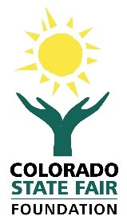 | 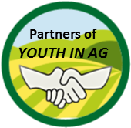

partners of youth in ag commitment form
Donation Levels

☐ | Best Of Show - $10,000 +* | ☐ | Red Ribbon - $500
☐ | Grand Champion - $5,000 | ☐ | White Ribbon - $250
☐ | Reserve Grand Champion - $2,500 | ☐ | Green Ribbon - $100
☐ | Blue Ribbon - $1,000 | ☐ | Other Amount

Donor Information
Full Name: | . | . | .
 | Last | First | Company
Address: | . |  | .
 | Mailing Address |  | Apartment/Unit #
 | . | . | .
 | City | State | ZIP Code
Telephone: | . | Email: | .

How would you like to be referenced for donor recognition? | .

Payment Information
Enclosed is a check for $ | . | Please make checks payable to: Colorado State Fair Foundation

For credit card purchases, please provide information below or call our office at (719)404-2010
☐ | VISA |  | ☐ | American Express
☐ | MasterCard |  | ☐ | Discover
Please charge my card for $ |  | .

Credit Card #: | . | Exp. Date: | . | Security Code: | .

Card Holder Signature: | .

Mail completed form with payment to: Colorado State Fair Foundation, P.O. Box 2218, Pueblo, CO 81004
CSFF Office Use Only
Date Received: _____________
By: _______________________
Partners of Youth in Ag is a Colorado State Fair Foundation annual giving program. The Colorado State Fair Foundation is a Colorado nonprofit 501 (c)(3) tax exempt organization (Federal Tax ID # 80-0613864)

All gifts are tax deductible to the fullest extent allowable by law. We encourage you to consult your financial advisor before finalizing any gifts to ensure you receive the maximum benefit from current tax laws
*Additional benefits offered for amounts over $10,000 – Please contact our office at 719-404-2010 for details.

