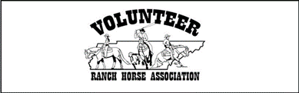 |  |  |  |  | 2023 VolRHA Membership Application  Important: All memberships are based on calendar year and expire December 31. Please allow 3 weeks for processing. One form per membership. RETURN TO: Rachael Snow 4807 Shadescrest Dr. Nashville, TN 37211
BENEFITS OF MEMBERSHIP:
By becoming a VolRHA Member, you receive discounts on show fees, have the right to vote on Officers, and will be in the running for Year-End and Show High Point Awards.
Name: |  |  |  |  |  |  |  |  | Email:
Address:
Phone: |  |  |  |  |  |  |  |  | Cell Phone:
New/Renew: |  |  |  | New Membership |  |  |  |  |  |  | Membership Renewal
Category: |  |  |  | Individual $30 |  |  |  |  |  |  | Family $40
If Family Membership, list family members (besides yourself) below:
(A family is defined as parents and children under the age of 18 years living in the same household)
Name: |  |  |  |  |  | Relation: |  |  | Birthdate  (if under 18 yrs): |  |  | Email Address (if different from that listed above):
FOR OFFICE USE ONLY
Payment: |  |  |  |  |  |  | Cash
 |  |  |  |  |  |  | Check Amount: |  |  | Check #: |  |  |  | $50 NSF Fee
 |  |  |  |  |  |  | Included with Show Tab Payment
Received by: |  |  |  |  |  |  |  | Date: |  |  |  |  | Card Issue Date:

