U.S. DEPARTMENT OF AGRICULTURE’S
MyPlate

MyPlate replaces the older Food Pyramid that many adults grew up with. The campaign's goal is to make healthy eating simpler and more practical by using the visual icon of your plate with what should be on it.
Good health depends on good nutrition. But sorting through complicated nutrition data can be confusing. The MyPlate campaign reminds you to plan meals based on a balanced diet. That means paying attention to the relative amounts of different food groups in your diet.
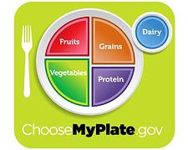
The science behind MyPlate lies in the 2010 Dietary Guidelines for Americans. With epidemic rates of overweight and obesity, the MyPlate icon simplifies healthy meal planning by focusing on the end result -- what ends up on your plate.

