REGULAR MEETING
OCTOBER 18, 2018

Four (4) Public Hearings and the Regular Meeting of the Town Board of the Town of Hampton, County of Washington and the State of New York was held at the Town Hall, 2629 State Route 22A, Hampton, New York on the 18th day of October 2018.

PRESENT: David K. O’Brien------------Supervisor
Tamme Taran----------------Councilwoman
Donald Sady-----------------Councilman
Andrea Sweeney------------Councilwoman
Roger Weeden---------------Councilman
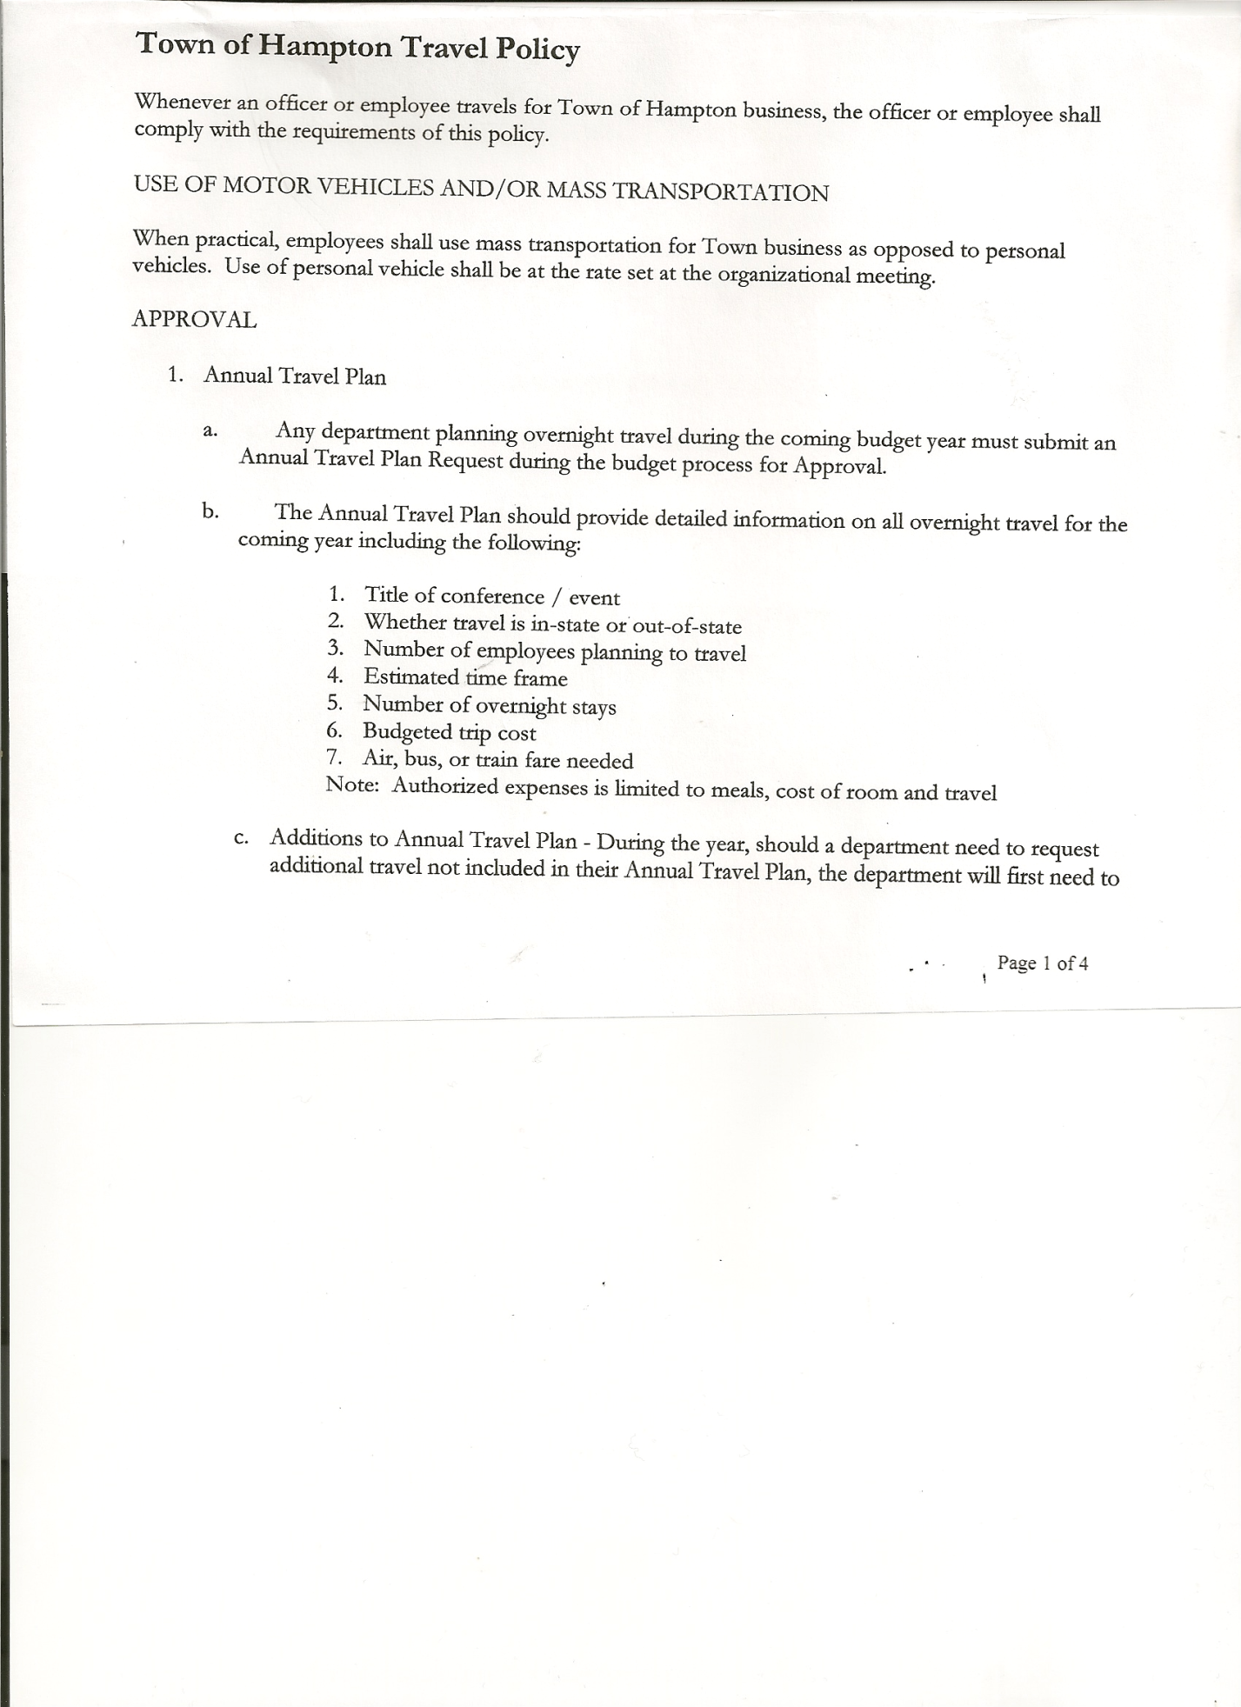
Rebecca Jones---------------Town Clerk
Camilla Shaw----------------Tax Collector/Deputy Town Clerk – came at 6:55pm
Herbert Sady, Jr.-------------Highway Superintendent
Kim Perry---------------------Budget Officer came at 7:36pm

Planning Board Member(s): Bonnie Hawley, Chair, Ginny Kinsey, Matthew Pratt

Also present: See attached sheet.

The FIRST Public Hearing was called to order by Supervisor O’Brien at 6:30pm

Town Clerk Jones read the Legal Notice of Public Hearing (copy attached), which was published in the Manchester Newspapers, for the Preliminary Budget for 2019.

Supervisor O’Brien gave a review of the Preliminary Budget.
General Fund: Highlights are as follows:
- Town Clerk CE up $30.00
- State Retirement up $400.00
- Social Security up $104.00
- Planning CE down $100.00
Revenues:
- Clerk Fees is up $100.00

Highway Fund: Highlights are as follows:
- Personal Services for Highway Employees up $4000.00
- General Repairs CE up $3855.47
- Snow Removal CE up $5000.00
- Employee Benefits-State Retirement up $400.00
- Employee Benefits-Social Security up $243.00
- Capital Fund Project up $12,500.00
Fire District #1 up $ 816.00
Fire District #2 up $2350.00

Supervisor opened the floor for comments.
John Mashak – any thought of leasing equipment vs buying
Highway Superintendent Herb Sady spoke about increases in Highway Budget
-increase amount for blacktopping/shimming, looking for a new method called Cold Mix Paving, it’s a form of stone & oil process thru Gorman’s

All persons desiring to be heard, having been heard, the Public Hearing was closed at 7:03pm

TOWN BOARD MEETING
OCTOBER 18, 2018 PAGE 2

The SECOND Public Hearing was called to order by Supervisor O’Brien at 7:03pm.

Town Clerk Jones read the Legal Notice of Public Hearing (copy attached), which was published in Manchester Newspapers to discuss the proposed local law to override the tax levy limit.

Several residents spoke in favor of overriding the tax cap.

Supervisor O’Brien explained that the Local Law is only for one year.

All persons desiring to be heard, having been heard, the Public Hearing was closed at 7:14pm.

The THIRD Public Hearing was called to order by Supervisor O’Brien at 7:15pm.

Town Clerk Jones read the Legal Notice of Public Hearing (copy attached), which was published in the Manchester Newspapers, to discuss the proposed contract with Hampton Fire Protection District 1.

Contract has an increase of $816.00. ($40,800.00 in 2018) for a total of $41,616.00 for 2019.

All persons desiring to be heard, having been heard, the Public Hearing was closed at 7:22pm.

The FOURTH Public Hearing was called to order by Supervisor O’Brien at 7:22pm.

Town Clerk Jones read the Legal Notice of Public Hearing (copy attached), which was published in the Manchester Newspapers, to discuss the proposed contract with Hampton Fire Protection District 2.

Contract has an increase of $2350.00 ($5,406.00 in 2018) for a total of $7,756.00 for 2019.

All persons desiring to be heard, having been heard, the Public Hearing was called at 7:29pm.

REGULAR MEETING
The Regular Meeting was called to order by Supervisor O’Brien at 7:30pm, followed by the Pledge of Allegiance. Location of Fire Exits were given. Quorum of board members present.

Supervisor O’Brien asked for a moment of silence in memory of Jeanne Lawrence (spouse of William Lawrence, former Town Board Member)

RESOLUTION NO. 68-2018
APPROVAL OF THE MINUTES
On a motion of Councilwoman Taran, seconded by Councilman Sady, the following resolution was ADOPTED: Ayes 5 O’Brien, Taran, Sady, Weeden, Sweeney
Nays 0
RESOLVED, that the Regular Town Board Minutes for September 20th, 2018 and the Special Town Board Minutes for September 27th, 2018 are approved.

PERMITS/SUBDIVISION
Charlotte Hollister to Cynthia Hollister 30 +/- acres. Subdivision application submitted and read by Supervisor O’Brien.

TOWN BOARD MEETING
OCTOBER 18, 2018 PAGE 3

RESOLUTION NO. 69-2018
SHORT ENVIRONMENTAL ASSESSMENT FORM/NEGATIVE DECLARATION
On a motion of Councilman Sady, seconded by Councilman Weeden, the following resolution was ADOPTED: Ayes 5 O’Brien, Taran, Sady, Weeden, Sweeney
Nays 0
RESOLVED, that the Short Environmental Assessment Form for Charlotte Hollister is complete and to adopt a negative declaration and finding that there will be no adverse environmental impacts and to consider it a minor subdivision, therefore waving the public hearing.

RESOLUTION NO. 70-2018
APPROVAL OF SUBDIVISION
On a motion of Councilwoman Sweeney, seconded by Councilwoman Taran, the following resolution was ADOPTED: Ayes 5 O’Brien, Taran, Sady, Weeden, Sweeney
Nays 0
RESOLVED, to approve Charlotte Hollister’s subdivision.

Camilla Shaw, Tax Collector- Zero balance. Submitted Bank Statement to the Board for review and signatures.

Larry Carman, Dog Control Officer submitted his report, which was read by Supervisor O’Brien, copy of report is attached for 9/17/18-10/14/18. Also received from NYS Agriculture & Markets a “Dog Control Officer Inspection Report”, services were rated Satisfactory.

Planning Board…Bonnie Hawley, Chairperson
- Working on verbiage regarding fee for minor/major site plan
- Next meeting will be November 14th, 2018 @ 7:00pm at the Town Hall

Herbert Sady, Jr., Highway Superintendent submitted his report, copy of which, is attached.

RESOLUTION NO. 71 -2018
APPROVAL OF SUPERVISOR’S MONTHLY REPORT
On a motion of Councilwoman Taran, seconded by Councilman Weeden, the following resolution was ADOPTED: Ayes 5 O’Brien, Taran, Sady, Weeden, Sweeney
Nays 0
RESOLVED, that the Supervisor’s Monthly report be accepted as submitted for SEPTEMBER 2018.
08/31/18 09/30/18
ACCOUNT BALANCE RECEIPTS DISBURSEMENTS BALANCE
General Fund $ 64,766.21 $ 5,771.36 $ 5,946.46 $ 64,591.11
Highway Fund $ 31,518.15 $ 1.21 $ 11,184.62 $ 20,334.74
Equipment Reserve $ 94,132.64 $ 3.87 $ 0.00 $ 94,136.51
Fire #1 $ 20,400.00 $ 0.00 $ 0.00 $ 20,400.00
Fire #2 $ 2,703.00 $ 0.00 $ 0.00 $ 2,703.00
Cemetery $ 1,706.93 $ 1.02 $ 0.00 $ 1,707.95
Totals $215,226.93 $ 5,777.46 $ 17,131.08 $203,873.31

All Board Members present signed Supervisor’s Report.

TOWN BOARD MEETING
OCTOBER 18, 2018 PAGE 4

COUNTY UPDATES/COMMUNICATIONS
Continuing to work on County Budget.
Transfer stations completely sold to Earth Waste & Metal.
Received Letter from NY Broadband Program Office (copy attached).

RESOLUTION NO. 72 -2018

MOTION BY: Councilman Donald Sady
SECONDED BY: Councilwoman Andrea Sweeney

RESOLUTION ADOPTING A LOCAL LAW TO OVERRIDE THE TAX LEVY LIMIT ESTABLISHED IN GENERAL MUNICIPAL LAW SECTION 3-C

WHEREAS, pursuant to Section 3-c(5) of the New York State General Municipal Law, the Town Board (the “Board”) of the Town of Hampton (the “Town”) has the authority to adopt a local law to override the real property tax levy limit as defined in General Municipal Law §3-c; and

WHEREAS, a budget has been prepared for the Town of Hampton for fiscal year beginning January 1, 2019 and ending December 31, 2019 that exceeds the tax levy limit as defined in General Municipal Law §3-c; and

WHEREAS, a local law to override the tax levy limit in accordance with the provisions of General Municipal Law §3-c has been prepared; and

WHEREAS, the Board scheduled a public hearing to be held before the Town Board on October 18, 2018 at the Offices of the Town of Hampton, 2629 State Route 22A, Hampton, New York 12837, to hear all interested parties regarding the adoption of the proposed Local Law; and

WHEREAS, notice of said public hearing was duly posted and then published in the Manchester Newspapers (The Granville Sentinel/The Whitehall Times), the official newspaper of the Town of Hampton pursuant to and in conformance with Section 20 of the Municipal Home Rule Law; and

WHEREAS, said public hearing was duly held and all parties in attendance were permitted an opportunity to speak on behalf of or in opposition to the proposed Local Law.

NOW, THEREFORE BE IT RESOLVED by the Town Board of the Town of Hampton as follows:

Section 1. The Town Board finds that the proposed Local Law is required pursuant to General Municipal Law section 3-c and is in the best interests of the residents, inhabitants and guests of the people of the Town of Hampton.

Section 2. The proposed Local Law, copies of which are attached hereto and made a part hereof, is hereby adopted.

TOWN BOARD MEETING
OCTOBER 18, 2018 PAGE 5

Section 3. The Law shall take effect immediately upon its filing in the Office of the Secretary of State.

Section 4. This resolution shall take effect immediately.

DATED: October 18, 2018 Supervisor O’Brien AYE
Councilwoman Taran AYE
Councilman Sady AYE
Councilwoman Sweeney AYE
Councilman Weeden AYE

Following a discussion on various Health Insurance Plans for Highway Employees, the following resolution was introduced.

RESOLUTION NO. 73 -2018
HEALTH INSURANCE
On a motion of Councilwoman Taran, seconded by Councilman Weeden, the following resolution was ADOPTED: Ayes 5 O’Brien, Taran, Sady, Weeden, Sweeney
Nays 0
RESOLVED, to go with a HMO Policy, with a 50% contribution of their deductible, (which will be placed into a separate account for Highway Employees/Spouse).

Fire Department….Info handed out “2018 New York State Firefighter Cancer Benefit Program”…Hampton currently has six (6) Interior fire fighters that need to be covered. The Fire Dept. is covering the cost for 2018, an anonymous resident from Low Hampton has agreed to pay for 2019.

Mortgage Tax received….total for 2018 is $15,800, had anticipated $9,000 in the Budget, increase of $6,800.00

The Town Board after a lengthy discussion regarding the 2019 Budget, decided to have a Special Meeting to reconsider the proposed increases to the budget to reduce the increase.

RESOLUTION NO. 74 -2018
SPECIAL MEETING
On a motion of Councilwoman Sweeney, seconded by Councilman Weeden, the following resolution was ADOPTED: Ayes 5 O’Brien, Taran, Sady, Weeden, Sweeney
Nays 0
RESOLVED, to set a Special Meeting for further discussion on the 2019 Budget, for October 29th, 2018 at 7:00pm

Received Financial Statements from Fair Haven Volunteer Rescue Squad, Inc.

The Town Clerk’s report for September 2018 was submitted to the Board. The Town Clerk had Board Members review and sign bank reconciliation statements for the Town Clerk Account and Special Town Clerk Account dated August September 30th, 2018.

TOWN BOARD MEETING
OCTOBER 18, 2018 PAGE 6

RESOLUTION NO. 75-2018

AUDIT OF CLAIMS
On a motion of Councilman Sady, seconded by Councilwoman Taran the following resolution was ADOPTED: Ayes 5 O’Brien, Taran, Sady, Weeden, Sweeney
Nays 0
RESOLVED that the bills have been reviewed by the Town Board and are authorized for payment in the following amounts.
General Fund No.108 through No.118 $ 1,141.24
Highway Fund No.105 through No.112 $ 2,766.37
Total both funds $ 3,907.61

On a motion of Councilwoman Sweeney, seconded by Councilwoman Taran, the meeting adjourned at 9:54pm. All in favor Aye.

Respectfully submitted,

Rebecca S. Jones, RMC
Town Clerk

