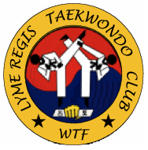

**8th Kup - Yellow Belt Test**

1. 20 press ups counting out loud on each
2. Outer crescent kick, in fighting stance 10x R leg, 10 L leg
3. Horse riding stance, double punch 10x counting out loud
4. Horse Riding Stance. Upper Block x8 Lower Block x8 Inner Block x8
5. Long stance moving forwards, lower block 6x turn then 6x back
6. Long stance moving forwards, Upper Block 6x turn then 6x back
7. Taeguek 1 – (il jang, heaven and light 18 moves.)
8. 1 for 1 kicking (1 step kicking)