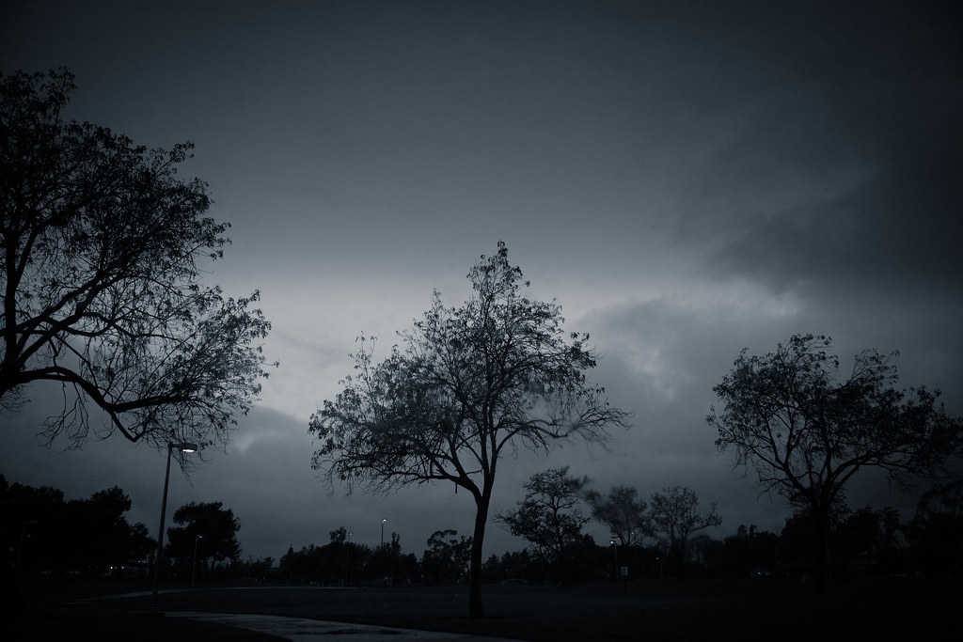
This Photo by Unknown Author is licensed under CC BY
Day 11: Deal with Winter Depression
In his book Arctic Dreams, Barry Lopez writes about the cold winters in this environment and the depiction of the season as a nightmare that sometimes deranges people:
“Winter darkness brings on the extreme winter depression the Polar Eskimo call perlerorneq. According to the anthropologist Jean Malaurie, the word means to feel the “weight of life.” To look ahead to all that must be accomplished and to retreat to the present feeling defeated, weary before starting, a core of anger, a miserable sadness. It is to be “sick of life,” a man named Imina told Malaurie. The victim tears fitfully at his clothing. A woman begins aimlessly slashing at things in the igloo with her knife. A person runs half-naked into the bitter freezing night, screaming out at the village, eating the waste of dogs. Eventually the person is calmed by others in the family, with great compassion, and helped to sleep. Perlerorneq. Winter.”
Although it may not manifest with these extreme symptoms, Seasonal Affective Disorder (SAD) is a real problem for many people during the winter months. If you suffer from this mood disorder, do not be afraid to seek help. Talk with your doctor about treatments, including light therapy. If you are not affected by winter darkness, be compassionate toward and sensitive to the needs of those who are. Check in with each other. Make sure others are OK. Lighten the mood, the day, the season in small ways for those who are struggling.

