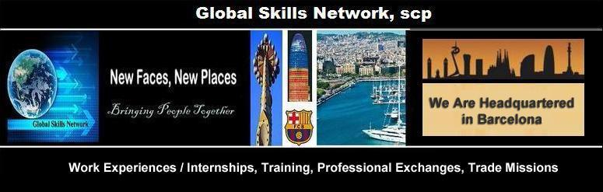
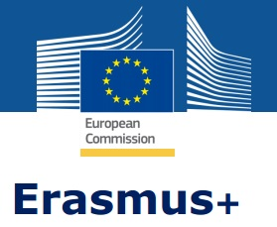

Global Skills Network, scp
PIC 936464385
Tax ID J66359399
Mobility Specialists for Projects
Sponsored Under Erasmus Plus
Email: info@erasmusactions.com
Mailing Address: Apartado Correos 19029,
08027 Barcelona Spain

MARKETING 101 - CLASSROOM ACTIVITIES
National School of Finance and Business, Sofia, Bulgaria
(Marketing – Hybrid Component)
BULGARIAN ENTITY CASE STUDY
Goals
Describe the terminology and definitions associated with defining a target market and how to research demographics
Discuss and inform others on the processes associated with marketing outcomes identified for a client
Compare marketing techniques between Bulgaria and Spain

Students will select an entity in Bulgaria to examine its need for marketing. This entity can be a business or corporation, nonprofit, or public sector (such as a city, utilities bureau, ministry for trade, tourism or international affairs, etc.), which would in essence become the “client”. Selection of an entity should be based on each student’s interest in pursuing a particular field or subsection of marketing, which should be determined during the first week of the course.
- Client. During this assignment, students will identify the “client” and describe the setting and challenges they face for which a marketing campaign would be beneficial. Market research on a similar entity in Spain.
- Stakeholder analysis. Once a “client” has been identified in need of marketing products and services, students will describe the relevant stakeholders involved.
- Project roadmap. This assignment asks students to develop detailed procedures to implement a marketing programme for their identified “client”.

2. Components

Client
Describe the “client” – what is its mission? What is its vision? Why was this particular client selected? What is its current repertoire of marketing activities? Select a similar entity in Spain and create the same description. What is the marketing challenge the client is facing? Utilize the “Bulgarian Case Study Project Template” downloadable from www.erasmusactions.org.

Stakeholder Analysis
Marketers develop a STAKEHOLDERS MAP to group persons that have an interest or can be affected by the strategy of an organization, normally including customers and consumers (external), staff and shareholders (internal), and an associated community (connected). Organisations need to be able to identify their stakeholders and also judge the level of power they hold to affect the decisions and outcomes of the organisation. Thus, a first step for any marketer is to create a generic stakeholder map. This map will include all the stakeholders for his or her organisation with the organisation at the centre:
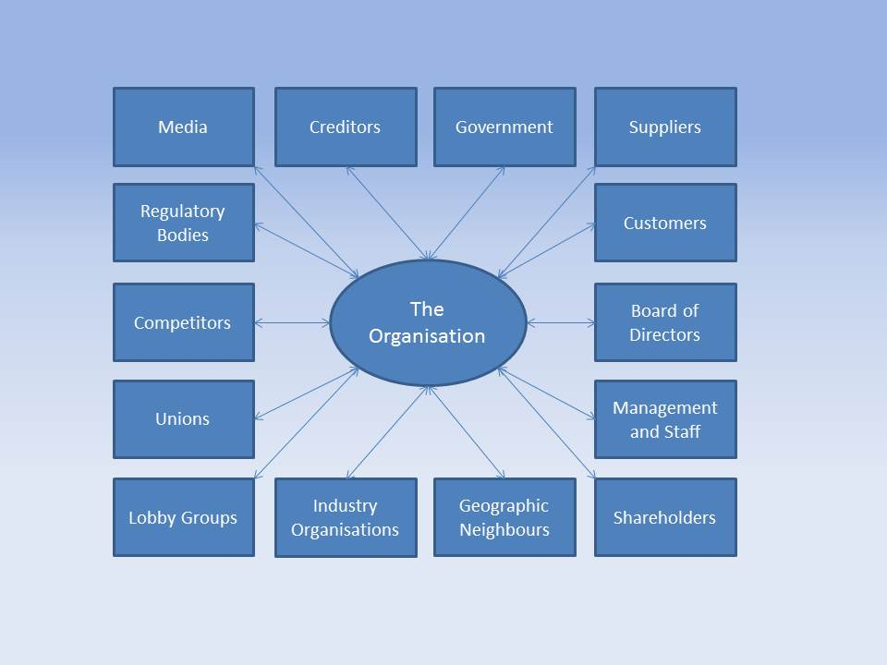
Organizations have many stakeholders. However, not all stakeholders are relevant to a marketing problem an entity might face. The following include some examples of who these stakeholders might be:
Customers
Distributors
Managers
Employees
Governments
Interest and groups
Local Communities
During this assignment, identify and describe those stakeholders that are the most influential to the needed marketing. Once you've identified these stakeholders, indicate how they view the current situation.
As you write this description, consider the following questions:
- What might their role be to influence change in your site?
- How involved might they get in implementing change?
- What roadblocks or barriers might they face?
- Are their views apparently at odds with other stakeholders? If so, how?
Be sure to support your claims with descriptions to justify your classifications. Although details for each stakeholder will likely take a paragraph or two to describe, those that are made up of diverse individuals, thoughts, and interactions with other stakeholders may require additional details.
Once this stage is of stakeholder mapping is done, the marketer should have a better understanding of who the stakeholders are for the organisation. This in itself can highlight the impact of certain stakeholders on the organisation that could have been overlooked in the past.

Project Roadmap
For successful marketing, it is essential to understand an audience and how potential buyers might perceive an offering – a product or service. Customers generally fall into three categories:
- Those interested in offerings that address a problem that few, if any, buyers in that market are aware of are creating “new concept” demand.
- Those interested in offerings that solve a known problem to which there are one or more common solutions are categorized as “new paradigm.”
- Those interested in offerings that virtually every company in a market sells - the “established market” category.
Selecting an appropriate target market may be the most important decision a company makes in the planning process, and is crucial for marketing success. The target market should be chosen before the entity can adapt its marketing mix to meet the customer’s needs and preferences. By demonstrating your knowledge of demand type, you convey to key constituents that you have a thoughtful and informed approach to everything from messaging to offerings.
Every successful marketing initiative — from publishing a single piece of thought-leadership content, to rolling out a complex ad campaign, to launching your company’s first product — must begin with a strategic vision and a clearly defined set of goals. Without an understanding of what you need to accomplish, and the ability to clearly communicate that strategic plan to your team, your initiative will have a lower chance of success.
A marketing plan is a blueprint that outlines your marketing strategy and efforts. It is a high-level roadmap that provides your stakeholders with a general overview of marketing initiatives across different categories. For example, one common way to splice your marketing roadmap is by your company’s positioning and messaging projects, your digital marketing programs, and your sales strategy.
In the example marketing plan (below), the roadmap is organized by “swim lanes” - the type of initiative and color-coded by the phase of the initiative. You could also potentially categorize initiatives by their owners or by the strategic goals they help achieve, such as increasing revenue, expanding to new markets or reducing churn, the amount of customers or subscribers who cut ties with your service or company during a given time period. These customers have “churned.”

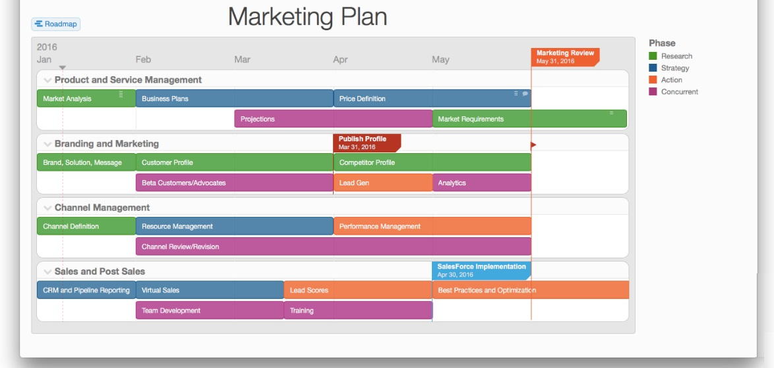
Swim Lanes for Marketing Plans
The swim lane flowchart differs from other flowcharts in that processes and decisions are grouped visually by placing them in lanes. Parallel lines divide the chart into lanes, with one lane for each person, group or subprocess. Lanes are labelled to show how the chart is organized.

.
This example roadmap is divided into four swimlanes:
- product and service management efforts,
- branding,
- channel management,
- sales/post sales initiatives.
Milestones intersect the roadmap to indicate specific goals or deadlines, such as the date of a marketing review.

3. Assignments
- Identify the Bulgarian client and a similar entity in Spain
- List and describe the stakeholders for the client
- Develop the beginnings of a Marketing Plan for the client
Required Reading
How to Define Your Target Market
Sample Stakeholders Analysis Report
Marketing Plan Template

- Project Template

DESCRIPTION OF “CLIENT”
What is the overall marketing and Communications Planning Goal for the “client”?
Sample: Support the mission of XXXXX by planning, implementing and evaluating marketing and communications to internal and external targeted stakeholder audiences.

Mission Statement:

Vision:

Purpose:

Beliefs that guide XXXX’s decision-making and operations:

What XXXX does:

What impact does XXXX make:

XXXX signature, motto, mantra:

CLIENT STRATEGIC GOALS
•
•
•
•

CLIENT KEY MESSAGES
(Distill this down to “inclusive” elevator speech and key strategic messages)
• Uniqueness –
• Accessible –

CLIENT MARKETING and COMMUNICATIONS STRATEGIES AND TACTICS

CLIENT TARGET AUDIENCES, KEY MESSAGES, STRATEGIES AND TACTICS
• Focus Messages
• Strategies
• Tactics
• Expected outcomes:

DESCRIPTION OF SPANISH ENTITY
What is the overall marketing and Communications Planning Goal for the Spanish entity similar to “the client”?

Mission Statement:

Vision:

Purpose:

Beliefs that guide XXXX’s decision-making and operations:

What XXXX does:

What impact does XXXX make:

XXXX signature, motto, mantra:

SPANISH ENTITY STRATEGIC GOALS
•
•
•
•

SPANISH ENTITY KEY MESSAGES
(Distill this down to “inclusive” elevator speech and key strategic messages)
• Uniqueness –
• Accessible –

SPANISH ENTITY MARKETING and COMMUNICATIONS STRATEGIES AND TACTICS

SPANISH ENTITY TARGET AUDIENCES, KEY MESSAGES, STRATEGIES AND TACTICS
• Focus Messages
• Strategies
• Tactics
• Expected outcomes:

