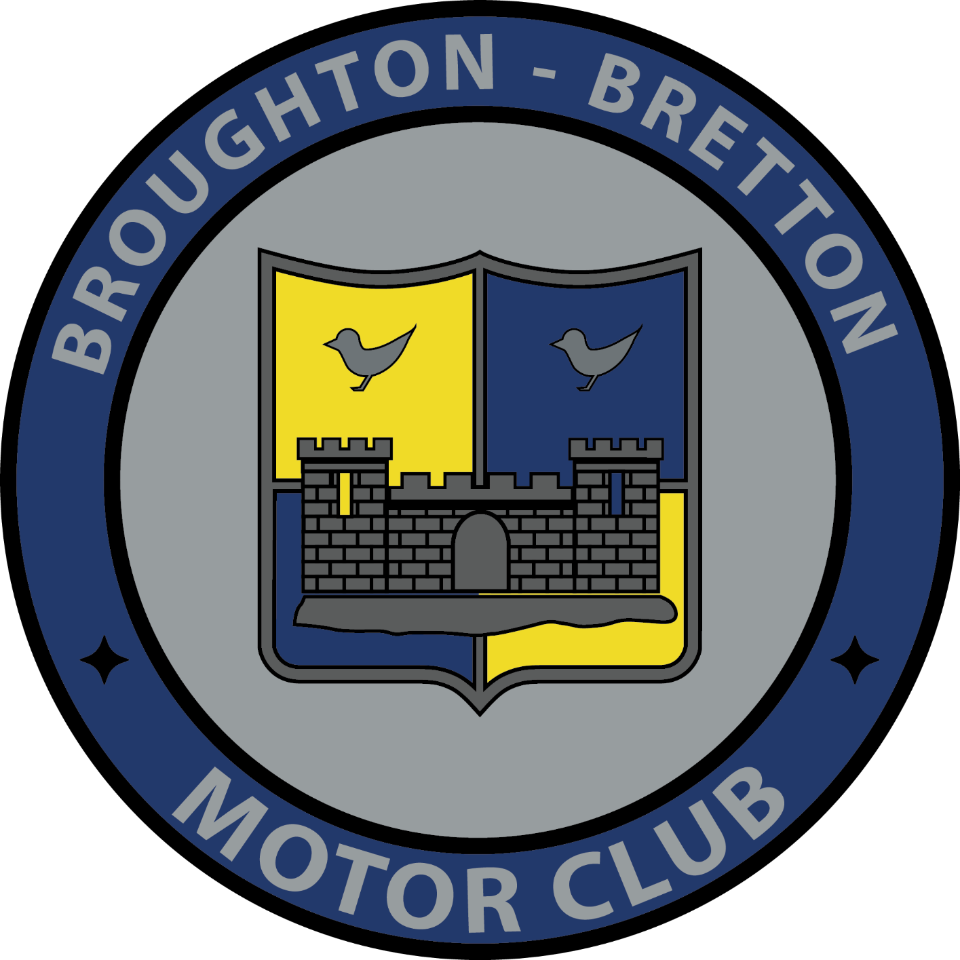
Broughton-Bretton Motor Club Ltd
Membership Application/Renewal Form

Membership runs from January to December and is £10. Family membership is £15 (2 adults and 2 under 17) Junior Membership is £5 (under 17). Please fill in the details below and hand or email (b-bmc@hotmail.com) to a club official with payment for membership fee.
Name (s): ………………………………………………………………………………………….
Address: …………………………………………………………………………………………………………………..
………………………………………………………………………………………………………………………………….
Contact Number: ……………………………………………………………….
Email: ……………………………………………………………………..
Date of Birth(s): ……………………………….
Please tick:
Standard Membership (£10) |  | Family Membership (£15) |  | Junior Membership (£5)

New Application |  | Renewal

Cash |  | Cheque
Please make all cheques payable to Broughton-Bretton Motor Club
“I hereby agree to abide by the rules and bylaws of Broughton – Bretton Motor Club and Motorsport UK. If I break or disagree with these rules then I agree to forfeit my membership “
Applicant Signature ……………………………………………..Parent/Guardian (if under 18 years old) : ………………………………………….
Proposed by Signature: ……………………………………….. Seconded by: ……………………………………………………….
You details will be kept for club use only and will not be shared to any 3rd parties.
For Office use only:
Form Complete: ……………….
Paid:………………….. Cash/Cheque/BACS:……………………..
Membership card given or sent:……………….
Membership Car Number: ……………………..

