SCOTT’S MILL HYDRO, LLC

April 23, 2018
The Honorable Kimberly Bose, Secretary
Federal Energy Regulatory Commission
888 First Street, NE
Washington, DC 20426

RE: SCOTT’S MILL HYDROELECTRIC PROJECT
FERC PROJECT NO. 14867
TRANSMITTAL OF AGENDA FOR JOINT MEETING

Dear Secretary Bose:

Included herein pursuant to the Commission’s regulations at 18 CFR §4.38 (c)(6)(iii) is the agenda for the Joint Meeting for the proposed Scott’s Mill Hydropower Project. The meeting will be held at the offices of Hurt and Proffitt in Lynchburg, Virginia starting at 10 am on May 8, 2018. Scott’s Mill Hydro, LLC (Scott’s Mill) coordinated with resource agencies and interested parties on the meeting date. Scott’s Mill welcomes Commission staff to attend the meeting.

While resource agencies and Scott’s Mill are in general agreement with upstream fish passage, there are a few issues that Scott’s Mill would like to resolve during the Joint Meeting. The primary issues needing resolution are safe, timely, and effective downstream fish passage and the use of spillway gates versus the proposed concrete cap.

At the request of Virginia Department of Game and Inland Fisheries, we are including their comments on the draft license application. These comments were timely received by Scott’s Mill on March 7, 2018.

If you have any questions, feel free to contact me at (540) 320-6762 or Wayne Dyok at (916) 719-7022.

Sincerely,
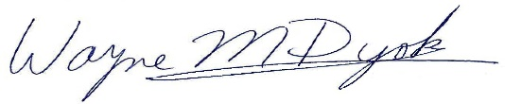 for
Mark Fendig, Managing Member

