2017 Scholarship Application
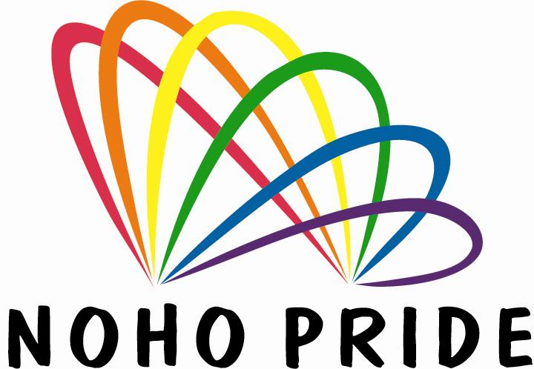

Contact Information
Name
Street Address
City ST ZIP Code
Phone
High School
E-Mail Address

Qualifications
- Must be a high school senior
- Must be a resident of either Franklin, Hamden, Hampshire or Berkshire county
- Must have financial need

The Essay
Compose an essay describing how you plan to be a positive role model in the LGBT community.
Use 8½ by 11 inch paper and double-space. The essay should not exceed 500 words. Submit this cover page (completed) and the essay to:
Noho Pride
Attn: Scholarship Committee
PO Box 866
Northampton, MA 01061

The deadline for the application is MAY 31, 2017. Applications postmarked later than May 31 will not be considered.

The Award
The winner of the scholarship will receive $500, to be paid directly to the college or university of choice prior to the beginning of the fall 2017 semester. Only the winner will be notified. The winner’s name will also be posted on the Noho Pride website no later than July 1, 2017.

Agreement and Signature
By submitting this application, I affirm that the facts set forth in it are true and complete. I confirm that I have a financial need for this scholarship. I give permission to Noho Pride to publish my name on www.nohopride.org if I win the award.
Name (printed)
Signature
Date

