BROWN BEAR INC.
2014 LANDSCAPE CONTRACT
SEASON MAY 1, 2014 TO SEPTEMBER 14, 2014
LAST NAME: WATER VALVE LOCATED:
_________________________ ______________________________
TRUCKEE ADDRESS: IRRIGATION CONTROLLER LOCATED:
__________________________ ______________________________
ELECTRICAL PANEL LOCATED:
_____________________________________
PLEASE CIRCLE ANY/ALL ITEMS YOU WOULD LIKE FOR THIS SEASON:
SPRING START UP: YES NO
PREMERGENT/FERTILIZER YES NO
(TWICE PER SEASON OR AS NEEDED)
MOW & BLOW
ONCE A WEEK: YES NO
BI-WEEKLY: YES NO
FALL SHUT DOWN: YES NO
ADDITIONAL SERVICES NOT LISTED:

PLEASE FILL OUT ABOVE INFORMATION
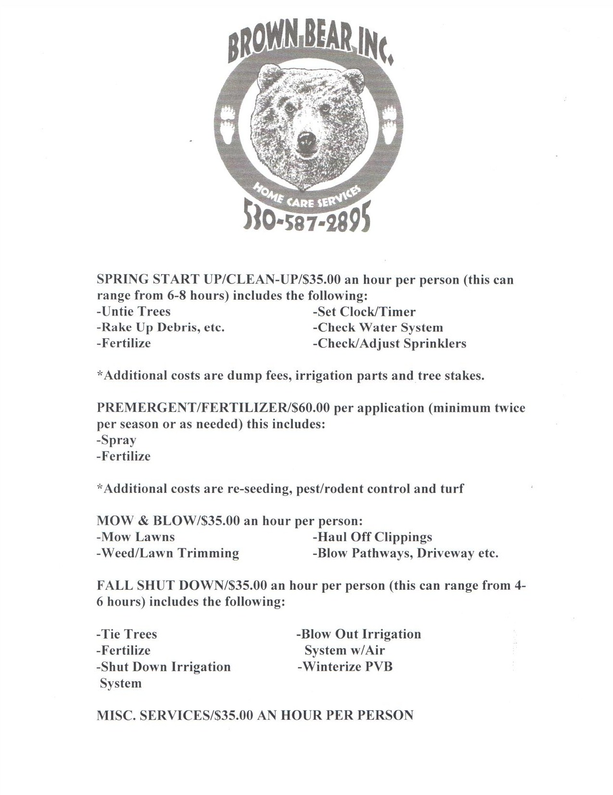

BROWN BEAR INC.
11675 DEERFIELD DR.
TRUCKEE, CA 96161
530/587-2895
brownbearoffice@sbcglobal.net
This agreement is entered by Brown Inc. (agent) and Owner (listed below). This agreement is for landscape services according to terms agreed upon. Both the agent and owner are subject to the following terms and conditions hereby set forth.

Services: Brown Bear Inc. shall provide a variety of services and landscaping. The owner shall allow Brown Bear Inc. and its employees to enter the property to perform landscape services as outlined by the owner. Should an urgent problem arise, Brown Bear Inc. has permission from the owner to repair and or replace in an attempt to prevent further damage from occurring in an emergency.

Indemnity: The owner hereby agrees to indemnify Brown Bear Inc. and its employees from all occurrences other than those, which are the direct action of Brown Bear Inc.

Terms of Agreement: This agreement is valid from April 15th thru September 30th. Contract can be cancelled within 30 days of written communication and must be done in writing. ALL INVOICES ARE DUE AND PAYABLE UPON RECEIPT. ALL OUTSTANDING INVOICES, AFTER 30 DAYS ARE SUBJECT TO A LATE PENALTY CHARGE.
PLEASE SIGN, DATE AND RETURN
(FIRST & SECOND PAGE OF CONTRACT)
THANK YOU FOR USING BROWN BEAR INC.!
Servicing your homes BEAR necessities and beyond…

OWNER:________________________________ DATE:______________________

