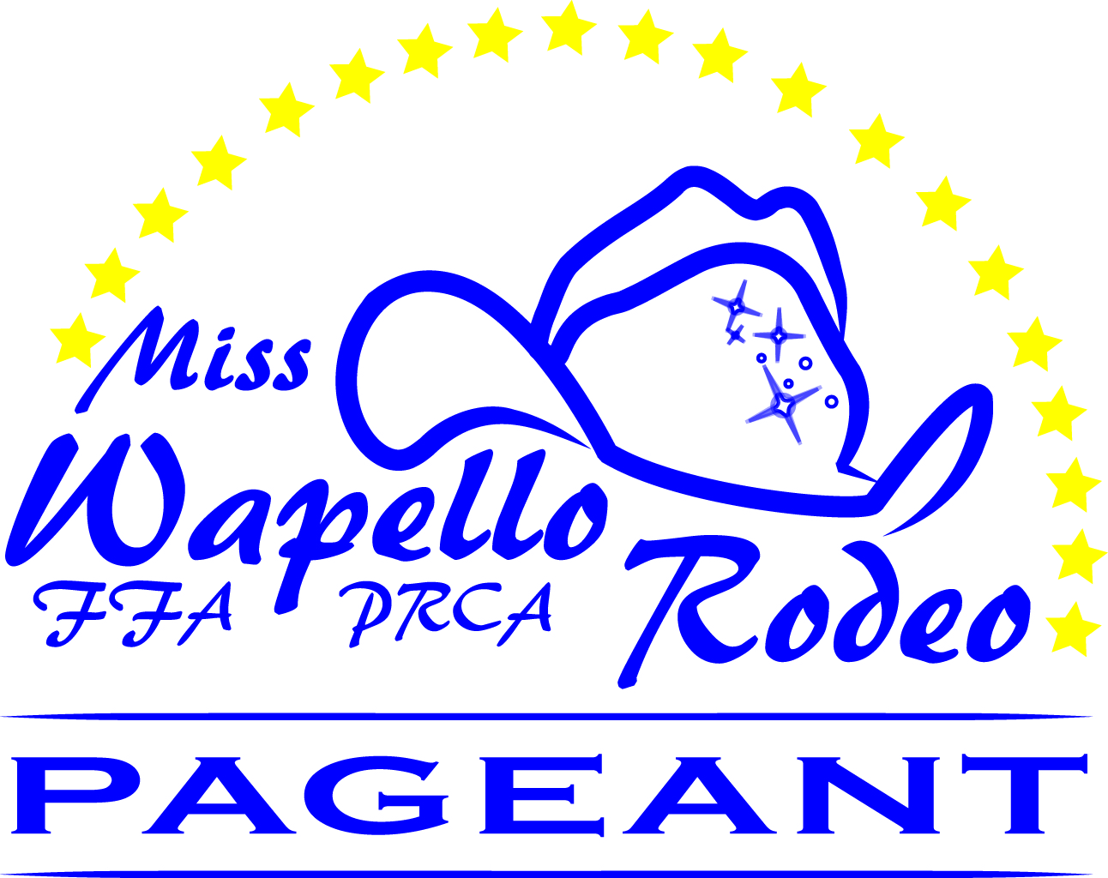
2018 Official Entry Form

Name: ______________________________________________________________________________
Address: ____________________________________________________________________________
City: __________________________ State: _______ Zip: ____________ County: __________________
Telephone: _________________ Cell: ___________________ Email: ____________________________
Date of Birth: ______________ Age at Competition: _________

Division of Entry:
_____ Miss Wapello Rodeo _____ Miss Teen Wapello Rodeo _____ Junior Miss Wapello Rodeo

T-Shirt Size: Youth Small Youth Medium Youth Large Adult Small Adult Medium Adult Large

School Currently Attending:
Elementary School: __________________ Middle School: __________________________
High School: ________________________ College: ___________________________________

Please provide a brief bio of yourself:

Hobbies and Interest:

School Activities:

Club Memberships:

Rodeo or Show Activities:

Career Goals:

What is your horse’s name? Tell us about the horse you chose and why:

On a separate piece of paper, please include your essay describing why you deserve to be selected to represent the Wapello FFA/PRCA Rodeo as Miss/Teen/Junior Wapello Rodeo.
I have read the rules, regulations and obligations for the MWR Pageant. My personal conduct as a contestant and or title holder will be in accordance with the rules established by the MWR Committee. Failure on my part to uphold the title of MWR in proper conduct, appearance and fulfillment of obligations will automatically result in loss of prizes and/or scholarships. The MWR Committee and Coordinators, Wapello FFA/PRCA Rodeo Committee and members will be released of any liability resulting in such action. _____ (Initial)
I am participating with the horse of my choice at my own risk and subject to the rules under which his contest will be conducted. I agree that in case of loss and/or injury involving either horse and/or contestant, I will make no claim what so ever, against the MWR Committee and Coordinators, Wapello FFA/PRCA Rodeo Committee and members. _____ (Initial)
I understand the enclosed photograph(s) will become property of MWR and I grant permission for the MWR Committee to use my photograph in their official publications and news releases without further consideration, and I acknowledge their right to crop or treat photo at their discretion. _____ (Initial)
My initials and signature on this application state I have read the above information.

Contestant Signature ____________________________________________ Date _________________
Parent or Legal Guardian _________________________________________ Date _________________
(if contestant is under the age of 18)

Camping: $95.00 Thursday – Sunday _____ YES _____ NO

This includes 2 tickets for Friday night performance and 2 tickets for Saturday night performance.
Please contact Lance Walker ahead of time, with any special arrangements that may need to be made. Phone #319.212.0637 Email: lwalker@midamerican.com

Include: 5x7 Color Headshot (Photos do not have to be professional however will be used for judging), Copy of your Birth Certificate, Completed Official Entry Form and Entry Fee. Camping fee if applicable. Must be postmarked no later than June 1, 2018.

RETURN ENTRY AND REQUIRED INFORMATION TO:
Heidi Pallister
Miss Wapello Rodeo Committee
430 South 6th Street
Wapello, Iowa 52653
misswapellorodeo@yahoo.com

