Medical Reserve Corps Well Check Program

STANDARD OPERATING GUIDELINES

Created by the Town of Middleboro, MA Health Department
Revised March 10, 2017. For more information visit
http://www.mrcvolunteer.org/well-check-program.html
POC: Liisa Jackson Medical Reserve Corps Coordinator
LiisaJackson@mrcvolunteer.org
Table of Contents
Mission Statement 3
Objectives 3
Introduction 4
Purpose and Scope of the Standard Operating Guidelines 5
Background Investigations 5
Risk Management and Liability 7
Confidentiality 8
Well Check Team Structure 9
Code of Conduct 10
Confidentiality 8
Confidentiality 8
Confidentiality 8
Confidentiality 8
XVI. ESF-6 (Annex C, Appendix C6, Mass Care OPlan) ........................ 69
XVII. Pandemic Influenza Annex ....................................................73
XVIII. DMH Central Office Activation Plan....................................75
Appendix i-- (DMH Directory/READI Team) ................................ 77
Appendix ii-- (Other Agency Names/Contacts)............................... 83
Appendix iii—(Facility Census/Resources) .................................... 85
Appendix iv-- (Model for Mental Health Response/Recovery)....... 87

Mission Statement
The Medical Reserve Corps Well Check Program provides daily well check communications to at risk citizens who require assistance to improve wellness in their life. We aim to improve our patron’s health and happiness by providing constant communication, emotional, social, and informative support, resource management, and medical mitigation techniques that will improve the health and well-being of each individual we serve.

Objectives
- Promote integration of patient care and improve patient adherence
- Provide early identification and intervention for potential health issues
- Provide social and emotional support
- Recruit patients who otherwise would not seek medical care such as bullying victims and individuals suffering from obesity
- Facilitate the coordination of individuals with resources and health care
- Improve overall wellness

Introduction

The Medical Reserve Corps Well Check Program (MRCWCP) is intended to provide a network of trained, HIPPA compliant volunteers that provide daily communication and support to at risk individuals within the community. For the purpose of this program, at risk individuals can be summed up as any person in need of additional support in their life to optimize wellness. Common populations of at risk individuals are the elderly, adolescent, individuals with chronic diseases, mental health disorders, or addiction difficulties. The scope of individuals who can benefit from the MRCWCP is limitless.
However, the primary task of the MRCWCP team is to improve patient adherence. “Adherence is defined as the extent to which a patient correctly follows a prescribed therapy. Adherence is the medically preferred term because it reflects active involvement of the patient and a therapeutic alliance between the patient and his or her physician.”¹ Adherence to long-term therapies in developed countries is typically reported to be less than 50%. Studies show that a large majority of patients stop taking their medications within days of hospital discharge. Poor adherence is also consistently linked to hospital readmission, disease exacerbation, morbidity, and mortality. In addition, medication nonadherence results in increased health care cost, with estimates from North America of approximately$100 billion being spent annually and $2000 spent per patient per year in excess physician visits.
In addition to improving patient adherence, the MRCWCP addresses individual patient needs with resource allocation. MRC volunteers assess individual patient situations, provide the necessary resource recommendations, and assist the patient with resource coordination as well as communicates with health care professionals to mitigate potential medical emergencies.
Purpose and Scope of the Standard Operating Procedure
The Standard Operating Procedure is a document which describes the regularly recurring operations to ensure that the operations are carried out correctly, protects the volunteers, and provides optimal results for our patients.
This SOP has been developed to provide clear guidance on the well check processes however, the document is intended to be used as a guide and not a policy.
Qualified, trained volunteers are allowed to use their best judgement to provide the best product for our patients.
The SOP has been written with a focus on elderly patients with chronic diseases. Many patients might present with much different health conditions or personal problems that require an adjustment from the standard well check process.
When in doubt, please reach out to the executive committee, the MRC coordinator, or your local leadership for guidance

Background Investigations
PURPOSE
In furtherance of the protection of our patients and according to Medical Reserve Corps policy as well as compliance with Massachusetts General Laws; all volunteers must complete CORI (Criminal Offender Record Information) and SORI (Sexual Offender Registry Information) checks through Human Resources before working, providing assistance and/or services in our community.
CORI Form (NEED HYPERLINK)
SORI Form (NEED HYPERLINK)
Background Investigations continued
To complete a CORI/SORI check, please visit the Middleboro Health Department. You must have a photo ID available. The process should take approximately 5-10 minutes.
Background checks are valid for three years from the date of approval. You only need to be checked once for the MRCWCP program. Since different standards may apply in other locations, background checks conducted for other towns/MRC divisions are not sufficient.
BE AWARE: The services of a potential volunteer shall not be accepted if the criminal record check shows:
1. Registration as a sex offender
2. Conviction of a felony
3. Conviction of a misdemeanor in the past 5 years
4. Conviction of a criminal violation in the past 2 years
5. Conviction of DUI in the past 5 years
6. Current EPO or DVO in place
Appeal
Any volunteer whose services are rejected as a result of information received from the criminal record check may appeal such decision and request an evaluation if the volunteer believes the decision was based on inaccurate information.

Background Investigations continued
Case-by-Case Review
An evaluation will determine if past conduct is compatible with working as a MRCWCP
Volunteer. Consultation may include the MRCWCP Program Coordinator, Middleboro
County Health Department Director, Emergency Management Director and the
Middleboro town manager. The volunteer shall be given the opportunity to provide evidence of mitigating circumstances prior to a decision being made concerning qualifications to serve.
Valid Operator’s License
Individuals operating a vehicle as a MRCWCP team volunteer shall be required to show proof of a valid Massachusetts operator’s license prior to volunteering. The license of the volunteer shall be checked by a member of the MRCWCP executive committee prior to assignment.

Risk Management and Liability

MRCWCP volunteers must only work within the scope of practice of the program.
MRCWCP volunteers are not acting in the capacity of healthcare professionals.
MRCWCP volunteers should only provide communication and support services
Volunteers MUST:
- Wear personal protective equipment (i.e. gloves, goggles, mask) as indicated,
- Observe Standard Precautions at all times (Appendix F),
- Maintain basic measures of sanitation and hygiene (Appendix G: “Clean Hands
Save Lives”).

Some unanticipated risk possibilities may be present during in home well check visits. MRCWCP volunteers agree to assume their own risk as a volunteer. Any incidents, accidents, or injuries should be reported to the MRCWCP Coordinator immediately.

Confidentiality

This addresses Massachusetts Statute and HIPPA Regulations regarding Confidentiality,Security and Protected Health Information.
During a volunteer’s involvement with the MRC, he/she may be privy to sensitive confidential information. Health information that must be kept secure is called Protected
Health Information (PHI). The Health Insurance Portability & Accessibility Act (HIPAA) of 1996 establishes in Federal Laws the basic principle that an individual’s medical records belong to that individual and cannot be reused, released or disclosed without the explicit permission of that individual or legal guardian. Protected health, confidential and sensitive information is either information that is protected by law or is of such a personal nature that it is not treated as public record and must be safeguarded.
All information pertaining to personal facts, medical records and/or circumstances seen, obtained and/or overheard in conversation is confidential. All information that may lead to the identification of an individual must also be protected as Patient Health
Information. This includes information that can be linked to a specific person through name, identifying number such as social security number, address or phone number.
Information may be in the form of a person’s medical records, excerpts from the medical record or conversations that identify an individual. We also identify response activities specifically related to an individual. All are considered confidential.
The identities of individuals a volunteer may see and specific information a volunteer may learn from conversation or observations while responding with MRC are confidential. This includes patient identifying information as noted above.
Volunteers understand that accessing or releasing confidential information and/or records or causing confidential information and/or records to be accessed or released to themselves or another individual would constitute a violation of the confidentiality agreement. This may subject the volunteer to civil and criminal liability for disclosure of confidential information to unauthorized persons.

MRC volunteers agree to abide by the terms of confidentiality as stated above and certify their agreement to these terms by signing and returning Form 3B to the MRC
Coordinator.

Well Check Team Structure

The Well Check team will consist of a minimum of four individuals; the patient MRC WCP volunteer, a HCP, and an emergency contact. Every effort should be made to expand upon the minimum number of members on a well check team. An optimal Well Check team would consist of 2-3 volunteers, 2-3 emergency contacts(preferably a combination of family, friends, and neighbors), and the patient’s healthcare provider.
Recruitment
The Medical Reserve Corps Well Check Team will maintain active and ongoing recruitment efforts. Active members are encouraged to assist with recruitment by encouraging appropriate potential volunteers and patients. Opportunities for outreach and recruitment at various venues (e.g., health and/or public services, community events) in the community will consistently be sought, as will opportunities for exposure in local media (newspapers, radio, television).
Public outreach and recruitment materials, such as brochures and flyers will be provided in locations throughout the jurisdiction and will be the responsibility of the MRC Coordinator, or designee, to maintain appropriate stock. The MRC Coordinator will continually seek new venues for information distribution. The MRC volunteer website will be utilized for recruitment and registration of volunteers and patients.
Volunteers: Within 5 business days of receiving notification of interest from a potential volunteer, the MRC Coordinator will attempt to contact that individual by phone or email. Assuming contact is made, the Coordinator will thank the person for his/her willingness to volunteer, offer to explain the program in detail and answer any questions the new volunteer may have in regard to the program.
Patients will be contacted within 48 hours, instructed on how to complete an intake survey, and assigned a volunteer team to begin well check process.

The website for both recruitment populations is:
http://www.mrcvolunteer.org/well-check-program.html.

If patients have difficulty accessing the website they can email the MRC coordinate or contact the Middleboro Health Department either by phone or in person.

Code of Conduct

As a MRC volunteer I shall:
- Maintain and abide by the standards of my MRC role.
- Not act in the capacity of a health care provider, nor present myself as a MRC volunteer, at any given site without prior authorization or instruction from the MRC coordinator or the Middleboro Department of Health
- Dress for the environment and wear closed toe shoe-wear
- Avoid profane and abusive language and disruptive behavior including behavior that is dangerous to self and others including acts of violence, physical or sexual abuse, or harassment.
- Avoid situations that could be interpreted as a conflict of interest as a MRC volunteer.
- Abstain from the use/ or consumption of alcoholic beverages and / or illegal substances while performing volunteer duties.
- Abstain from responding for duty under the influence of alcohol or illegal substances or under the influence of prescription / non-prescription medication that may influence my ability.
- Abstain from the use of audio or video recording equipment, unless authorized.
- Put safety first in all volunteer activities.
- Promote healthy and safe work practices.
- Take care of self and others.
- Report injuries, illnesses, and accidents to the appropriate MRC member.
- Respect the cultures, beliefs, opinions, and decisions of others although you may not always agree.
- Treat others with courtesy, sensitivity, tact, consideration, and humility.
As a MRC volunteer I shall not:
- Comment, answer questions or divulge any information to the media.
- Accept or seek on behalf of myself or any other person, any financial advantage or gain as a result of the volunteer’s affiliation with the Medical Reserve Corps.
- Publicly use any Medical Reserve Corps affiliation in connection with the promotion of partisan politics, religious matters, or positions on any issue.
- Disclose or use any confidential Medical Reserve Corps information that is available solely as a result of the volunteer’s affiliation with the Medical Reserve Corps to any person not authorized to receive such information.
- Knowingly take any action or make any statement intended to influence the conduct of the Medical Reserve Corps in such a way as to confer any financial benefit on any person, corporation, or entity in which the individual has a significant interest or affiliation.
- Authorize the use of or use for the benefit or advantage of any person, the name, emblem, services, or property of the Medical Reserve Corps, except in conformance with Medical Reserve Corp policy.

Well Check Operating Guidelines
In Processing
- Individuals submit an inquiry on http://www.mrcvolunteer.org/well-check-program.html.
- A link to complete the intake survey is sent to the individual via survey monkey
- The MRCWCP receives the information, assigns a volunteer group, and the volunteer group initiates contact via the communication platform identified by the patient on the intake survey
- During the 1st contact the volunteer ensures the intake survey in complete, completes a daily well check survey, identifies any resources the patient may require assistance with, and creates a follow up schedule
- After 1st contact, the volunteer uploads the data on to the secure database located at http://www.mrcvolunteer.org/well-check-program.html
Daily Well Checks
- Attempt to gauge how the patient is acting in comparison to previous contacts, take a note of the differences or similarities, and consider that throughout your interview.
- Ask the questions on the Daily Well Check form in your own words or verbatim whichever your best judgement dictates.
- Do not force the patient to answer a pre-written answers. If he/she provides a different answer then write their answer in the comments section.

Working with Older Adults
Older adults have strengths as well as vulnerabilities. Many older adults have .acquired effective coping skills over a lifetime of dealing with adversities.
For those who may have a hearing difficulty, speak clearly and in a low pitch..
Don’t make assumptions based only on physical appearance or age, for example,.that a confused elder has irreversible problems with memory, reasoning, or judgment. Reasons for apparent confusion may include: disaster-related disorientation due to change in surroundings; poor vision or hearing; poor nutrition or dehydration; sleep deprivation; a medical condition or problems with medications; social isolation; and feeling helpless or vulnerable.
An older adult with a mental health disability may be more upset or confused .in unfamiliar surroundings. If you identify such an individual,
- Information Reporting
- Unusual Occurrence Reporting
- Patient Referrals
- Data Collection
- Patient Discontinuation
Appendix Resources
Appendix Forms
Appendix Contact List
39
Appendix F
STANDARD PRECAUTIONS
Standard Precautions are basic infection control guidelines for preventing the spread of
diseases. These “work practices” should be used in the care of ALL patients ALL of the time—
even if they don’t seem sick! Using standard precautions reduces your risk of getting an
infection from someone else, whether you know they are ill or not.
Standard Precautions should be used with every patient AND when you have
contact with:
• Blood
• All other body fluids, secretions and excretions
(except sweat), even if you don’t see blood
• Broken skin
• Mucous membranes (like the inside of the eyelids, nose or mouth)
• Dried blood and body fluids, including saliva
Preventing Disease Transmission
When you follow standard precautions, you reduce your risk of getting a disease or
infection. Whenever possible, you should:
• Avoid contact with blood and other body fluids.
• Avoid touching objects that may be soiled with blood or other body fluids.
• Cover any cuts, scrapes or sores before you put on protective equipment, such as
gloves.
• Remove jewelry such as rings and watches before giving care.
• Avoid eating, drinking, smoking, applying cosmetics or lip balm, handling contact lenses,
or touching your mouth, nose or eyes when you may be exposed to infectious materials.
• Place barriers between you and a person’s blood or other body fluids using such items
as:
o Disposable gloves
o Protective eyewear (goggles, glasses, face shield)
o CPR breathing barriers (CPR mask or face shield)
Hand Washing is the single most important thing you can do to prevent
the spread of infection!! Wash your hands following contact with blood & body
fluids (liquid or dried), broken skin, mucous membranes. (See following page for
general information on hand washing and proper hand washing technique).
Remember:
• Assume that all patients have a disease or illness that can be spread to you. You
cannot tell if a person is infected with a bloodborne disease by their appearance.
• Assume that all blood or body fluids are possibly infected with germs that can make you
sick.
• After coming into contact with a patient, avoid touching your mouth, nose, or eyes until
you have washed your hands thoroughly. Hand sanitizer may be used.
• If you are involved in any situation involving blood or other potentially infected materials,
make sure to avoid getting another persons blood or body wastes on your skin or
mucous membranes by wearing protective equipment.
**To learn more about how to protect yourself while helping others,
Appendix G
Clean Hands Save Lives: Emergency Situations
After an emergency, finding running water can be difficult. However, keeping your hands
clean helps you avoid getting sick. It is best to wash your hands with soap and water for 20
seconds. However, when water is not available, you can use alcohol-based hand products
made for washing hands (sanitizers).
When should you wash your hands?
• Before preparing or eating food
• After going to the bathroom
• After changing diapers or cleaning up a child who has gone to the bathroom
• Before and after caring for someone who is sick
• After handling uncooked foods, particularly raw meat, poultry, or fish
• After blowing your nose, coughing, or sneezing
• After handling an animal or animal waste
• After handling garbage
• Before and after treating a cut or wound
Using alcohol-based hand sanitizers
When your hands are visibly dirty, you should wash them with soap and water when
available. However, if soap and water are not available, use alcohol-based hand sanitizers.
• Apply product to the palm of one hand.
• Rub hands together.
• Rub the product over all surfaces of hands and fingers until your hands are dry.
Note: the volume needed to reduce the number of germs on hands varies by product.
Washing with soap and water
1. Place your hands together under water (warm water if possible).
2. Rub your hands together for at least 20 seconds (with soap if possible). Wash all
surfaces well, including wrists, palms, backs of hands, fingers, and under the
fingernails.
3. Clean the dirt from under your fingernails.
4. Rinse the soap from your hands.
5. Dry your hands completely with a clean towel if possible (this helps remove the
germs). However, if towels are not available it is okay to air dry your hands.
6. Pat your skin rather than rubbing to avoid chapping and cracking.
7. If you use a disposable towel, throw it in the trash.
Remember: If soap and water are not available, use an alcohol-based hand sanitizer.
For more information, visit www.bt.cdc.gov/disasters, or call CDC at 800-CDC-INFO
(English and Spanish) or 888-232-6348 (TTY).
Also visit
www.cdc.gov/cleanhands

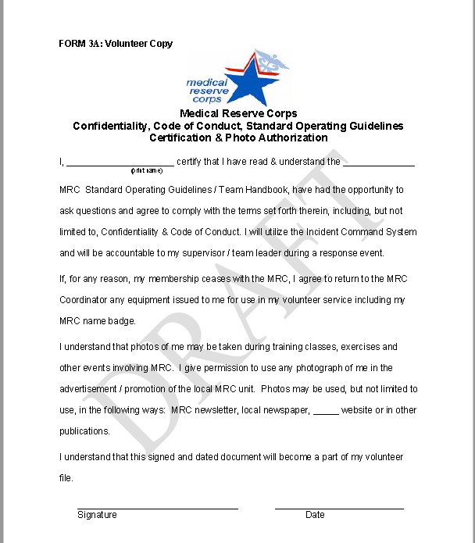

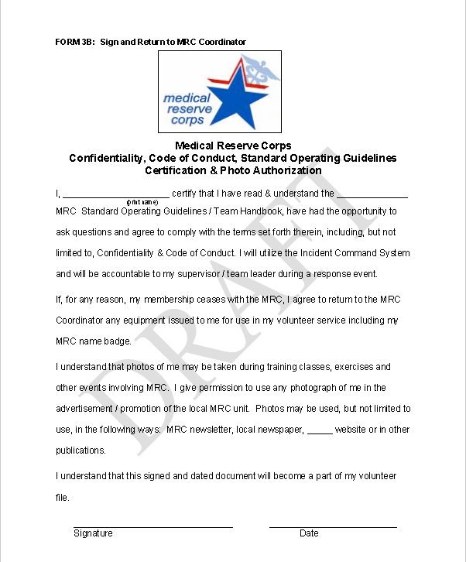
Appendix References
- Thakkar J, Kurup R, Laba T, et al Mobile Telephone Text Messaging for Medication Adherence in Chronic Disease A Meta-analysis. JAMA Intern Med. 2016;176(3):340-349. doi:10.1001/jamainternmed.2015.7667 Available at: Available at: http://jamanetwork.com/journals/jamainternalmedicine/fullarticle/2484905?resultClick=24. Accessed on March 9, 2017
- WHO. SOG for coordinating Public Health Event Preparedness and Response in the WHO Africa Region. Available at: http://www.who.int/hac/techguidance/tools/standard_operating_procedures_african_region_en_2014.pdf?ua=1. Accessed on March 9, 2017

