|  |  |  |  |  |  |  |  |  |  |  |  |  |  |  |  |
| --- | --- | --- | --- | --- | --- | --- | --- | --- | --- | --- | --- | --- | --- | --- | --- |
| **TEST SCHEDULE ENTRY FEE**  MASTER 12:30 p.m., Sunday, 03/25/18 $50.00  SENIOR To follow Master $50.00  JUNIOR 1:00 p.m., Sunday, 03/25/18 $45.00  **COURSES**  All Test levels will be single course with bird field.  Junior Test will be blank pistol only.  NO horseback handling will be permitted without AKC approval.  **BIRDS**  Quail to be released in all levels.  Chukars/quail to be released in Senior level.  Chukars/quail to be released in Master level.  **MASTER/SENIOR OFFICIAL GUNS**  All shooting done by Official Gunners only.  John Naughton (Capt.), David Furr, Michael Waddell, Pete Lamont  **PRIZES**  STANDARD AKC ROSETTES TO ALL DOGS THAT RECEIVE A QUALIFYING SCORE.  **PLEASE NOTE!**  ALL HANDLERS AND GALLERY **MUST** WEAR AN ARTICLE OF BLAZE ORANGE CLOTHING **IN ALL TESTS**!  Breakfast/lunch will be available at the shelter. Pet-friendly accommodations are available near the grounds. Contact Debbie Shelley at 301-963-4741 for details. | | | | | | | |  |  | | | | | | |
|  | | | | |  | | |  | | | | | | | |
|  |  | |  | | |  | | |  | | | | |  | |
|  | | | | | | | | | | | | | | | |
|  | |  | | | | |  | | | |  | |  | | |
|  | | | | | | | | | | | | | | | |
|  | | | | | | | | | | | | | | | |
|  | | | | | | | | | | | | | | | |
|  | | | | | | | | | | | | | | | |
| **CLUB OFFICERS ADDRESS TITLE**  **Beth Ritchie**  2711 Judes Ferry Road, Powhattan, VA 23139 President  **Tina Parker-Craig** 192 Serviceberry Court Stephens City, VA 22655 Secretary  **Barbara Cullerton**  2609 Deerdell Lane Reston, VA. 20191 Treasurer  **HUNT TEST COMMITTEE**  **Hunter Shelley, Hunt Test Chairman, 4 Billingsgate Court, Gaithersburg, MD 20877**  David Furr Beth Ritchie John Lehman  Pat Dady John Naughton | | | | | | | | | | | | | | | |
|  | | | | | | | | | |  | |  | | | |
|  | | | | | | | | | | | | | | | |
|  | | | | | | | | | | | | | | |
|  | | | | | | | | | |  | |  | | |
|  | | | | | | | | | | | | | | | |
|  | | | | | | | | | | | | | | | |
|  | | | |  | | | | | | | | | | | |

AFN999(10/03)

**OFFICIAL AMERICAN KENNEL CLUB FIELD TRIAL or HUNT TEST ENTRY FORM**

|  |  |  |  |  |  |  |  |  |  |  |  |  |  |  |  |  |
| --- | --- | --- | --- | --- | --- | --- | --- | --- | --- | --- | --- | --- | --- | --- | --- | --- |
| Club:  **Mason-Dixon German Shorthaired Pointer Club, Inc.** | | | | | | | | Date:  **03-25-18** | | | Event#:  **2018151502** | | | | | |
| Location**: McKee-Besher W.M.A., Seneca, MD** | | | | | Event type (test or trial): **Hunt Test** | | | Enter in Stake/Test: | | | | | | | | |
| **☑**  AKC No. | **□**  AKC Litter No. | | **□**  ILP No. | | | **□**Foreign & list country:  **_______________** | | | I enclose entry fees in the amount of: | | | | | |  | |
| Full Name of Dog: | | | | | | | | | | | | | | | | |
| Breed: | | Reg. #: | | | | | Call Name: | | | | | Sex: | | Date of Birth: | | |
| Sire: | | | | | | | | | | | | | | | | |
| Dam: | | | | | | | | | | | | | | | | |
| Name of Breeder: | | | | | | | | | | | | | | | | |
| Actual Owner(s): | | | | | | | | | | | | | | | | |
| Owner's Address | | | | | | | | | | | | | | | | |
| City: | | | | | | | | | | State: | | | Zip: | | | |
| Name of Owner's Agent/Handler: | | | | | | | | | | | | | | | | |
| Agent/Handler's Address: | | | | | | | | | | | | | | | |
| City: | | | | | | | | | | State: | | | Zip: | | |
| AKC Rules, Regulations, Policies and Guidelines are available on the American Kennel Club website: **www.akc.org**  **AGREEMENT**  I certify that I am the actual owner of the dog, or that I am the duly authorized agent of the actual owner whose name I have entered above. In consideration of the acceptance of this entry, I (we) agree to abide by the rules and regulations of The American Kennel Club in effect at the time of this event, and any additional rules and regulations appearing in the premium list of this event and entry form and any decision made in accord with them. I (we) agree that the club holding this event has the right to refuse this entry for cause which the club shall deem sufficient. In consideration of the acceptance of this entry and of the holding of this event and of the opportunity to have the dog judged and to win prizes, ribbons, or trophies, I (we) agree to hold the AKC, the event-giving club, their members, directors, governors, officers, agents, superintendents or event secretary and the owner and/or lessor of the premises and any provider of services that are necessary to hold this event and any employees or volunteers of the aforementioned parties, and any AKC approved judge, judging at this event, harmless from any claim for loss or injury which may be alleged to have been caused directly or indirectly to any person or thing by the act of this dog while in or about the event premises or grounds or near any entrance thereto, and I (we) personally assume all responsibility and liability for any such claim; and I (we) further agree to hold the aforementioned parties harmless from any claim for loss, injury or damage to this dog. Additionally, I (we) hereby assume the sole responsibility for and agree to indemnify, defend and save the aforementioned parties harmless from any and all loss and expense (including legal fees) by reason of the liability imposed by law upon any of the aforementioned parties for damage because of bodily injuries, including death at any time resulting there from, sustained by any person or persons, including myself (ourselves), or on account of damage to property, arising out of or in consequence of my (our) participation in this event, however such, injuries, death or property damage may be caused, and whether or not the same may have been caused or may be alleged to have been caused by the negligence of the aforementioned parties or any of their employees, agents, or any other persons. **I (WE) AGREE THAT ANY CAUSE OF ACTION, CONTROVERSY OR CLAIM ARISING OUT OF OR RELATED TO THE ENTRY, EXHIBITION OR ATTENDANCE AT THE EVENT BETWEEN THE AKC AND THE EVENT-GIVING CLUB (UNLESS OTHERWISE STATED IN TIS PREMIUM LIST) AND MYSELF (OURSELVES) OR AS TO THE CONSTRUCTION, INTERPRETATION AND EFFECT OF THIS AGREEMENT SHALL BE SETTLED BY ARBITRATION PURSUANT TO THE APPLICABLE RULES OF THE AMERICAN ARBITRATION ASSOCIATION. HOWEVER, PRIOR TO ARBITRATION ALL APPLICABLE AKC BYLAWS, RULES, REGULATIONS AND PROCEDURES MUST FIRST BE FOLLOWED AS SET FORTH IN THE AKC CHARTER AND BYLAWS, RULES, REGULATIONS, PUBLISHED POLICIES AND GUIDELINES.** | | | | | | | | | | | | | | | | |
| Signature of owner or his  agent duly authorized to make this entry: ____________________________________ | | | | | | | | | | | | | | | | |
| Telephone: | | | | Email address: | | | | | | | | | | | | |

AFN999(10/03)

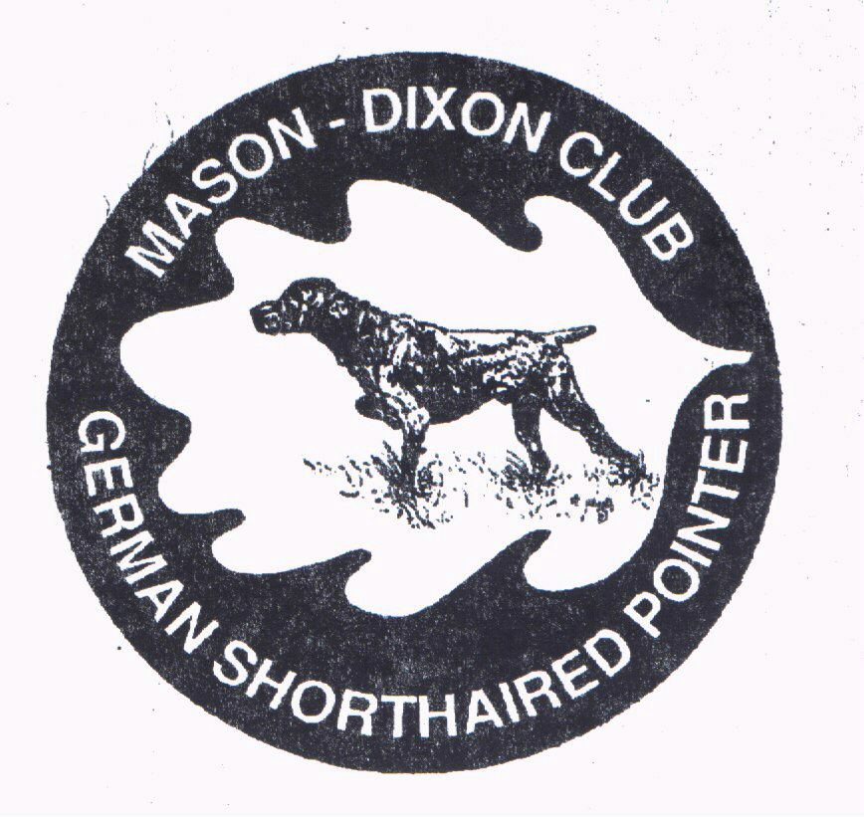

**HUNTING TEST PREMIUM 2018151502**

**AKC LICENSED HUNTING TEST**

McKee-Besher Wildlife Management Area

Hunting Quarter Road

Seneca (Poolesville), Maryland

**GPS Coordinates 39.080282, -77.414683**

Sunday afternoon, March 25, 2018

All test levels open to all AKC registerable pointing breeds

**ENTRIES LIMITED** to the number of dogs which can be run in four (4) hours and entries will close when the limit is reached, if this occurs prior to the specified closing time. The club reserves the right to cancel or postpone this Hunt Test for extreme weather conditions.

THIS HUNTING TEST IS HELD UNDER THE RULES AND PROCEDURES OF

**THE AMERICAN KENNEL CLUB**

***BITCHES IN SEASON ARE NOT ELIGIBLE FOR ENTRY.***

**AKC approved tracking collars will be permitted in all test levels.**

Make checks payable to “**Mason-Dixon GSP Club**” and mail with completed entry form to:

**Debbie Shelley, Hunt Test Secretary**

**4 Billingsgate Court**

**Gaithersburg, MD 20877**

**Home 301-963-4741,** [**hshelley@starpower.net**](mailto:hshelley@starpower.net)

**NO DOG WILL BE PERMITTED TO BE RUN PRIOR TO PAYMENT**

**NO TELEPHONE ENTRIES WILL BE ACCEPTED**

**ENTRIES WILL BE ACCEPTED BY EMAIL, FOLLOWED BY MAILED CHECK**

**NO CONFIRMATION WILL BE SENT**

**Entries open Tuesday, February 13, 2018 at 8:a.m.(EDT). Entries will close at 7:00 p.m.(EDT) Friday, March 16, 2018 and the drawing will take place at 4:00 p.m.(EDT) Sunday, March 18, 2016 at 4 Billingsgate Court, Gaithersburg, MD 20877**

**Judge # Level Judge # Level**

**John Lehman 98683 Master/Senior Tracey Johnson 94007 Master**

11175 Bemisderfer Road 1260 Washington Avenue

Greencastle, PA 17225 Woodbine, NJ 08270

**Mike Moser 93542 Senior**

647 Huffs Church Road

Alburtis, PA 18011

**Phil Rosenbaum 98693 Junior – A Alison Bierhoff 96459 Junior – B**

39 Olive Lane 2135 Grove Street

Owings Mill, MD 21117 Denver, CO 80211

**Will Kitts 98688 Junior - B Lisa Price 90958 Junior - B**

881 Quaker Meeting Road 3495 Marble Arch Drive

Dover, PA 17315-2848 Pasadena, MD 21122-6454

**THE STANDARDS OF PERFORMANCE**

**JUNIOR HUNTER**

**A Junior Hunting Dog must show a keen desire to hunt, be bold and independent, have a fast, yet attractive, manner of hunting, and demonstrate not only intelligence in seeking objectives, but also the ability to find game. A Junior Hunting Dog must establish point** on at least fifty (50) percent of the birds it encounters**, but no additional credit shall be given for steadiness to wing and shot. If the handler is within reasonable gun range of a bird which has been flushed after a point, a blank cartridge must be fired by the handler. Junior hunting dogs must hold point until the handler gets within normal gunshot range.** *This requirement should be tempered by practical considerations such as the dog’s distance from the handler when it finds a bird.*  **Junior Hunting Dogs must also show reasonable obedience to their handler’s commands.**

**SENIOR HUNTER**

**A Senior Hunting Dog must show all of the attributes of a Junior Hunting Dog. In addition, the** Senior Hunting **dog must be steady to wing** on all pointed birds **and must remain in position until the shot or they are released. A Senior Hunting Dog must retrieve.** All birds that are pointed by the Senior dog in a bird field must be shot where safety allows. If gunning is being done on course, all birds pointed on course must be shot where safety allows. A legitimate attempt to retrieve all downed birds must be made. *Conditions such as the type of cover where the bird landed, the terrain,* and the condition of the downed bird, sometimes make a retrieve impossible and this should not reflect negatively on the score of the Senior dog. **Whenever it encounters its brace mate on point, it must honor. A dog that steals its brace mate’s point cannot receive a Qualifying score.**

**MASTER HUNTER**

**A Master Hunting Dog must positively demonstrate its steadiness to wing and shot.**  All birds that are pointed by the Master dog in a bird field must be shot where safety allows. If gunning is being done on course, all birds pointed on course must be shot where safety allows. Gunning must be done by Official Guns only. A legitimate attempt to retrieve all downed birds must be made. *Conditions such as the type of cover, where the birds landed, the terrain, and the condition of the* downed bird, sometimes make a retrieve impossible and this should not reflect negatively on the score of *the Master dog.* All killed birds must be retrieved promptly, tenderly and absolutely to hand.  **The handler shall not command or signal the dog to retrieve until positive steadiness has been demonstrated.**