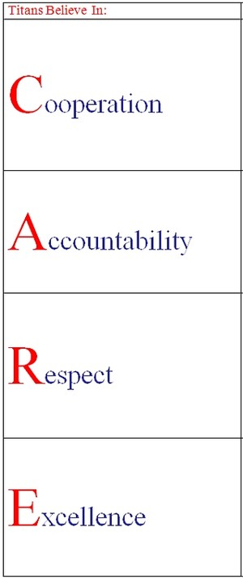

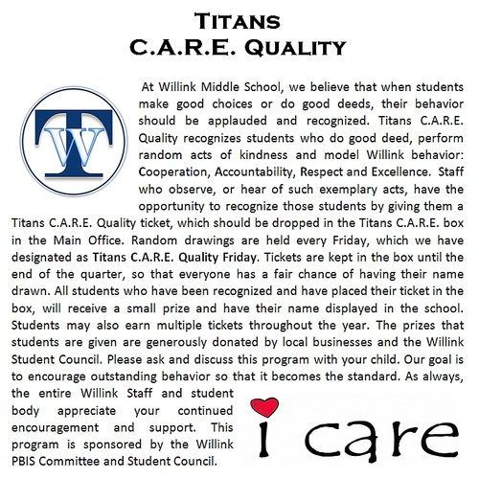

This year, we will be using the CARE (Cooperation, Accountability, Responsibility, Excellence) acronym to teach students about our expectations in the building.

