|  |  |  |
| --- | --- | --- |
| January 2018  Volume 4, Issue 1 | Park Times Little Neck Edition  Park’s World Tae Kwon Do  Quarterly News Letter | C:\Users\ParkTKD\Dropbox\TKD\케릭터\TKD Art\attack2.wmf |

Grandmaster’s Message

**A true Martial Artist is the integration of the warrior and sage. He or she is an instrument of peace but has the ability to destroy if necessary. Martial Arts is about having the knowledge of combat, but hopefully never having to use this knowledge under any circumstance. Always walk away from the fight but at the same time always have the knowledge and ability to protect yourself and the weak.**

**It may hurt at times. It will take time.**

**It will require dedication. It will require will power.**

**You will need to make healthy decisions.**

**It requires sacrifice.**

**You will need to push your body to its max.**

**There will be temptation.**

**But, I promise you, when you reach your goal, it’s WORTH IT!**

**1/20 – Annual Banquet Party**

**2/19-23 – Winter Recess Camp**

**3/8 – Blanc Belt Stripe Test**

**3/24 – Hong Ik Championship**

**3/29 – Color Belt Test**

**4/2-4/6 – Buddy Week**

**2/21 – Children’s Overnight Training**

**\* Upcoming Events \***

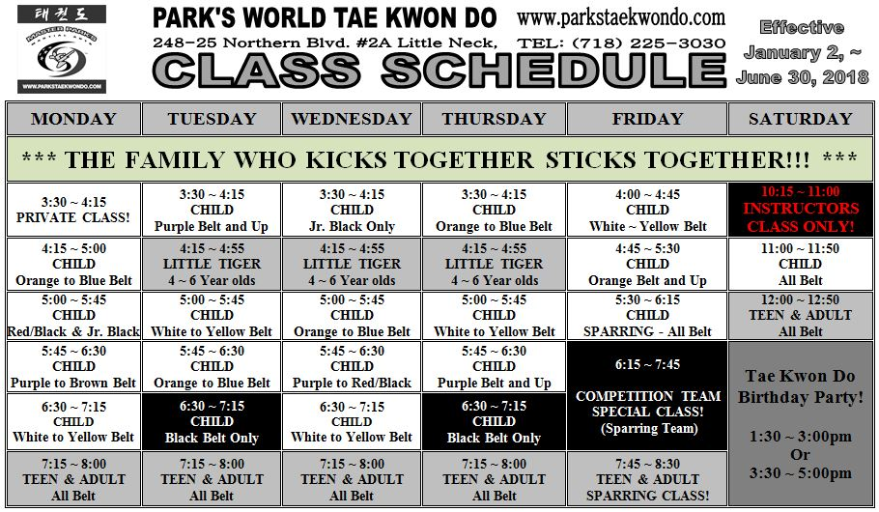

|  |  |  |  |  |  |  |  |  |  |  |  |  |  |  |  |  |  |  |  |  |  |  |  |  |  |  |  |  |  |  |  |  |  |  |  |  |  |  |  |  |  |  |  |  |  |  |  |  |  |  |  |  |  |  |  |  |  |  |  |  |  |  |  |  |  |  |  |  |  |  |  |  |  |  |  |  |  |  |  |  |  |  |  |  |  |  |  |  |  |  |  |  |  |  |  |  |  |  |  |  |  |  |  |  |  |  |  |  |  |  |  |  |  |  |  |  |  |  |  |  |  |  |  |  |  |  |  |  |  |  |  |  |  |  |  |  |  |  |  |  |
| --- | --- | --- | --- | --- | --- | --- | --- | --- | --- | --- | --- | --- | --- | --- | --- | --- | --- | --- | --- | --- | --- | --- | --- | --- | --- | --- | --- | --- | --- | --- | --- | --- | --- | --- | --- | --- | --- | --- | --- | --- | --- | --- | --- | --- | --- | --- | --- | --- | --- | --- | --- | --- | --- | --- | --- | --- | --- | --- | --- | --- | --- | --- | --- | --- | --- | --- | --- | --- | --- | --- | --- | --- | --- | --- | --- | --- | --- | --- | --- | --- | --- | --- | --- | --- | --- | --- | --- | --- | --- | --- | --- | --- | --- | --- | --- | --- | --- | --- | --- | --- | --- | --- | --- | --- | --- | --- | --- | --- | --- | --- | --- | --- | --- | --- | --- | --- | --- | --- | --- | --- | --- | --- | --- | --- | --- | --- | --- | --- | --- | --- | --- | --- | --- | --- | --- | --- | --- | --- | --- | --- |
| |  |  |  |  |  |  |  | | --- | --- | --- | --- | --- | --- | --- | | January 2018  **C:\Users\Lisa\AppData\Local\Microsoft\Windows\Temporary Internet Files\Content.IE5\NLUTVA2K\MC900436236[1].png**  May 2017 bring you and your family much  health and happiness! That’s **365** days for hopes  and dreams to be realized. Make it count.  **Parent’s Message**  **Why do we bow?** Bowing is an expression of gratitude and respect. The bow is the Eastern way of greeting, the same as a handshake in the west. Bowing shows sincerity, respect, and deep appreciation. When sparing, you are in effect thanking your opponent for the opportunity to improve your technique.  **Black Belt News**  Good luck to all Black Belts testing for stripes here at Park’s Martial Arts on Thursday, February 10th. The next Black Belt test for degree will be on May 20th in Long Beach.  A Black Belt is nothing more than a belt, a piece of cloth. Your ultimate goal should not be to get your Black Belt. Your ultimate goal should be to **BE** a Black Belt. Being a Black Belt is a state of mind, a way of life.  **Color Belt News**  It’s not about being better than someone else. It’s about being better than you were the day before.  I am, in competition with no one.  I run my own race  I have no desire to play  the game of being better than anyone  in any way, shape or form  I just aim to improve  to be better than I was before.  Once you learn to remain calm under the stressful circumstances of a fight (sparring), you will have no trouble remaining calm under the stressful circumstances of life.  **Welcome** to all of our new students. When you become a student here at Park’s Martial Arts Tae Kwon Do School, you become a member of our family. | | | | | | | | Sunday | Monday | Tuesday | Wednesday | Thursday | Friday | Saturday | | Closed for Holidays | 1 | 2 | 3 | 4 | 5 | 6 | | 7 | 8 | 9 | 10 | 11 | 12 | 13 | | 14 | 15  Board Breaking Week | 16 | 17 | 18 | 19 | 20  Banquet  Party | | 21 | 22 | 23 | 14 | 25 | 26 | 27 | | 28 | 29 | 30 | 31 |  |  |  |  |  |  |  |  |  |  |  | | --- | --- | --- | --- | --- | --- | --- | | February 2018 | | | | | | | | Sunday | Monday | Tuesday | Wednesday | Thursday | Friday | Saturday | |  |  |  |  | 1 | 2 | 3 | | 4 | 5  Board Breaking Week | 6 | 7 | 8 | 9 | 10 | | 11 | 12 | 13 | 14 | 15 | 16 | 17 | | 18 | 19  Winter Camp | 20 | 21 | 22 | 23 | 24 |  |  |  |  |  |  |  |  | | --- | --- | --- | --- | --- | --- | --- | | March 2017 | | | | | | | | Sunday | Monday | Tuesday | Wednesday | Thursday | Friday | Saturday | | Feb 25 | Feb 26 | Feb 27 | Feb 28 | 1 | 2 | 3 | | 4 | 5  Board Breaking Week | 6 | 7 | 8  Black Belt  Stripe Test | 9 | 10 | | 11 | 12 | 13 | 14 | 15 | 16 | 17 | | 18 | 19 | 20 | 21 | 22 | 23 | 24  **Hong Ik**  **Championship** | | 25 | 26 | 27 | 28 | 29  Color Belt  Test | 30 | 31 | |

**Our Staff**

|  |  |  |
| --- | --- | --- |
| **Grandmaster S. H. Park** | | |
| Master Park  Instructor: Erin Kelly | | Secretary: Christine Cazzola |
|  |  | |
|  |  | |