Student Name
Instructor’s Name
ENG 102
Section Number
Date
Company Name
Logos
.
Ethos
.
Pathos
.
Audience
.
Color
.
Rule of Thirds
.
Representation
.
Foregrounding
.
Syllogism and Enthymeme
.
Kairos
.
Rhetorical Situation
.
Symbols
.
Metaphors
.
Intertextuality
.
Tone
.
Reflection
.
Works Cited

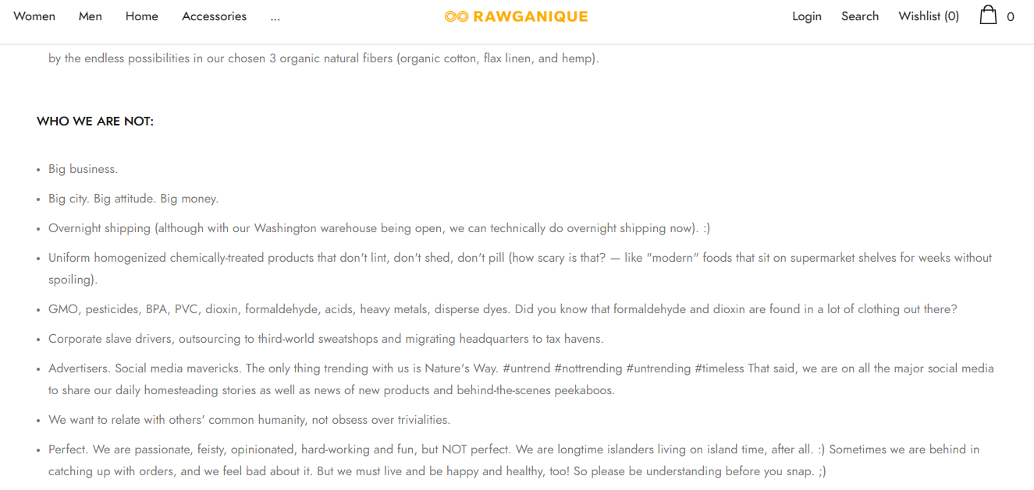
Figure 1 - Insert caption for each image attached

