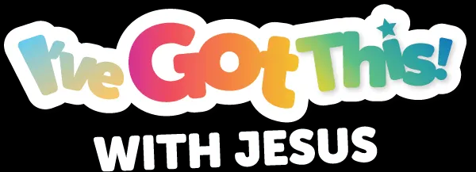

YOUTH/TEEN VIRTUAL VBS LESSON PLAN
Middle District Baptist Association
North Carolina
July 13 - 15, 2021

TUESDAY, JULY 13, 2021

Title of Lesson: CONQUERORS BATTLE PLAN

Purpose: Overview of what it means to be a conqueror. We will use games as a tool and technique to not only get students involved on our first day of learning, but also to engage students with the Bible content.

Learning Outcome: Students will build their trust, faith, and belief on the truth – Jesus Christ!

TIME | ACTIVITY | OUTCOME
6:15pm -6:30pm | GREETINGS | As each student enters the room, the instructors will greet them enthusiastically! We are excited for them to come to Virtual VBS!
6:30pm – 6:35pm | OPENING PRAYER  WELCOME & ICE-BREAKER | Prayer, Welcome and Introductions. Our daily ice-breaker will engage students to know Jesus more.
6:35pm-- 6:40pm | PACE-SETTER:  - Ground Rules  - Expectations  - Teamwork | We are in this together, so each student will select one topic and cast their vote. The youth/teen class will discuss topics based upon the top three selected via polling. Because we are partners together, each student has input to the success and outcomes of the class. Then, each can proclaim, “I’ve Got This! with Jesus.”
6:40pm – 6:45pm | OPEN THE MAIL  - Lesson Introduction  - Word of the Day | The opening exercise is what is needed for teens to open their Bibles daily, just as they would mail that comes as a text from a friend! Everyday they can open the Good News from Jesus!
6:45pm – 6:50pm | SNACK BREAK  - Bible Memory Verse of the Day | Students will read the memory verse of the day and find an item at their location in which they can relate to the verse. This is not an actual snack break, but a “Bible Verse Break” to taste and see that the Lord Jesus is Good!
6:50pm – 7:10pm | BIBLE LESSON via GAMES | Use of the Word of the Day (Conquerors), Bible Memory Verse of the Day and the Lesson Introduction to foster learning through various games. Students will use multi-sensory to retain learning.
7:10pm –  7:20pm | LESSON FOR LIFE | Each student will relate the Bible Lesson to their individual life. Conversation encouraged. Questions to determine direct application of materials.
7:20pm –  7:25pm | CONQUEROR RECAP | Closing Activity for retention of learning. Questions to determine understanding of materials.
7:25pm –  7:30pm | CLOSING PRAYER & BENEDICTION

