Observations on the Use of Supplemental feeders on Elizabethtown Beagle Club.

John Gibble and Clark Hammaker

Introduction:

It is the goal of beagle clubs to provide ample populations of cottontail rabbits for training and field trialing beagles. Many clubs and running areas employ supplemental feeding to retain individual rabbits throughout the winter and improve individual health at the start of the breeding season. Some have inferred that providing supplemental feed can reduce the amount of winter foraging time during which rabbits are exposed to predation.

Throughout a number of years, Elizabethtown Beagle Club has maintained as many 50 rabbit feeders on 73 acres. The success of this feeding program was only judged by casual observation. Rabbit sign (such as tracks in snow or fecal pellets in or adjacent to feeders) and the frequency with which feed disappeared were used to judge the success of the feeding program.

Further, many clubs and running grounds operators argue on the best type of supplemental feed. Several clubs with apparently successful programs used only oats, other operators insisted that rabbit pellets directly addressed the dietary needs of rabbits, while yet others insist that the protein and carbohydrates in corn were the most appropriate winter feed due to climate conditions.

Observations in past years have shown, providing supplemental feed for rabbits affects others species. It is not uncommon to see other small animals targeting the food source. A number of songbirds utilize oats and corn. Squirrels were thought to be frequent users of all food sources targeted for rabbits. In years past, deer had been observed to use feeders, with some individuals actually learning how to turn over the feeders to spill corn, pellets, or oats, out onto the ground. In unusually cold and snowy years it has not been uncommon to find opossums in feeders and evidence of use by raccoons and other non-target species. Some have posited that supplemental feeding stations also attract predators and by providing feed, clubs may be drawing rabbits to areas where they could be more susceptible to predators.

Our study attempted to quantify the use of supplemental feeders by measuring the disappearance of feed at eight feeder locations. In addition, many of the feeding stations were monitored with a game camera that recorded the comings and goings of various wildlife. We also attempted to identify a preference by providing corn, oats, and commercial rabbit pellets in feeders.

Methods of Observation:

Six feeding stations were established on November 22, 2011 and two additional stations were established on December 8, 2011. All other feeder stations were removed. Feeding stations consisted of a commercial wood pallet laid on the ground. A cut-off 5-gallon paint bucket was used as a bowl and placed on top of the pallet. Four cups of feed were placed in each feeder. The food placed in each feeder varied randomly, but generally once one type of food (corn, pellets, or oats) was placed in a feeder we tried to keep that type of food in the same feeder. The bowl was then covered with half of a plastic barrel. The 35-gallon barrel was cut lengthwise, and either the ends were knocked out or an entrance way (about 6 X 6 inches) was cut into each end. The barrel was secured to the pallet with a bungee strap to prevent the cover from blowing off and to prevent deer and other larger animals from knocking the cover off to access the feed.

Feeders were installed in areas where they were easily accessible. Consideration was given to placing feeders near newly cut areas that provided both brushy access and cover for approaching rabbits. Consideration was also given to place feeders in areas where rabbits were frequently jumped during training of beagles.

Game cameras were installed at Feeders 1, 2, 3, 5, and 6.

Feeding stations were monitored about every week to two weeks. The feed remaining in the bowl was measured to determine how much feed had been consumed. Then the feeders were filled again with four cups of feed. The data from game cameras was downloaded and the number and type of animals using the feeders were recorded, and observations made regarding the time of day each used the feeders.

Cameras:
The club used five remote game cameras, memory cards, and batteries. Cameras were employed to monitor 6 feeders from November 2011 through April 2012. Captured images were downloaded, examined, and the species photographed was recorded. Club member Clark Hammaker was instrumental in monitoring and maintaining the game cameras, as well as interpreting the data. While cameras provided a “round-the-clock” record of use, there were certain drawbacks that limited their effectiveness. Weather conditions including heavy rain and extreme cold affected the battery life and quality of pictures. Also, windy conditions would cause the camera to trigger by the movement of background leaves or branches

Results:
Over 2,000 photographic images were captured on the game cameras. Images included cottontail rabbits, squirrels, cats, mice, birds, fox, raccoon, hawk, opossum, and white-tailed deer. Camera placement and view from the camera may have resulted in greater or fewer observations of cottontails. For instance, the squirrels would spread the feed out of the feeder and the rabbits were camera shy when the flash would go off. The cameras were set very close to the feeders with the thought of catching detailed photos. The cameras should have been set further away to capture the area around the feeder.

Table 1: Volume of Food Used by Feeding Station

Feeder# | 1 Pellet | 2 Oats | 3 Oats | 4 Pellets | 5 Corn | 6 Corn | 7 Pellets | 8 Corn
Dec. 8 | 0 cups | 1 cup | 4 cups | 0 cups | 0 cups* | 4 cups | --- | ---
Dec. 23 | 0 | 4 | 4 | 0.5 | 2-corn | 3 | 4 | 4
Jan. 6 | 0 | 4 | 4 | 0 | 3.5 | 4 | 3 | 4
Jan. 16 | 0 | 4 | 4 | 1 | 3.5 | 3.5 | 1.5 | 3.5
Jan. 22 | 0 | 1 | 3 | 0 | 2.5 | 1 | 0 | 4
Jan. 31 | 0 | 3.5 | 4 | 1 | 4 | 4 | 4 | 4 pellets
Feb. 13 | 0 | 4 | 4 | 0.5 | 4 | 4 | 4 | 0 pellets
Feb. 29 | 0 | 4 | 4 | 3 | 4 | 4 | 4 | 4 pellets
Mar. 15 | 0 | 4 | 4 | 2 | 3.5 | 4 | 4 corn | 4 oats
Totals | 0 | 29.5 cups | 31 cups | 8 cups | 27 corn | 26.5 corn 1 pellets | 20.5 pellet  4 corn | 15.5 corn 8 pellets 4 oats
*For feeder 5 pellets were initially installed but switched to corn.

Table 2: Volume (cups)of Food Consumed by type

Corn | Oats | Pellets
73 | 64.5 | 37.5

Table 1 indicates the amount and type of feed utilized at each feeder. Table 2 summarizes the amount of each feed type used throughout the period of observation. Based on these numbers, corn appeared to be the preferred food type, oats were highly acceptable, and pellets were used only in moderation. Feed useage did not seem to vary much by feeder location. Food type seemed to be the biggest variable.

Table 3: Species Observed on Camera by Feeder

Feeder |  | 1-Pellets |  | 2-Oats |  | 3-Oats |  | 5-Corn |  | 6-Corn
Rabbit |  | 9 |  | 6 |  | 29 |  | 36 |  | 0
Squirrel |  | 5 |  | 130 |  | 271 |  | 178 |  | 6
Deer |  | 4 |  | 10 |  | 1 |  | 0 |  | 0
Mice |  | 0 |  | 3 |  | 5 |  | 8 |  | 12
Cat |  | 3 |  | 0 |  | 0 |  | 3 |  | 0
Birds |  | 0 |  | 0 |  | 0 |  | 140 |  | 35
Fox |  | 0 |  | 0 |  | 1 |  | 0 |  | 0
Raccoon |  | 0 |  | 1 |  | 0 |  | 0 |  | 0
Hawk |  | 0 |  | 1 |  | 0 |  | 0 |  | 0
Fox |  | 0 |  | 0 |  | 0 |  | 0 |  | 0
Opossum |  | 0 |  | 0 |  | 0 |  | 2 |  | 2

Table 4: Species Observed on Camera

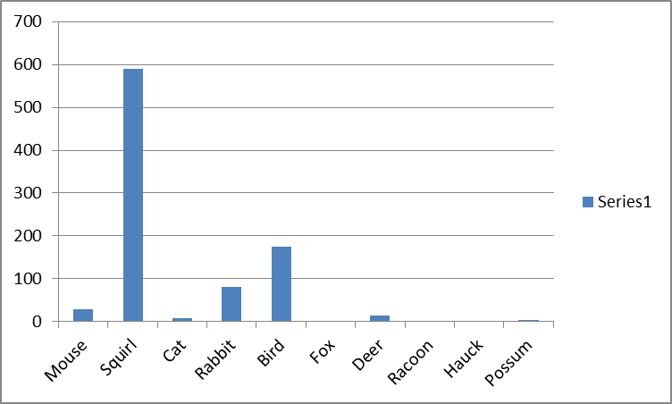

Table 5: Rabbit sightings over time

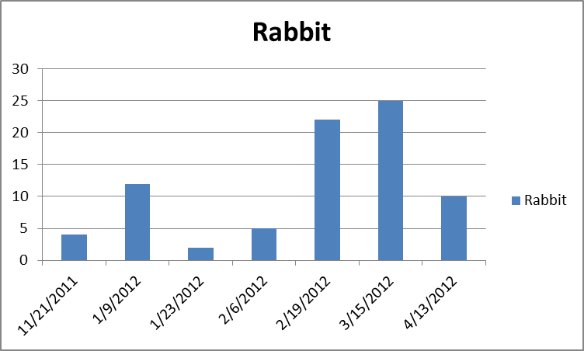

Discussion

As indicated by Tables 1 and 2, Corn seemed to be the preferred feed, oats were highly acceptable, and pellets were used only in moderation. Table 3 also supports the assertion that corn, oats, and then pellets were the preference for cottontails. Several factors may contribute to the results. Photo documentation and interpretation of physical signs indicated that squirrels, mice, and birds used these food sources extensively. While not observed, high pellet use at Feeder #7 may have been the result of small deer that learned to access the feeder evidenced by the barrel being pushed back.

Corn and oats use seemed to be constant throughout the period of observation. Photo documentation indicated that food use by rabbits peaked in February and March. It may be that rabbits and other species recognize and can target these foods immediately when provided. That pellet use and the increase in rabbit occurrence in the photo record seemed to increase throughout the period indicates that rabbits may need to become acclimated to using pellets, not recognizing a processed food immediately. Feeder 1 was interesting in that there was very little use of pellets in this location at any time throughout the study. Any use was so negligible that it didn’t register in terms of feed volume, though the cameras indicated some use by rabbits. However, several times the investigators jumped a rabbit within several yards of Feeder 1 when servicing the feeder or running dogs.

Climate variations in the winter of 2011-2012 may have adversely affected feeding as well. During the period of observation there were only two measurable snowfalls (January 22 and February 9). In January the snow lasted about 48 hours on the ground. In February the snow lasted about three days. Otherwise, temperatures remained in the 50s during the day and often failed to fall below freezing at night. By the end of February it was noted that clovers, chickweed, and several other forage species had emerged. Further, there was little environmental stress occasioned by frigid temperatures or snowy conditions. It seems odd that while a great deal of new growth was available early in 2012, rabbit feeding seemed to increase (based on photos) in February and March.

Table 3 indicates that rabbits primarily used corn, then oats, then pellets. Photo documentation from Table 3 indicates that squirrels and birds targeted corn and oats, but rabbits were the primary users of pellets. Photos indicated that rabbits used the feeders near dusk and dawn while squirrels and birds were daylight users. To better target rabbit feeding and reduce use by other species, one strategy would be to reduce availability of feed during daylight hours since it would be difficult to develop a system that physically excludes squirrels, birds, and mice, but allows rabbits access.

In terms of addressing the introductory questions, our results give decent indications, but only sketchy conclusions. Corn seemed to be the most favored food, oats came second. However, these feeds also drew a lot of use by non-target species. Our feeder design, with a low cover secured by a bungee cord, seemed effective at deterring use by deer. Only Feeder 8 seemed to have any problem with deer.

On the question as to whether feeding stations draw predators, our evidence indicates that predators did not concentrate on feeders. We have a few pictures of foxes passing by, several pictures of cats, and an image or two of other predators. However these seem to be passing by rather than targeting/waiting around. When snow lay on the ground overnight, effort was made to visit the feeders and surrounding areas to enumerate tracks. Fox tracks led past feeders but did not circle or cover them.

Analysis of photo records indicated that rabbit use increased throughout the study. Considering that the area experienced an early green-up with fresh, quality forbs and grasses becoming available as early as late February, it seems odd that supplemental food use would increase. There are several possibilities to consider. Trapping and importation of rabbits may have increased the population on the club and visits to the feeders by imported rabbits. With the advent of breeding season rabbits may be more active, thus requiring more calories and also increasing their chances of finding supplemental feeding stations. Finally, individual rabbits may take several weeks to acclimate to using feeding stations. The longer the stations were left in place, the greater the use by rabbits.

Conclusions

It appears that rabbits do successfully utilize supplemental food sources. Based on our observations, rabbits preferred corn over oats, and oats over pellets. Based on the significant use of feeders by squirrels and birds, we would recommend that feeding costs can be reduced and rabbit feeding could be more effectively targeted by providing a limited amount of food at dusk, rather than leaving food available throughout the daylight hours. A timed game feeder may provide better results than simply allowing feed to be available continually.

Some clubs provide supplemental feed throughout the year, others only during colder months. Based on Table 5, it appears that use of supplemental feed by rabbits peaks in February and March. While this may be the result of adding new rabbits to the population through trapping or perhaps the result of rabbits learning to identify and utilize feeders over time, we would suggest that grains, high in carbohydrates, and rabbit pellets, with relatively high protein levels, support increased needs for nutrition at the advent of the breeding season. Providing supplemental feed at the beginning of the breeding season likely results in increased reproductive success.

The study period was unique in that 2012 was unusually warm and snow cover was very low. Interesting results could be obtained from monitoring feeding stations throughout periods with lasting snow cover.

Acknowledgements: We would like to thank Nestle’-Purina and the National Beagle Club for providing cost assistance with this study through the Purina Parent Club Program. Additional thanks to club member Bernie Smith for assisting in keeping feeders monitored.

List of Photographs:

- Typical game camera monitoring site. The plastic tub is strapped down to the pallet. This prevented the deer from turning the tub over and eating the feed. The pallet kept the feed off the ground.
- Photo shows rabbit in the feeder.
- Photo shows squirrel in the feeder.
- First in a series of photos showing rabbit hitting feeder.
- Second in a series of photos showing rabbit hitting feeder
- Third in a series of photos showing rabbit hitting feeder

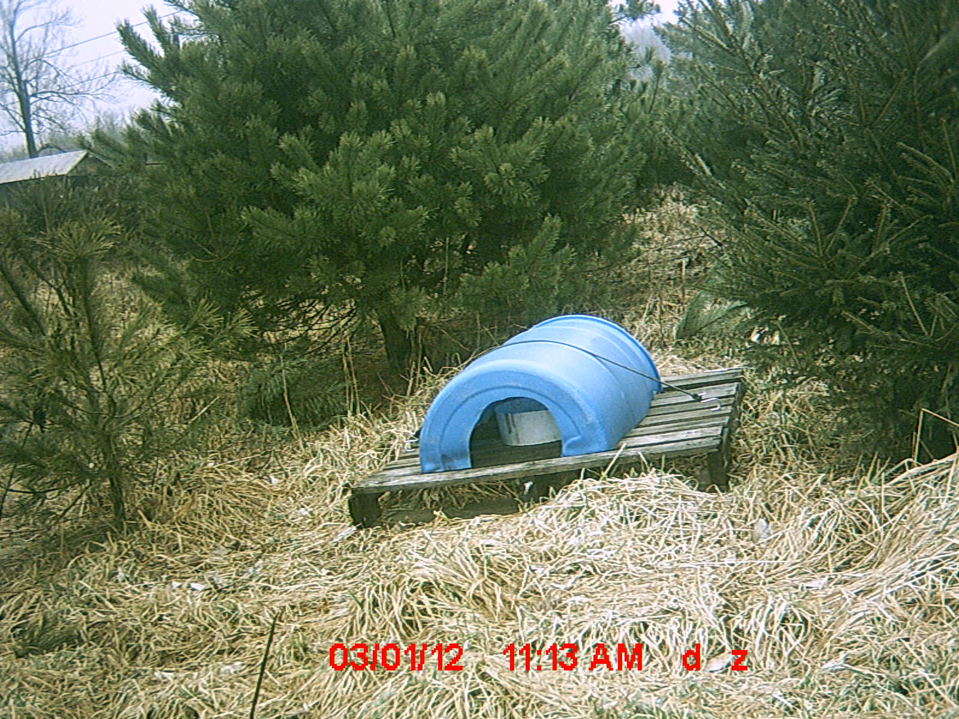
Picture 1
Typical feeding station

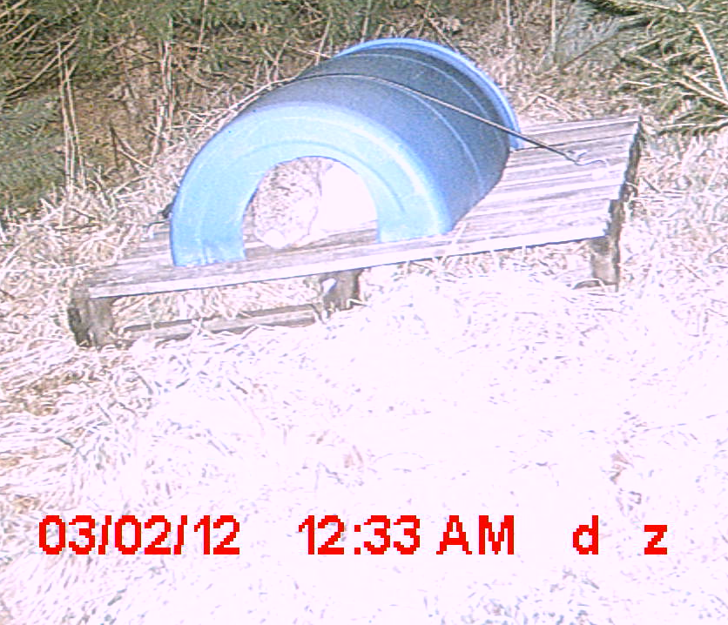
Picture 2
Rabbit in feeder
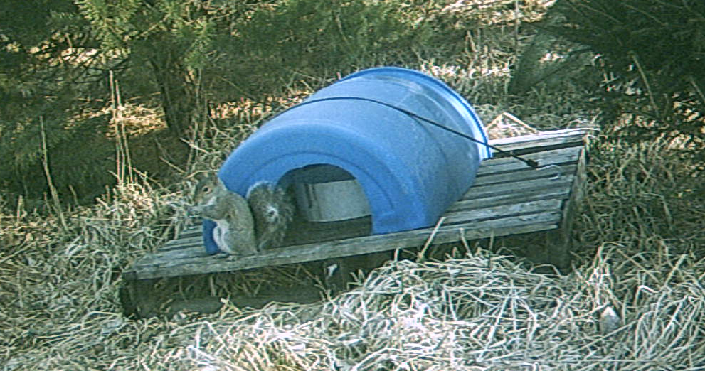
Picture 3
Our best eater the Squirrel

The next three Photos show a typical three frame series of a rabbit hitting the feeder, note the time. Rabbits all hit the feeder under cover of darkness, squirrels always during the day.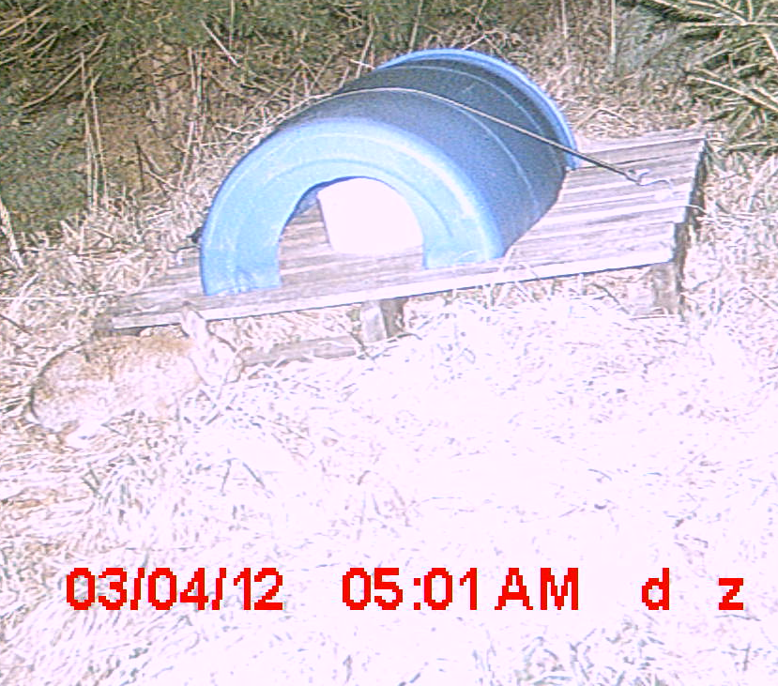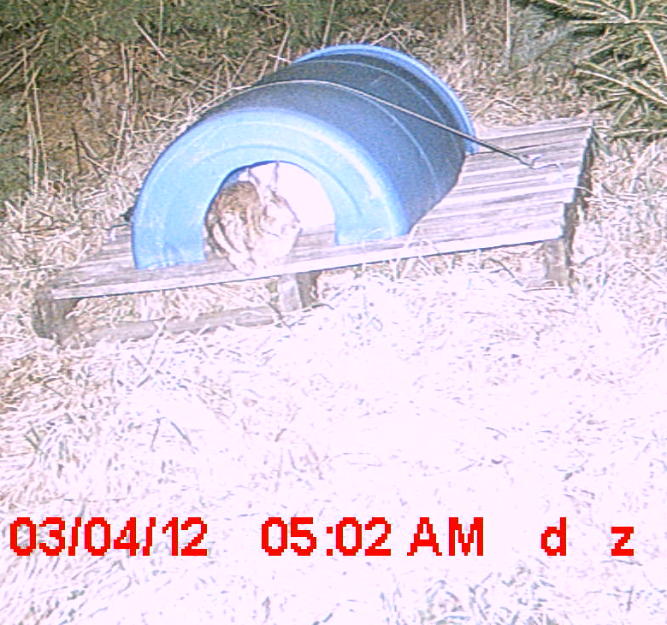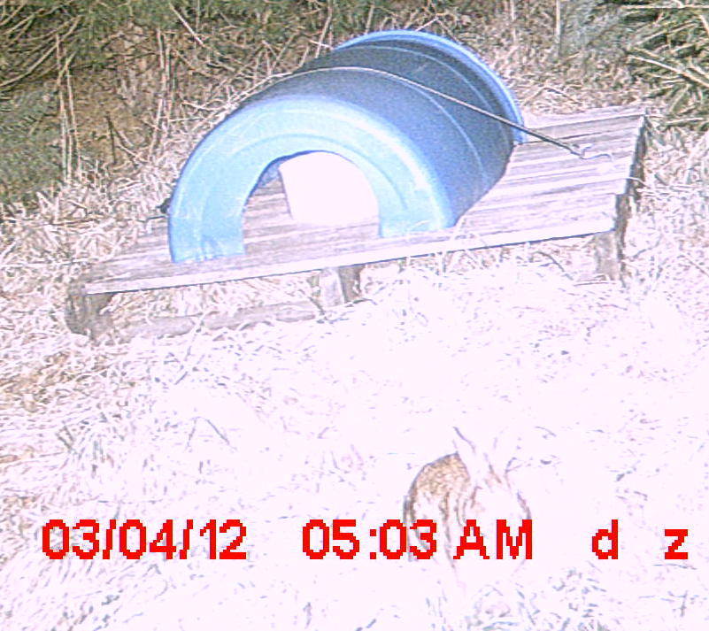
Pitcures 4,5,6

