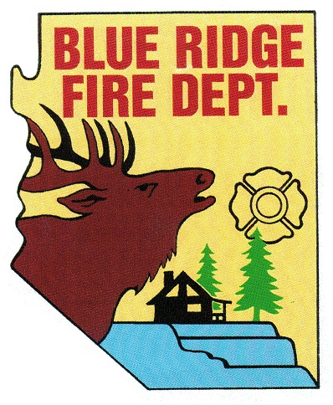
BLUE RIDGE FIRE DISTRICT

Public Safety Personnel Retirement System
Local Board
5023 Enchanted Lane
Happy Jack, Arizona. 86024
928-477-2751
www.brfdaz.org

NOTICE OF PUBLIC MEETING

Pursuant to A.R.S. 38-431.02, notice is hereby given to the members of the general public that members of the Public Safety Personnel Retirement System (PSPRS) Local Board will hold a regular meeting on Friday, November 15, 2019 directly following the Work Study Session at the Blue Ridge Fire District Station in Happy Jack, Arizona.

Members of the PSPRS Local Board may attend in person or by telephone conference call.

The PSPRS Local Board reserves the right to move into Executive Session for Legal Advice under the Authority of A.R.S. 38-431.03 (A) (1) through (7) on any agenda item.

Pursuant to the AMERICANS WITH DISABILITIES ACT, special accommodations will be made available upon a 24-hour prior notice to the Secretary of the PSPRS Local Board.

Date: November 15, 2019
Time: Directly following the Work Study Session
Place: Blue Ridge Fire District Station

Meeting Called to Order: (meeting will be recorded)
Time:

Pledge of Allegiance:

Roll Call of PSPRS Local Board Members and Accepted Quorum Met:
Cindy Perelli
Linda Blosser
Tammy Rosenhagen
Brandon Sewell
Ryan McNeal

Adoption of the Agenda:

Approval of Previous Meeting Minutes: October 18, 2019

Chairperson Perelli’s Report:
None

Old Business: Discussion and Possible Approval
- Obtaining and retaining a PSPRS Local Board Attorney
- Obtaining and retaining a PSPRS Independent Medical Examiner

New Business:
None

Call to the Public: A.R.S. 38-431.01 (H)
A public body may make a call to the public, subject to reasonable time, place and manner restrictions, to allow individuals to address the public body on any issues within the jurisdiction of the public body. At the conclusion of any open call to the public, individual members of the public body may respond to criticism made by those members who have addressed the public body, may ask staff to review a matter to be placed on a future agenda. However, members of the public body shall not discuss or take action on matters raised during an open call to the public unless the matters are properly noticed for discussion and legal action.

Request for future agenda items:

Adjournment:
Time:

Agenda Posting: Wednesday, November 13, 2019
- BRFD Website
- BRFD Bulletin Board
- Starlight Pines Community Building Board
- Pine Canyon Bulletin Board

