2018 S.W.A.P.S.
“Special What-cha-ma-call-its Affectionately Pinned Somewhere”
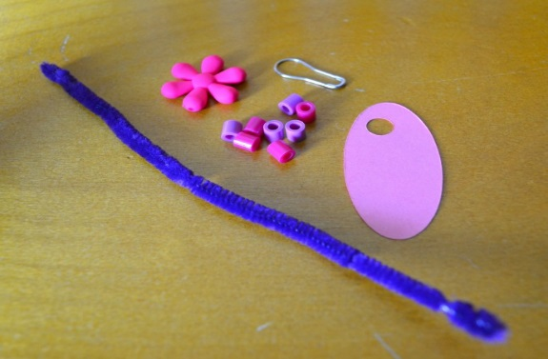
Please join Cadette Troop 55092 for the 3rd Annual S.W.A.P.S. Event. Learn about Girl Scout Traditions and Customs. Many table stations again this year with some new S.W.A.P.S. and a few old favorites.
Date: Friday, January 26, 2018
Time: 6:30 to 8:30
Where: Falcon Ridge MS – Cafeteria (lower level)
RSVP requested to make sure we have enough supplies for everyone.
We will have a free-will can for Family Giving as well. Thanks

2018 S.W.A.P.S.
Troop Number: ____________________________
Leaders: ____________________________________
Girls: (optional) ____________________________
______________________________________________
______________________________________________
Cost per Girl: $6 x _____ = __________
Please send registration & payment to:
Troop 55092 c/o Sally Blake & Molly Munson
7492 Germane Trail
Apple Valley, MN 55124
Phone: 952-686-4083
Email: chickaleemom@gmail.com

