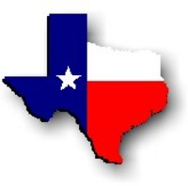Texas History with Mr. Brown Name ____________________ Period _____
Ch 20 The Oil Industry: Test REVIEW

Directions: Define, identify, or answer the following

1) Petroleum -
2) Reserve -
3) Geologist -
4) Lease -
5) Derrick -
6) Boom -
7) Natural Gas -
8) Boomtown -
9) Refinery -
10) Wildcatter -
11) Petrochemical -
12) Synthetic Rubber -
13) Toxic Waste -
14) What did the early Spanish settlers of Texas use oil for?
15) When the _________________________ began using oil for fuel in the 1880s, the fossil fuel was suddenly in high demand.
16) Why did some farmers complain about oil?
17) In 1866 the ____________ Oil Company drilled Texas’s first successful oil well in Nacogdoches County.
18) After Higgins failed to locate oil, who did he lease his land to?
19) Where did Higgins believe he could find oil?
20) Prior to the oil boom what was the leading industry in Texas?
21) As drilling increased, __________________ sprang up around successful wells.
22) How did the oil industry effect the development of roads?
23) What effect did oil boomers have on Texas towns?
24) __________________ made working on oil rigs extremely dangerous.

25) _________ is a town that is home to major oil refineries.
26) Name three oil based products that you have used today:

