

**JERSEY International Open**

International 2025 Open Competition Weekend 25th to 27th July

**Minimum Guaranteed Prize Fund for the Weekend over £2000**

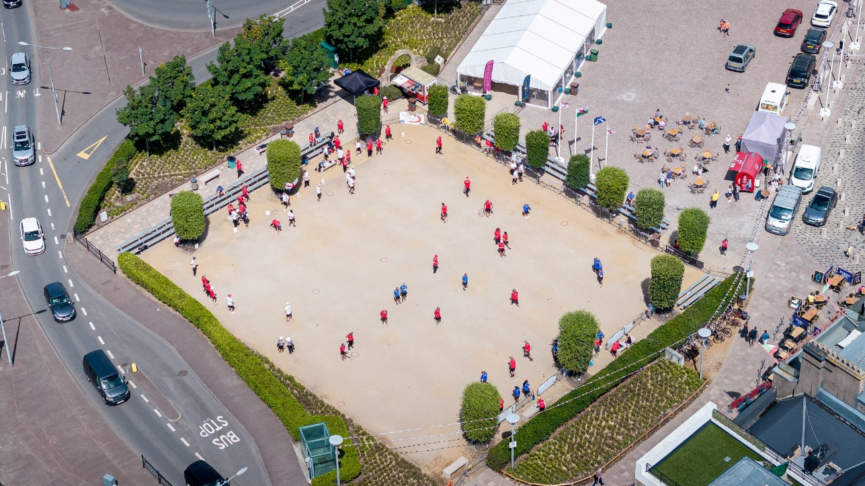

We are based in the Heart of Jersey’s Capital, St Helier surrounded by Bars, Restaurants, and the main shopping centre.

Following the success of our first International Open in 2022 and even greater success in 2023 and 2024 we have been encourage to put on another event in 2025. The event will be spread over the three days with a different competition to be held each day.

Friday - Open Singles Competition

Saturday - Open Doubles Competition

Sunday - Open Triples Competition

**Entry Fees and Prize Fund Breakdown**

**Entry Fees are as follows:**

**Singles - £20 per person**

**Doubles - £40 per team (£20pp)**

**Triples - £60 per team (£20pp)**

**Singles First Prize – Minimum starting amount of £200**

**Doubles First Prize – Minimum starting amount of £400 per team**

**Triples First Prize – Minimum starting amount of £300 per team**

**Once minimum entries have been met the prize fund will increase with each entry received thereafter.**

**Competition Format’s**

We will be using the Swiss System for all three competitions (As used in the European and World Championships).

Start Time is 8.45

Maximum Entries 40 Teams / Players (Maybe increased)

5 Qualifying Rounds

Timed Matches Singles 40 Minutes, Doubles 50 Minutes and Triples 50 Minutes. All + additional 1 end* increasing to 2 additional ends in the knockout stages.

Qualifying Criteria - Wins

- BHN (Opponents Wins)

- Points Difference

*Example with 32 Players / Teams

Top 16 Teams / Players through to Main Competition

Teams / Players finishing 17th to 32nd through to the Plate Competition.

Remaining Teams / Players eliminated from the competition

**\*Note: This is an example only and the exact format will be confirmed once final entry numbers are known.**

**Knockout stages - Last 16**

Last 16 Match 1 - 1st v 16th

Last 16 Match 2 - 2nd v 15th

Last 16 Match 3 - 3rd v 14th

Last 16 Match 4 - 4th v 13th

Last 16 Match 5 - 5th v 12th

Last 16 Match 6 - 6th v 11th

Last 16 Match 7 - 7th v 10th

Last 16 Match 8 - 8th v 9th

**Knockout Stages - Quarter-Finals**

Winner - Match 1 v Winner - Match 8

Winner - Match 2 v Winner - Match 7

Winner - Match 3 v Winner - Match 6

Winner - Match 4 v Winner - Match 5

**Knockout Stages - Semi-Finals**

Winner - Match 1 v Winner - Match 4

Winner - Match 2 v Winner - Match 3

**We will also be holding a Buffet Evening again this year on the Saturday Evening.**

**Links and Travel Information**

[**https://www.jersey.com/getting-here**](https://www.jersey.com/getting-here)

**Two Hotels right next to the terrains**

**The Royal Yacht**

[**https://www.guestreservations.com/the-royal-yacht/booking?msclkid=8baf2515ce0910ef1311441871889839**](https://www.guestreservations.com/the-royal-yacht/booking?msclkid=8baf2515ce0910ef1311441871889839)

**Pomme D’Or**

[**https://www.seymourhotels.com/pomme-dor-hotel/**](https://www.seymourhotels.com/pomme-dor-hotel/)

**or try** [**https://www.booking.com/**](https://www.booking.com/)

**There are also 2 Premier In in Jersey.**

**Club Contacts**

**Email: liberationpc@gmail.com**

**Website:** [**http://www.liberationpetanque.co.uk/**](http://www.liberationpetanque.co.uk/)

**Phone: (Toby) 01534 723442 or Mobile 07700 330537**

**Any Questions please let us know.**

**Kind Regards**

**Toby Northern**

**Chairman**

**Liberation Petanque Club**

*Please note the club holds the right to cancel the competition if there is an Insufficient number of teams who enter.



**International 2025 Open Competition - Weekend 25th to 27th July**

**Entry Form**

**Friday (26th July) - Open Singles Competition**

**SOLD OUT**

**Player 1** ____________________

**Email:** ____________________ **Contact No.** ____________________

**Saturday (27th July) - Open Doubles Competition**

**Player 1** ____________________ **Player 2** ____________________

**Email:** ____________________ **Contact No.** ____________________

**Email:** ____________________ **Contact No.** ____________________

**Sunday (28th July) - Open Triples Competition**

**Player 1** ____________________

**Email:** ____________________ **Contact No.** ____________________

**Player 2** ____________________

**Email:** ____________________ **Contact No.** ____________________

**Player 3** ____________________

**Email:** ____________________ **Contact No.** ____________________

**Buffet Evening**

**No. of People** ____________________ **£20 per person**

Please email entry forms to [liberationpc@gmail.com](mailto:liberationpc@gmail.com)

The clubs preferred method of payment is BACS which should be sent once entry has been confirmed. **To be Provided once entry confirmed.**

Alternatively, you can send this form and payment to Flat 5, Zeeland House, 6 Midvale Road, St Helier, JERSEY JE2 3YR