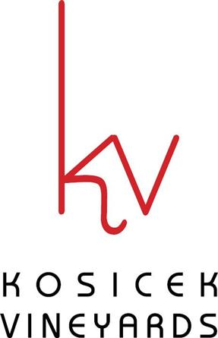

MONDAY-THURSDAY FOOD MENU
(KITCHEN CLOSES ONE HOUR BEFORE CLOSING)
Bread Dipping Plate
Warm Tuscan Boule bread, served with olive oil, balsamic vinegar, and herbs for dipping. $9.95
Flat Bread Pizza Slate
Four choices: $8.95
- Red sauce and cheese
- Red sauce, cheese, Slovenian sausage, and ham
- Seasoned olive oil and cheese
- Seasoned olive oil, cheese, and roasted red peppers

Soft Pretzel Sticks Four warm, soft pretzel sticks served with brewpub mustard and black raspberry dipping sauces. $9.95
Apple Strudel Baked fresh here at the winery. $3.50
Cheesecake Made locally by Simply Cheesecakes. $4.75 Beverages Soda (can) $1.25 Welch’s Grape Juice $1.25
Coffee $1.25 Bottled Water .93

