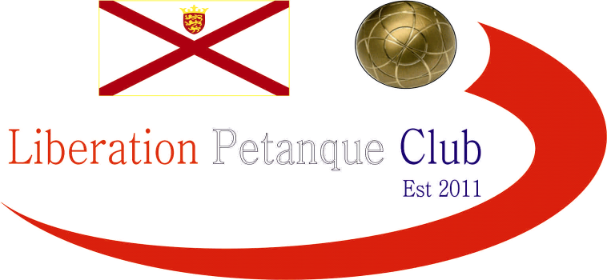

2022
MIXED DOUBLES OPEN

Only 7 teams entered this year, with Covid preventing 2017 winners Seb & Delphine from Guernsey taking part.

Round 1 saw champions Dawn Buckley & Geoffroy Buffetrille get the win due to a bye as their opponents were meant to be Seb & Delphine.

Kat Stewart & Paul Bell played 2019 winners Alice Ibitson & Matt Pinel and unfortunately struggled to get out of the starting block as Alice & Matt ran out 13 – 3 winners.

Callum & Jean Stewart played Karolina Zaorska & Laurent Pellaton and they also won big 13 – 4

Martin Schwartz & Mo De Gruchy played Andrew Bellamy-Burt & Cassie Stewart, with the latter leading the league table after round 1 with a 13 – 1 win.

Round 2

Alice & Matt had the bye so a 13 – 7 win.

Karolina & Laurent played Dawn & Geoffroy and were close to beating the champions just losing 13 – 11.

Andrew & Cassie played Kat & Paul beat Kat & Paul to be joint top after

Martin & Mo played Callum & Jean with the latter winning 13 – 5.

Round 3

Karolina & Laurent had the bye so got their first win.

Alice & Matt played Andrew & Cassie in what you would have expected to be a close match, but instead a comfortable scoreline at least as Alice & Matt won 13 – 2.

Dawn & Geoffroy played Martin & Mo winning 13 – 3 for three straight wins also.

Kat & Paul played Callum & Jean, with the latter also making it three from three going into the final round.

Round 4

Martin & Mo lost their last match 13 – 3 to Karolina & Laurent who finished 5th with two wins.

Andrew & Callum got the bye to get three wins and finish fourth qualifying for the semi finals.

Kat & Paul, lost a close match to Dawn & Geoffroy 13 – 11 to end with zero wins with Dawn & Geoffroy finishing second with four out of four.

Alice & Matt topped the table with a close win over Callum & Jean 13 – 9 with the latter finishing third..

So the final tables were as follows:

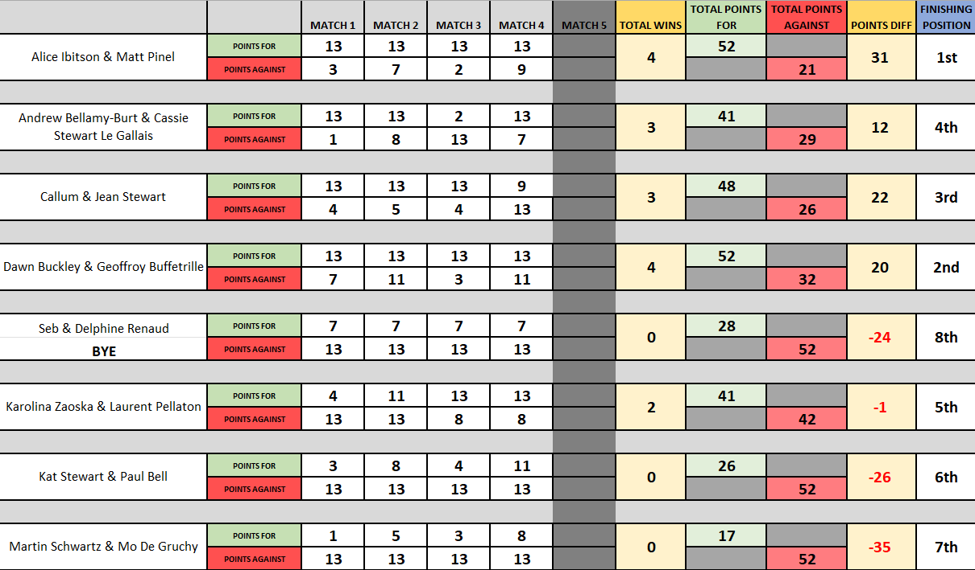

Semi Finals

Ranked 1st Ranked 4th

Alice Ibitson & Matt Pinel v Callum & Jean Stewart

Ranked 2nd Ranked 3rd

Dawn Buckley & Geoffroy Buffetrille v Andrew Bellamy-B & Cassie Stewart-LG

Alice & Matt again won heavily over Andrew & Cassie after a Round 3, 13 – 2 win this time won 13 – 3!

The second Semi-final though was very close and the third time in the competition that Dawn & Geoffroy won 13 – 11! This time against Callum & Jean.

Third Place went to Callum & Jean who beat Andrew & Cassie 13 – 10 in a very closely contested match.

The final though was as close as it could get with four titles between them. In the end it was 2019 winners Alice Ibitson & Matt Pinel who just won 13 – 12 as Dawn Buckley & Geoffroy Buffetrille had to settle for the Runners up spot.

2022 - Winners

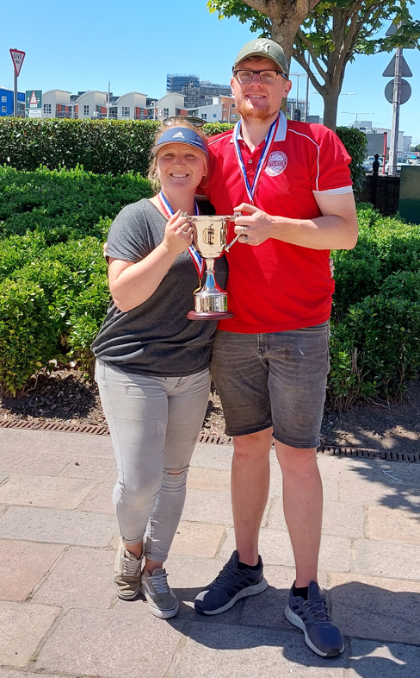

Special thanks to Matt Pinel for running the competition on the day and anyone else who helped out.

Sponsored by



CoinShares | Digital Asset Investment Strategies for Professionals 🚀

NEXT WEEK - SINGLES LEAGUE

Club email address - liberationpc@gmail.com

Club Website - www.liberationpetanque.co.uk

Kind Regards

Toby Northern

Chairman

Liberation Petanque Club

