MEDICAL RESPONSE INSTITUTE
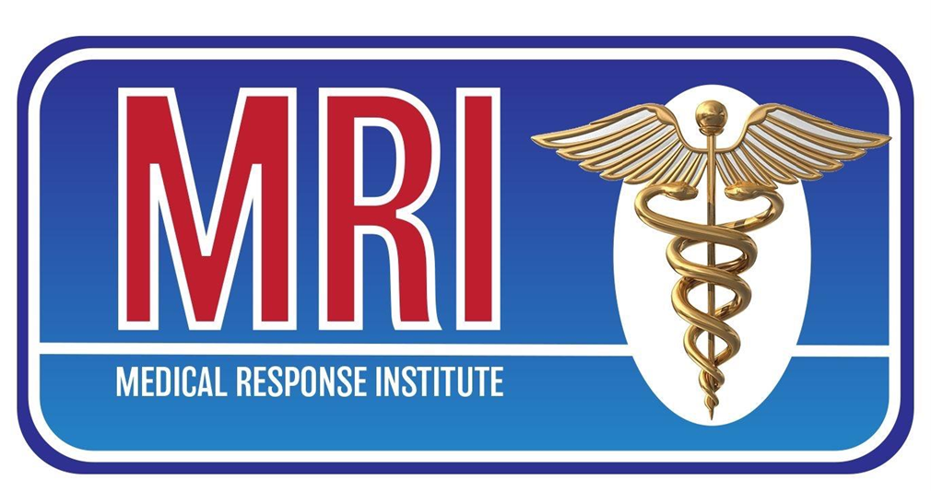

STUDENT HANDBOOK

MEDICAL ASSISTANT AND PHLEBOTOMY TRAINING

AFFORDABLE CLASSES
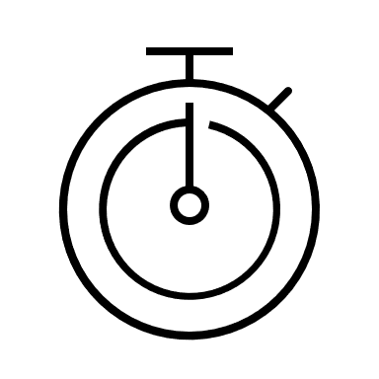
SHORT TIME FRAME PROFESSIONAL EDUCATION

TABLE OF CONTENTS

ABOUT US…………………………………………………………………………..………….03
OWNER & FACULTY………………………………………………………………………...04

MISSION & VISION…………………………………………………………………………..05

ACADEMIC CALENDAR……………………………………………………………………05

PROGRAM DESCRIPTION………………………………………………………….………06

ENROLLMENT PROCEDURES…………………………………………………………….06

CLASS REQUIREMENTS……………………………………………………………………07

FINANCIAL ASSISTANCE…………………………………………………………………..07

POLICIES AND PROCEDURES…………………………………………………………….08

ADMISSION REQUIREMENTS.………………………………………………………….…09

CANCELLATION/REFUND POLICY………………………………………………………11

ATTENDANCE POLICY……………………………………………………………………..12

COPYRIGHT POLICY………………………………………………………………………..12

ABOUT US

MRI was established to meet a real need in a real world. Most people don't have two years to get an associate degree. MRI packs 200 classroom hours into 10 weeks, learning at a high level of competency. Upon completion of school the students then can get 40 clinical hours. Students are then eligible to take their national exams as Certified Medical Assistants AND Phlebotomy Technicians. The Medical Assistant job will continue to be the number 1 fastest growing field in the medical industry per the US Dept of Labor through 2025. With a major push toward Vocational type skills it was very important that an educational opportunity be created that is Affordable, Shorter Time Frame and Professional. MRI has a proven track record and even though we are a privately owned small school our students are making a major impact in the medical work force.

The Medical Assistant job will continue to be the number 1 fastest growing field in the medical industry per the US Dept of Labor. With a major push toward Vocational type skills it was very important that an educational opportunity be created that is Affordable, Shorter Time Frame and Professional. MRI has a proven track record in Middle Tennessee and even though we are a privately owned small school our students are making a major impact in the medical work force.

MRI’s MISSION is to help an individual begin their journey into the Medical Industry with a high level of confidence and a greater desire to affect the people in their community.
MEDICAL RESPONSE INSTITUTE is authorized by the Tennessee Higher Education Commission. This authorization must be renewed each year and is based on an evaluation by minimum standards concerning quality of education, ethical business practices, health and safety, and fiscal responsibility.
OWNER AND FACULTY

DIRECTOR/OWNER: James B. Miller

Photo Not Available

LEAD INSTRUCTOR: Rose Bryant, RN

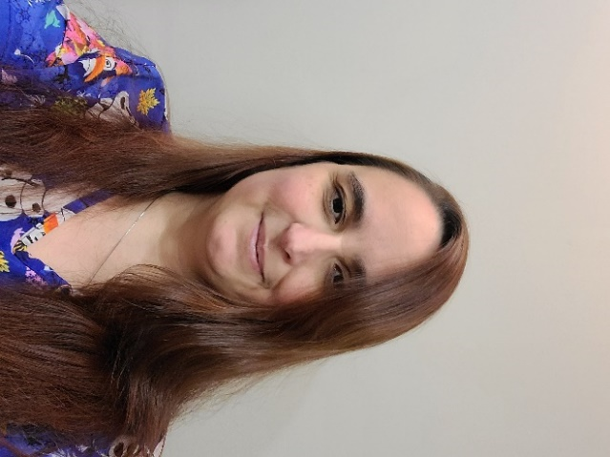

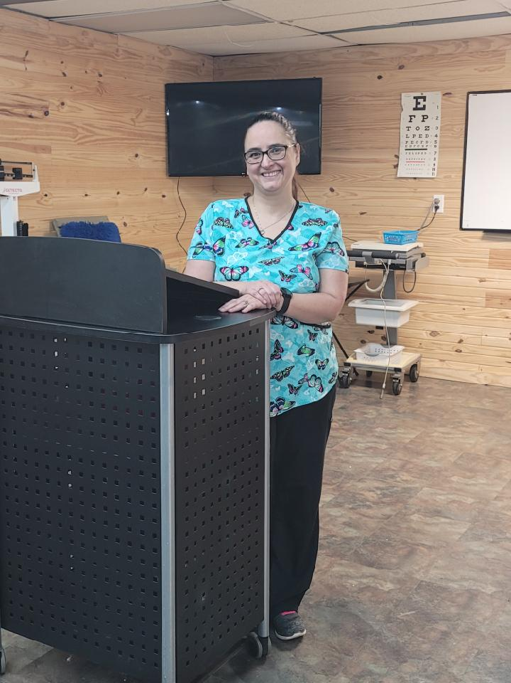

MISSION AND VISION STATEMENT

**MISSION STATEMENT**

​MRI PROVIDES EXCEPTIONAL, AFFORDABLE TRAINING TO HELPSTUDENTS QUICKLY ATTAIN THEIR GOALS OF SERVING OTHERS IN THEIR LOCAL COMMUNITY BY WORKING IN THE MEDICAL FIELD

**VISION STATEMENT**

Our vision for Tennessee is to be able to provide an extremely high-quality education at an extremely low cost. Education should not handicap a student financially. I know it is possible to accomplish that task by keeping overhead as low as possible. We invest our money in instructors and not a fancy structure. The purpose of the education is to assist the student in pursuing their career dreams. A building looks nice, but an instructor can make a difference in a life. MRI is so proud to be a part of that dream. Our system is proven and successful, thank you for trusting MRI with a part of your future.

CLASS SCHEDULES

Class is every Monday – Friday 5PM – 9 PM for 10 weeks. The 2022-year classes are as follows:

TERM CLASSES BEGIN CLASSES END

WINTER 2022 January 10, 2022 March 18, 2022

SPRING 2022 March 28, 2022 June 3, 2022

SUMMER 2022 June 13, 2022 August 26, 2022

FALL 2022 September 6, 2022 November 11, 2022

PROGRAM DESCRIPTION

This program is designed to teach students the skills necessary for employment in the modern medical facility as a Medical Assistant. A qualified medical assistant can perform a wide range of duties, with a variety of technical detail, helping the physician in many clinical and administrative situations. The ratio of students to instructors in both classroom and lab is 20:2.

Throughout the Medical Assistant/Phlebotomy Training Course, an individual will have a total of 300 contact hours, including classroom and laboratory time. The clinical and classroom aspect of the Medical Assistant Training includes patient care, communication, office administration, medical law, and ethics. In the Phlebotomy Section of the Medical Assistant Training students are taught patient preparation, collection techniques, processing, and safety and compliance consideration. EKG monitoring and all aspects of it are covered. Importance is given to coding and billing; included in this area are anatomy and physiology, medical terminology, coding, insurance principles, claims processing and compliance, and ethics. Upon successful completion of this course, students will receive a certificate of completion and will be eligible for National Certification.
ENROLLMENT PROCEDURES

There is no pre-requisite class to take the Medical Assistant Training course. Students should be at least 18 years of age and have a reliable way of transit to class. MRI participates in the THEC option for students that do not have a GED/equivalent or high school diploma by using a short entrance exam to determine reading capability. The program is relatively short in nature (2 months and 2 weeks) and fees are as follows:

Registration Fee ...................$200
Tuition.................................$2000
Testing Fees..........................$240
Book Rental............................$40
Cap & Gown...........................$50
Total Cost to Student…….$2,530

The $240 testing fee is paid to NCCT by students that complete the course and choose to take NCCT national certification exams. The completion of our MA program is required by NCCT before students are eligible to take their exams. Each student has an option to take the exams or not to take them. Our instructor will assist each student in getting registered with NCCT and setting up their exam dates. MRI is a national test site; therefore, students do not have to travel to take their national exams. Registration Fee is non-refundable. Tuition Refunds are state regulated and refunded at the percentages regulated by the THEC.

*Registration Fee is non-refundable
CERTIFICATION EXAM

MRI is a completion course; upon completion of the course each student receives a diploma from Medical Response Institute. Completion of this course qualifies each student to take national certification exams with the NCCT. MRI is a national test site.

STUDENTS’ RIGHTS

Students have the right to inspect and review information in their education records. They may request a correction to their record. To file a complaint: Contact U.S. Department of Education Family Policy Compliance Office, 600 Independence Ave, SW, Washington, DC 20202.

CLINICAL & CLASSROOM REQUIREMENTS

- Textbook” Kinn’s Medical Assistant 14th edition
- Watch with second hand
- Stethoscope (available for $20-$25)
- Paper and Black ink pen – Clinical
- Paper and Pen – Classroom

There are no additional requirements for the class such as CPR, immunizations, medical physical exams, background checks or drug tests. Though they are made available to our students for an additional fee.

Students are eligible for clinical hours upon completion of their MA program. Clinical hours are required for the completion of the Medical Assistant Course. It is highly recommended that students take advantage of the clinical experience to provide them hands on opportunity to assist in seeking employment.

OTHER SERVICES
Medical Response Institute does NOT offer other student services such as…housing.

FINANCIAL AID/FINANCIAL ASSISTANCE
MRI does offer financial assistance, but currently does NOT offer or receive state or federal funding.
ADMISSION REQUIREMENTS

GED or equivalent is required by NCCT to take the national exam. Students must have a prior grade point average of 2.5 or 75% to enroll in MRI. Students will be preparing to become Medical Assistants. MRI accepts cash, checks, money orders, cashier checks and most credit cards. The method used for collecting delinquent tuition at MRI is very fair and consistent for all students. If a student does not have all tuition paid in full by the end of class, they may be transferred to the next class at no cost to the student. Diploma will be released immediately upon full payment of account. *Exceptions may apply.

MRI offers all former students the ability to...
- Sit through the program as a refresher in case the student was delayed in reaching the field of work desired (at no cost to the student).
- Sit through the program, if they failed to pass their national exams, to have a better opportunity to pass the exams on the re-take.

HIPAA CONFIDENTIALITY STATEMENT

Students at Medical Response Institute at no time shall discuss a patient, the patient’s health, or the patient’s healthcare outside of the clinical or classroom setting. At no time shall a patient, their family, or their healthcare be discussed in hallways, elevators, or public access areas.

POLICIES AND PROCEDURES

TRANSFERABILITY OF CREDITS/CONTACT HOURS POLICY
Medical Response Institute is a special purpose institution. That purpose is to train Medical Assistants. This purpose does not include preparing students for further college study. MRI provides contact hours. Contact hours do not translate directly into credit hours. Students should be aware that transfer of contact hours from Medical Response Institute is always the responsibility of the receiving institution and MRI does not guarantee that the students contact hours at MRI will be accepted by any other institute. Whether or not contact hours transfer is solely up to the receiving institution. Any student interested in transferring contact hours should check with the receiving institution directly to determine to what extent, if any, contact hours can be transferred. Because the job of a Medical Assistant is a vocational training there are very few credits available for transfer from another school.

MRI provides a completion diploma for students. That diploma is required by the Certification companies for Medical Assistants. MRI is responsible to provide sufficient training to provide the student the opportunity to take the exams and the best possible chance of passing their National Exams. Those exams are only available to students that complete training from a qualified institution.

50 live sticks are required by MRI to complete the Phlebotomy portion of the program. The student will still be required to attend the classroom instructional portion of the program if MRI determines that the students Phlebotomy training is adequate then “Credit” can be awarded to any student from their former educational training for the 50 live sticks if it was completed within two years (Certification Company policy) of the entrance of MRI and is accompanied by a document from the former institution verifying the 50 live sticks. This will allow MRI to have this information in the students file to provide support for any audits made by the Certification Company that MRI is following their policies. The student will still be required to show proficiency in the Phlebotomy skill to MRI instructor to pass the MRI program. MRI will credit to the students account $50.00 the cost of equipment used for Phlebotomy training. This amount will be subtracted from the total cost of the tuition. MRI will also provide institutions a copy of the students file including Diploma, test scores and Phlebotomy completion sheets upon the request for “credit Transfer”. MRI will attempt to comply with any institute requesting such information either by faxing or emailing information to the appropriate personnel.

RECRUITING POLICIES
Recruiting for the Medical Assistant Training program is primarily done through local papers, website, and word of mouth. There are no pre-requisites prior to taking any course at MRI. MRI does not discriminate based on sex, race, ethnic origin, or religion. MRI is not fully equipped at this time for many special needs. Please see Grading Policy and Facility There are not any conditions or relevant state requirements that may adversely impact the student’s ability to benefit from training or certification testing.

UNIFORM POLICY
Uniforms are described here as scrubs. During class and clinical hours students will be required to wear scrubs. Students will provide their own uniforms. The uniform must be clean, neat, and pressed. Shoes must be closed toed and may not be made of a canvas material.

HAIR & NAILS POLICY
Hair must be worn up off the neck and not cover the face or fall in the face during clinical hours. Fingernails must be neat, clean, and rounded not pointed. Nails must be short enough to prevent scratching patients when providing care. During clinical care no artificial nails, no overlay wraps (silk) and no chipped nail polish is allowed.

PLACEMENT ASSISTANCE POLICY
Medical Response provides graduating students job placement assistance by offering interview training, and classes on resume’ writing. MRI does not guarantee employment.

GRADING POLICY
The Medical Assistant Training is a Pass/Fail course based upon attendance, performance, and clinical/laboratory procedures. Medical Response Institute provides a “Certificate of Completion” upon completion of the course. National certifications are available to those who complete the course with an additional cost per exam paid to the certification company.

Students are required to complete fifty (50) live phlebotomy sticks prior to the certification exam. No exam will be given unless all phlebotomy requirements are met, all exam fees have been paid, and Medical Response Institute fees have been paid in full by the eighth week of class.

Grades in class are determined by the average score of tests, quizzes, and project. Quizzes and Project completion will add 3 points to final grade. 75% is the passing grade for MRI Students.

(National exam minimum passing score is 70%)

*For students with dyslexia extra time is given during testing and notes may be given.

SATISFACTORY ACADEMIC PROGRESS POLICY – CLOCK HOURS
MRI is 300 clock hours. Satisfactory progress is evaluated every week throughout the program. After every exam the students and instructor will know the students current ongoing average for the class. To be making satisfactory academic progress, a student must attend at least 90% of the scheduled class hours on a cumulative basis during each evaluation period.

The student’s academic average is reviewed to determine qualitative progress. The minimum required is 75% at the conclusion of the program. An exam is given at the end of sections in the Textbook (between 8-10 exams over the period of the 10-week program). Students must retake any test in which they earn less than a 60%. After failure to score above a 60% on the first exam the student will receive counseling and be reminded of the average score necessary to complete the course. The student will be given the opportunity to request tutoring.

If the student fails to meet the cumulative 85% attendance or 75% grade average from week to week, then the student is counseled and advised as to the necessary Exam grades required on each of the following exams to complete the course. At the end of the 5th week of the program, If the student is not averaging a percentage high enough to achieve completion, the student is then advised at that point if it is still possible to complete the course by scoring high enough on each remaining test to achieve a Pass Rate of 75% in the final week.

Failure to be able to achieve (due to very low-test scores), by the end of the program either 85% attendance or a 75% grade average, will result in the administrative withdrawal of the student. If the student still has a reasonable ability to raise their test average to 75% to complete the course, the student will be placed on WARNING. Students will be notified in writing when they are placed on WARNING and the steps necessary to be removed from WARNING status. Students will also receive attendance or academic counseling, from the Lead Instructor, as appropriate, when they are placed on WARNING. The institution will notify a student by mail if he or she is being administratively withdrawn for unsatisfactory academic progress and the inability to score high enough on the remaining exams to achieve a test score avg of 75%.

STUDENT CONDUCT POLICY
Student conduct during all aspects of the Medical Assistant Training course must always remain professional. Students will maintain a professional attitude and appearance in the classroom and in the clinical setting, anything other than professionalism will not be tolerated. Students face expulsion for unauthorized use/distribution of COPYRIGHTED MATERIALS. Students may face civil/criminal liabilities for unauthorized use/distribution of COPYRIGHTED MATERIALS.

CANCELLATION AND REFUND POLICY
MRI has a fair and equitable refund policy which governs the repayment of a student as follows: MRI per THEC requires written or verbal notification of withdrawal by student to maintain proper records keeping by MRI for THEC. This notice is not required to provide proper refunds to student. The following information will be documented and used to calculate refunds for each student that cancels, withdraws or is withdrawn from training. This documentation will be sufficient to demonstrate that refunds are timely and accurate.

- Start Date
- Last Date of Attendance
- Date of Determination
- Charges to the student
- Total amount paid
- Weeks earned and resulting percentage of program completed
- Calculation of Refund

If the student never attends class for the period of enrollment for which he or she was charged; or the student withdrawals, drops out, is expelled from MRI, or otherwise fails to complete the period of enrollment for which he or she was charged all refunds must be made within 45 days of the start of the 1st day of class or 45 days from initial registration (or whichever is earliest).

If a student withdraws from MRI on or before the first day of classes or fails to begin classes, the refund shall equal the sum of all fees paid for the period of enrollment, less the non-refundable registration fee of $200.

For an enrolled student, the refund due must be calculated using the last date of attendance and be paid within forty-five days from the documented date of determination. The DOD is the date the student gives written or verbal notice of withdrawal MRI, or the date MRI terminates the student. In short, all refunds will be paid within 45 days of notification from student. The non-refundable registration fee of $200 is maintained by MRI and is not in consideration used by the formal to calculate a refund for the student.

If MRI discontinues class or terminates the program, all fees paid including Registration fees will be refunded.

In determining the number of weeks completed by a student in consideration for a refund. MRI considers one full week completed if the student attends one day. If a student withdraws or is withdrawn from MRI during the first week of class, the Refund percentage will be 90% to the student, calculated on the length of the program being 10 weeks in length.

After the first week and up through the end of week 5 (50% of the ten-week program) the refund is pro-rated at 10% per week. Ex. Number of weeks student completed 3 of 10 = 33.3%, pro-rated 33.3% = $666, administration fee = $100

Tuition…………$2000
Admin - $100
Pro-rate - $666
Student refund…$1234

WITHDRAWAL PROCEDURES
Students that withdraw from the Medical Assistance Training course are encouraged do so in writing either by mail or email; however, it is not required. If a refund is applicable, it will be reimbursed as described under Refund Policies.

ATTENDANCE POLICY
Consecutive & Non-consecutive days: Students taking the Medical Assistant Training course must be present for 90% of contact hours to receive a Certificate of Completion from cumulative attendance. The Attendance Policy is stated as such that no student shall be absent for three consecutive days or five non-consecutive days.

Communicate with your instructor to avoid any problems. In the event of prior approval or an emergency the student will be given an opportunity to provide make up work. The student must provide makeup work within three classroom dates.

Students with excused absences may get in touch with the instructor for class notes missed.

3 tardies equal 1 day absent
3 early departures equal 1 day absent

ANTI-DISCRIMINATION POLICY
MRI does not discriminate on the basis of sex, race, ethnic origin or religion.

CAMPUS SECURITY POLICY
Medical Response Institute has a no security policy. Students are responsible for the safekeeping of their belongings.
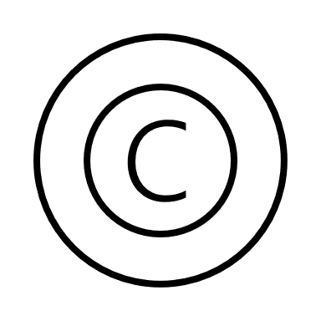
MRI COPYRIGHT POLICY

SINGLE COPIES FOR EDUCATIONAL USE
Teachers are permitted to make a single copy of an excerpt of copyrighted print material for use in researching or otherwise preparing to teach a class. This generally includes, for example, a chapter from a book or a single article from a newspaper or magazine. An excerpt from a work cannot be more than 1,000 words or 10 percent of the work, whichever is less. Students may copy portions of books under the fair use copyright exemption, provided copying is not being used as a substitute for buying a textbook.

CLASSROOM USE
A teacher may make one copy per student of copyrighted print material for classroom discussion and use, provided each copy includes a copyright notice and meets statutory tests for brevity, spontaneity, and cumulative effect. To pass the brevity test, the portion copied should be an excerpt of the whole. For example, a story or essay copied should be less than 2,500 words. If the teacher made the decision to copy the material from an instant inspiration such that requesting permission would be unreasonable, the copying satisfies the spontaneity requirement. Finally, the cumulative effect requirement dictates the copying can be only for one class, in one class term, with no more than nine instances of multiple copying in one class term.

PROHIBITIONS
Teachers may not make copies of workbooks, tests, or other material intended to be consumable during study. Copying must come from the individual teacher’s inspiration and cannot be directed by a supervisor. Teachers should not use copying to take the place of purchasing needed materials. Finally, students making copies for educational purposes cannot be charged by non-profit schools more than the actual cost of photocopying.

FAIR USE
Copying that does not fall within the confines of the agreement may still qualify as fair use. Fair use is an exception to the exclusive rights of copyright holders. Fair use is a defense that a teacher could raise if sued for copyright infringement. Courts look at the purpose of the use, the nature of the work copied, the amount of the copyrighted work that was copied, and the effect of that copying on the market for the copyrighted work. Although many instances of using copyrighted material in a noncommercial, nonprofit educational context are considered fair use, there is never any guarantee of this, because the balancing of the factors depends on the analysis of the judge in an infringement case.

COPYRIGHT VIOLATIONS
Copies cannot be used as a substitute for purchasing a copyrighted work and there are instances in which copying clearly does not qualify as fair use. For example, if a teacher copies an entire text because her budget does not allow her to purchase textbooks for each child, she has likely violated copyright law. Teachers also cannot reproduce videos for classroom use, though they may be able to use videos in the classroom and can make copies for archival purposes if replacements are unavailable or available only in obsolete formats.

PUBLIC DOMAIN
Some works are considered public domain and, as such, are not copyrighted. These works can be used freely by teachers without concern that they are violating copyright laws, and teachers do not have to worry about fair use when using works in the public domain. These works include items created by federal government employees as part of their jobs, such as manuscripts from the Federal Writers' Project or other written or photographic material produced by persons working for federal agencies. Teachers can copy these works for classroom projects or other classroom use without first obtaining permission.

GRIEVANCE PROCEDURE

If a student has a complaint with an instructor, another student, a faculty member, or member of the facility, he or she may contact James B. Miller, the director/CEO, in writing at 1155 South College Street, Winchester, TN 37398, by email at jimbofur@yahoo.com, or by phone at 901-282-9438.

When issues arise, students should make every attempt to find a fair and reasonable solution through the institution’s internal complaint procedure, which is required by ACCET and frequently requires the submission of a written complaint. Note that ACCET will process complaints which involve ACCET standards and policies and, therefore, are within the scope of the accrediting agency. If a student has exercised the institution's formal student complaint procedure, and the problems or issues have not been resolved, the student has the right and is encouraged to take the following steps:

1. Complaints should be submitted in writing (by email or mail) to the ACCET office. Complaints received by phone will be documented; however, the complainant will be requested to subsequently submit the complaint in writing.
2. The written complaint must contain the following information:
a) Name and location of the institution.
b) A detailed description of the alleged problem(s).
c) The approximate date(s) that the problem(s) occurred.
d) The names and titles/positions of all individual(s) involved in the problem(s), including faculty, staff, and/or other student). What was previously done to resolve the complaint, along with evidence demonstrating that the institution's complaint procedure was followed prior to contacting ACCET;
f) The name, email address, telephone number, and mailing address of the complainant. If the complainant specifically requests that anonymity be maintained, ACCET will not reveal his or her name to the institution involved; and
g) The status of the complainant with the institution (e.g., current student, former student, etc.).
3. In addition to the written complaint, copies of any relevant supporting documentation should be forwarded to ACCET (e.g., student’s enrollment agreement, syllabus or course outline, correspondence between the student and the institution).
4. SEND TO: ACCET CHAIR, COMPLAINT REVIEW COMMITTEE 1722 N Street, NW Washington, DC 20036 Telephone: (202) 955-1113 Email: complaints@accet.org Website: www.accet

Note: Complainants will receive an acknowledgement of receipt within 15 days.

Facility Description
1155 South College St
Winchester, TN 37398

The building is approximately 1000sq ft of classroom space.
300sq ft of common area.
One-bathroom 150sq ft

SIGNATURE & DATE OF DIRECTOR/CEO TO VERIFY RECENT HANDBOOK

I certify by signature on this date March 28, 2022 this is a true and correct copy of the document that will be used during the term of this application Rose A Bryant, RN/Lead Instructor, Medical Response Institute.

