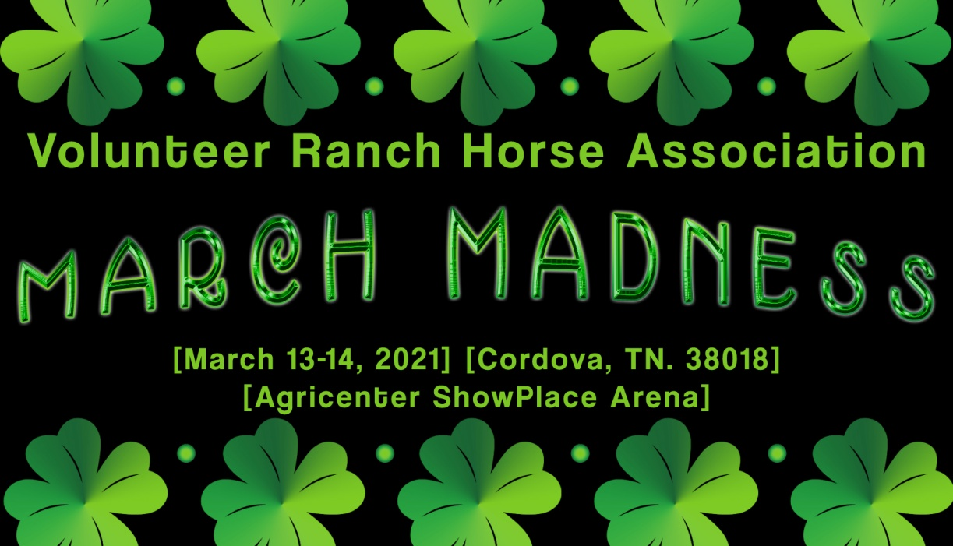

CLASS |  | ADD BACK | OFFICE FEE | JUDGE FEE | CATTLE FEE | NRCHA FEE | TOTAL ENTRY | ADDED MONEY
OPEN BRIDLE |  | $60 | $40 | $17 | $30 | $8 | $155 | $300
INT OPEN BRIDLE - MUST SHOW IN OPEN BRIDLE |  | $45 | $30 | $17 |  | $8 | $100 | $50
LTD OPEN BRIDLE |  | $45 | $30 | $17 | $30 | $8 | $130 | $50
NON PRO BRIDLE |  | $45 | $30 | $17 | $30 | $8 | $130 | $50
INT NON PRO BRIDLE |  | $45 | $30 | $17 | $30 | $8 | $130 | $50
NOV NON PRO BRIDLE |  | $30 | $20 | $17 | $30 | $8 | $105 | $50
OPEN HACKAMORE |  | $60 | $40 | $17 | $30 | $8 | $155 | $300
INT OPEN HACKAMORE - MUST SHOW OPEN HACKAMORE |  | $45 | $30 | $17 |  | $8 | $100 | $50
LTD OPEN HACKAMORE |  | $45 | $30 | $17 | $30 | $8 | $130 | $50
NON PRO HACKAMORE |  | $45 | $30 | $17 | $30 | $8 | $130 | $50
OPEN TWO REIN |  | $30 | $20 | $17 | $30 | $8 | $105 | $50
NON PRO TWO REIN |  | $30 | $20 | $17 | $30 | $8 | $105 | $50
YOUT BRIDLE |  | $9 | $6 | $17 | $30 | $8 | $70
YOUTH BRIDLE 13 & U |  |  |  |  |  | $8 | $8
BEGINNING FENCE WORK |  | $21 | $14 | $17 | $30 | $8 | $90
NON PRO LTD |  | $30 | $20 | $17 | $30 | $8 | $105 | $50
5K NON PRO LTD |  | $21 | $14 | $17 | $30 | $8 | $90
1K NON PRO LTD |  | $21 | $14 | $17 | $30 | $8 | $90
YOUTH LTD |  | $9 | $6 | $17 | $30 | $8 | $70
YOUTH LTD 13 & U |  |  |  |  |  | $8 | $8
VolRHA Non-Cattle Classes |  |  |  |  |  |  | $25
VolRHA Cattle Classes |  |  |  |  |  |  | $55
AQHA |  |  |  |  |  |  | $30
AQHA w/ Cattle |  |  |  |  |  |  | $60

