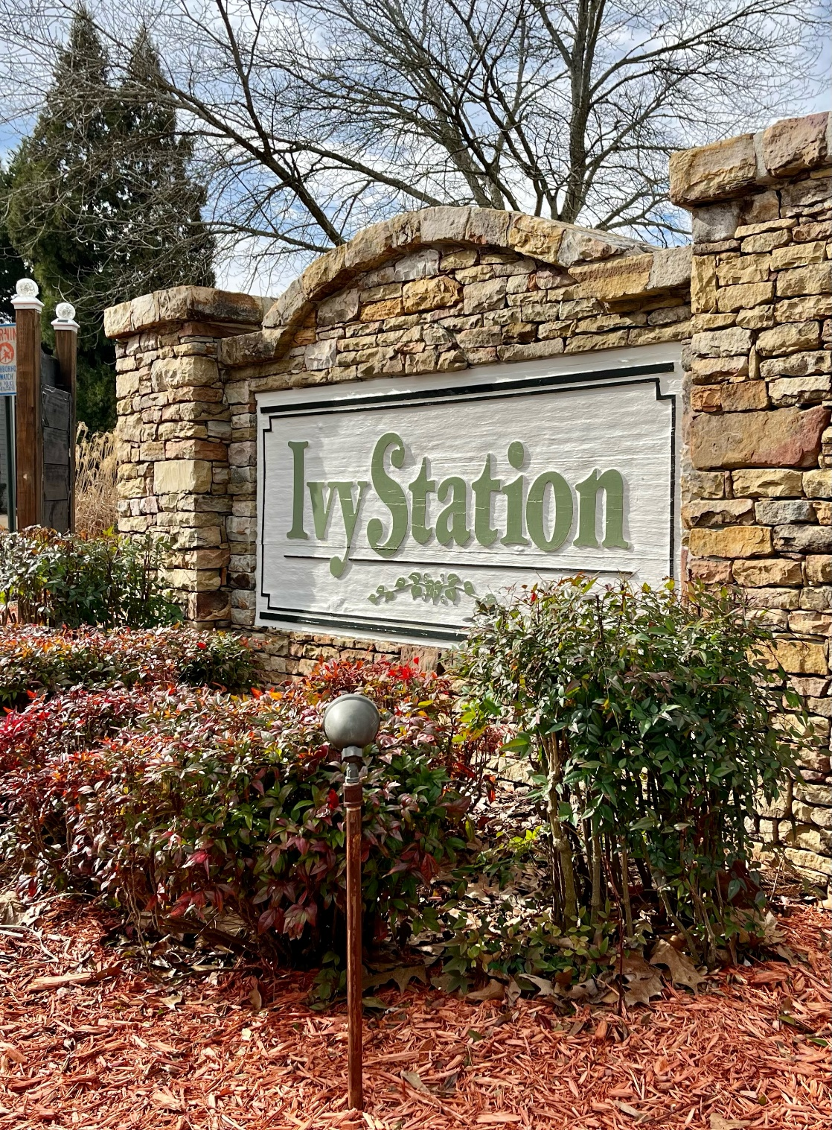

**2023**

April

*Creating Curb Appeal*

the City of Duluth Police will check on your home when you’re on vacation?

*Making a good first impression counts!*

*Creating Curb Appeal*

*Upcoming Events*

*Springtime Crossword Puzzle*

*Reminders*

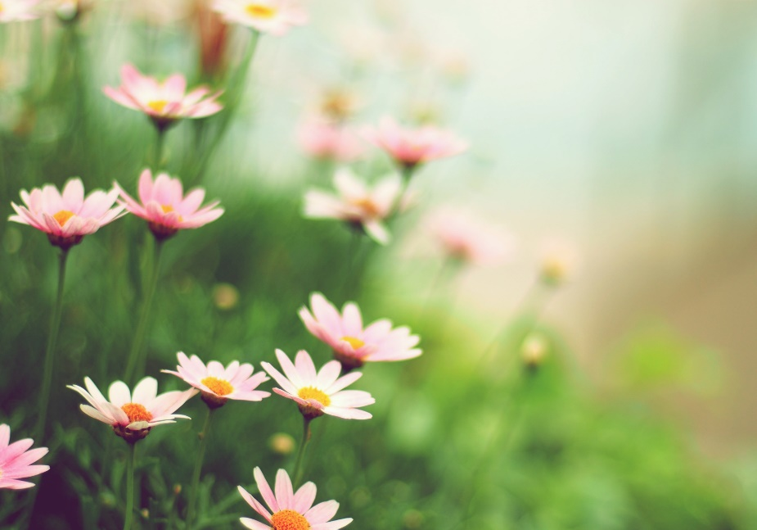

***in this issue >>>***

Landscaping – Another not so expensive way to improve curb appeal is to pull weeds from flower beds and add a few perennials. Perennials are more expensive but will come back every year. Hostas are a great option for those who have a lot of shade in their front yards. They grow bigger each year. Daylilies are another great perennial. They stay full and bloom all spring and summer and add a pop of color. They do great in full sun. Another way to improve your yard’s look is to add mulch or pine straw to flower beds after they’ve been weeded. It looks great and helps control weeds. Keeping hedges and bushes trimmed can give your yard a cleaner, well-maintained look.

Lighting – Changing out old or broken light fixtures is another quick and fairly inexpensive way to improve your curb appeal.

Painting – Painting can spruce up your home’s exterior. Even painting the door and shutters can make an improvement.

Well maintained

landscaping and

decorative painting

will help spruce up

a home's exterior

***Did you know…***

Fill out the form online to request this free service:

[www.duluthga.net](http://www.duluthga.net)

Services -> I want to -> Request Vacation House Check

Curb appeal is the way your home looks from the outside or from the street, and how attractive it is to anyone who visits or drives past.

*.*

Cleaning – This could involve getting your home’s exterior power washed. Also, power washing walkways and driveways makes a huge improvement without needing to spend a lot. Washing doors and windows is an easy and inexpensive way to make a difference as well. Getting gutters cleaned can also help give your home an overall cleaner look.

***Ivy Station Newsletter***

**For Residents of the Ivy Station Community in Duluth GA**



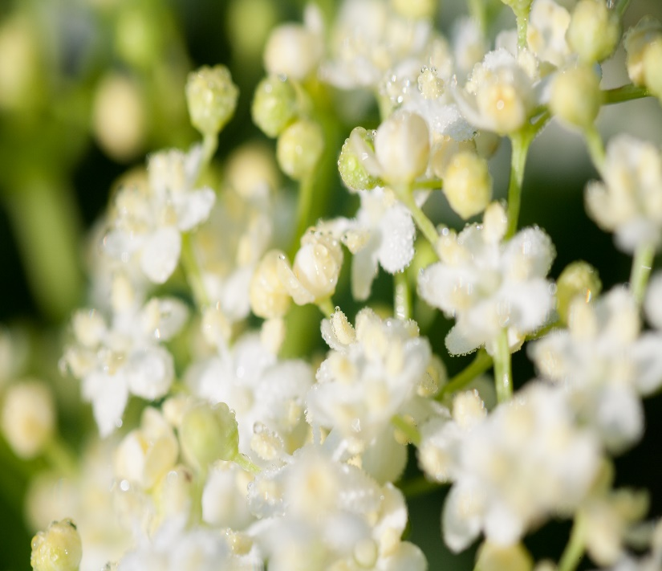

Annual HOA Dues are due by March 31st. Please send in your payment timely to avoid late fees.

Duluth Parking Ordinance – No parking on city streets (including Ivy Station streets) from 10 pm to 6 am. Violators will be ticketed by the City of Duluth.

Please remember to pick up pet waste when walking your pets.

Please don’t feed stray cats.

All outdoor pets must have a collar.

Front yards need to be weed-free.

The HOA Board is still in need of an ACC Chairperson. Send an email to [ivystationduluth@gmail.com](mailto:ivystationduluth@gmail.com) if you’re interested.

April 8, 4-5 pm Easter Egg Hunt (Location 4195)

April 10, 5-6 pm HOA Meeting (Location 4010)

May 6, 6-8 pm Outdoor Game Night (Location 3895)

May 8, 5-6 pm HOA Meeting (Location TBD)

May 20, 9-2 pm Neighborhood Clean Up Day – Dumpster (Location 4030) and Food Drive (Boy Scouts will pick up non-perishable food items left at your front door, or you can bring items to 4050)

***Calling all Graduates…***

Do you have a student graduating from high school or college this Spring? If so, please email us their name and school so we can add them to our Congratulations Graduates banner.

*Finding An Agent That’s Right For You*

*Reminders*

***Contact Us***

Email: [ivystationduluth@gmail.com](mailto:ivystationduluth@gmail.com)

Website:

[www.ivystation.org](http://www.ivystation.org)

Facebook Page:

Ivy Station HOA

***Upcoming Events***

***ask the experts >>>***

ACROSS

4. these bring May flowers

5. achoo! (watch out for this)

6. these little guys turn into plants

8. type of dress popular in Springtime

DOWN

1. kick it to me (sport)

2. beautiful red birds

3. fire up the grill for this

7. tall, Springtime flowers

9. flowering tree that starts with ‘d’ and ends with ‘d’

<< Here’s a letter we received last year thanking us for the food donations during last year’s food drive. Let’s do it again this year!

**Springtime Crossword Puzzle**

aliquam erat volutpat. Nam liber tempor cum soluta nobis sed.

.