SPECIAL MEETING
DECEMBER 29, 2014

A Special Meeting of the Town Board of the Town of Hampton, County of Washington and the State of New York was held at the Town Hall, 2629 State Route 22A, Hampton, New York on the 29th day of December, 2014.

PRESENT: David K. O’Brien----------Supervisor
Tamme Taran---------------Councilwoman
David Jensen----------------Councilman
Donald Sady----------------Councilman
Andrea Sweeney-----------Councilwoman
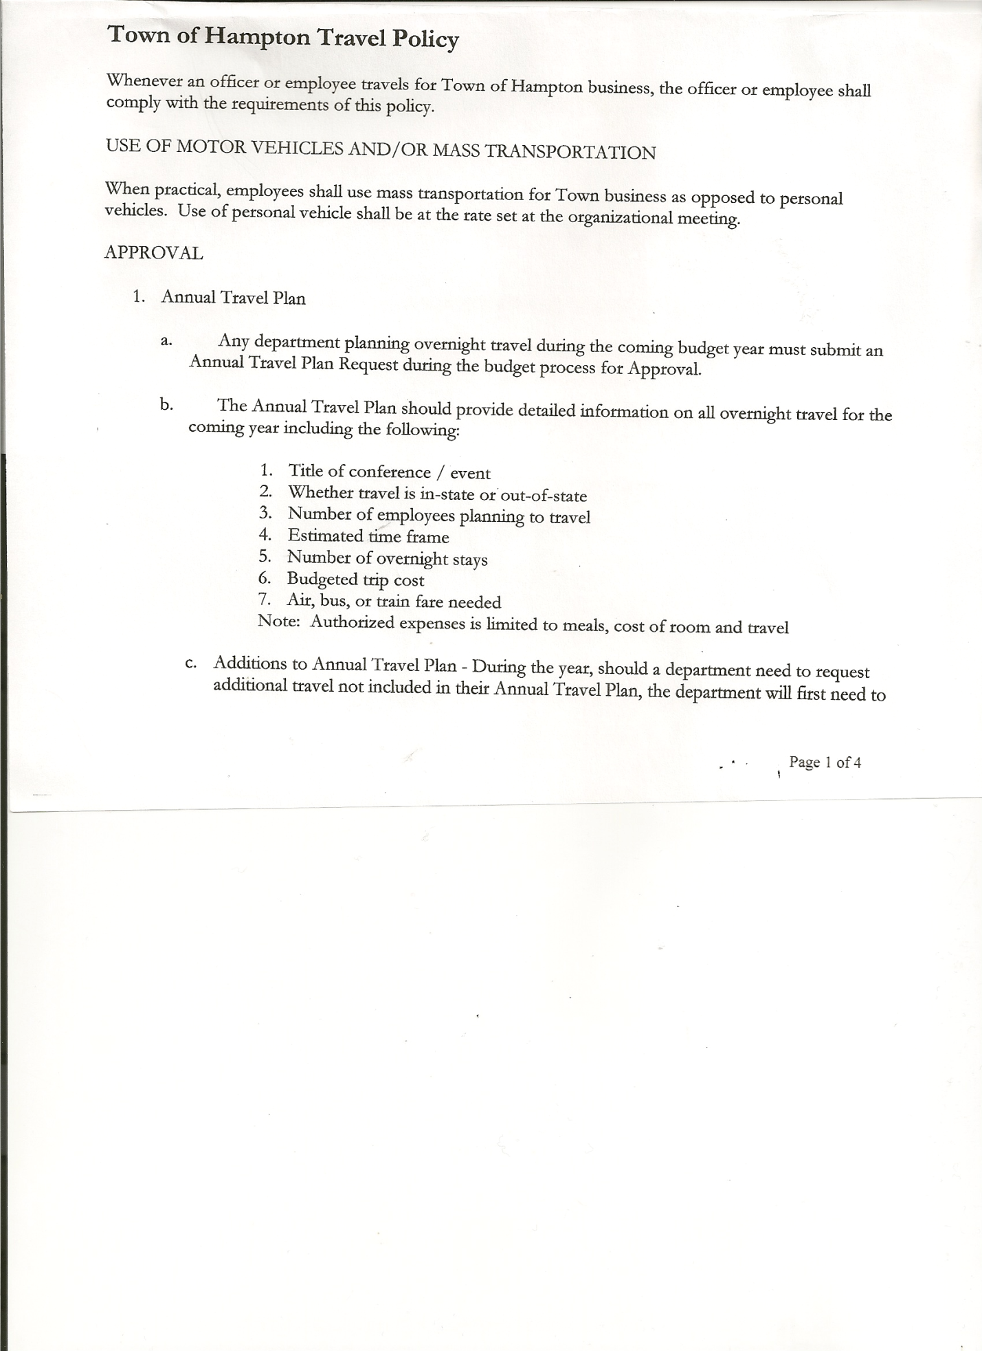
Rebecca Jones--------------Town Clerk

Also present: Artie Pratt

The meeting was called to order by Supervisor O’Brien at 7:00pm followed by the Pledge of Allegiance. Location of Fire Exits were given.

RESOLUTION NO. 106 -2014

AUDIT OF CLAIMS
On a motion of Councilwoman Taran, seconded by Councilwoman Sweeney the following resolution was ADOPTED Ayes 5 O’Brien, Taran, Jensen, Sady, Sweeney
Nays 0
RESOLVED that the bills have been reviewed by the Town Board and are authorized for payment in the following amounts.
General Fund No. 186 through No. 188 $ 339.11
Highway Fund No. 146 $ 950.20
Total both funds $ 1289.31

RESOLUTION NO. 107 -2014

CLOSE THE BOOKS FOR 2014
On a motion of Councilman Sady, seconded by Councilman Jensen the following resolution was ADOPTED Ayes 5 O’Brien, Taran, Jensen, Sady, Sweeney
Nays 0
RESOLVED to Close the Books as of 12/31/14 for 2014.

Highway Department Town of Hampton, Washington County, Road Side Tree Policy was handed out to Board Members for their info.

RESOLUTION NO. 108 -2014

TOWN OF HAMPTON EMPLOYEE HANDBOOK
On a motion of Councilman Sady, seconded by Councilwoman Taran the following resolution was ADOPTED Ayes 5 O’Brien, Taran, Jensen, Sady, Sweeney
Nays 0
RESOLVED to adopt the Town of Hampton, Washington County, Employee Handbook.

TOWN BOARD MEETING
DECEMBER 29, 2014 PAGE 2

End of Year Audits need to be completed by January 20th for the Town Justice/Town Clerk/Tax Collector and Bookkeeper.

On a motion of Councilman Sady, seconded by Councilwoman Taran , the meeting adjourned at 7:12pm. All in favor Aye.

Respectfully submitted,

Rebecca S. Jones, RMC
Town Clerk

