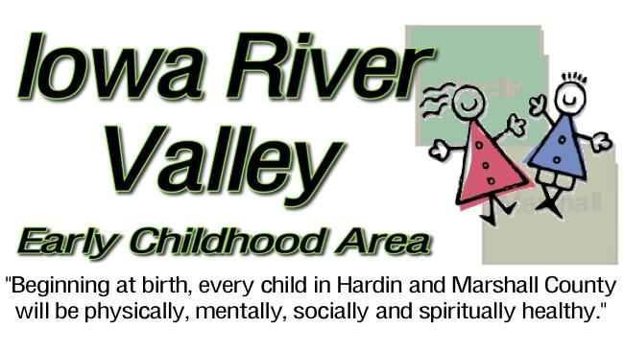
Iowa River Valley Early Childhood Area Board Meeting
BCLUW Middle School (Library) * 704 Commercial, Union, IA 50258
June 19, 2018 @ 4:30pm - AGENDA
Time | Item | Lead | Action/Information
4:30pm | Welcome and Introductions | Barb Winkels | Information
4:35pm | Approve Agenda (1) | Barb Winkels | Action
4:37pm | Approve Minutes from May 15, 2018 (2) | Barb Winkels | Action
4:40pm | Financial Report | Darwin Miller | Action
4:48pm | Committee Report (3) | Carrie Kube | Information
*BUSINESS ITEMS*
4:50pm | Board Membership Application: if any (4) | Barb Winkels | Action
4:55pm | Board and Director Performance Reviews (5) | Board Admin | Information
5:00pm | Fy’19 Board Professional Development: Recommendation from Board Admin Committee | Board Admin | Information
5:05pm | Fy’19 Director Salary, Budget and Contract Awards (6) | Barb Winkels | Action
5:35pm | Fy’19 Board Election of Officers, Representations, and Committees (7) | Board Admin | Action
5:40pm | Community Plan Update (8) | Barb Winkels | Action
5:45pm | Indicator Update (9) | Barb Winels | Action
5:55pm | Board Member Recognition | Public | Information
6:00pm | Agency Updates | Barb Winkels | Information
6:05pm | Public Comment (limit 2 minutes per person) | Barb Winkels | Information
6:10pm | Adjourn
Next meeting: September 11, 2018 @ 4:30pm, BCLUW Middle School Library, Union

Board Members
Barb Winkels * Citizen, Chair | Betsy Macke* Co-Chair, Citizen | Sherry Tuttle, * Citizen
Pat Thompson * Health | Tim Holmgren* Education | Allison Brennan * Human Svcs.
Bill Patten * Elected Official | Melissa Miller * Consumer | Lisa Naig * Citizen
Elly Mack* Faith | Ken Walton* Business | Vacant
Vacant | Vacant | Vacant
ECI Director: Carrie Kube
Iowa River Valley Early Childhood Area Board
524 Lawler, Iowa Falls, IA 50126 * (641) 648-6575 * http://iowarivervalleyeca.com
Meetings of the IRVECA Board are open to the public and adhere to Open Meetings/Records laws. Meetings are held at locations and times reasonably accessible to the public. When necessary, reasonable special accommodations for attendance are provided. Submit any questions to 641.648.6575 or iarivervalleyeca@gmail.com

