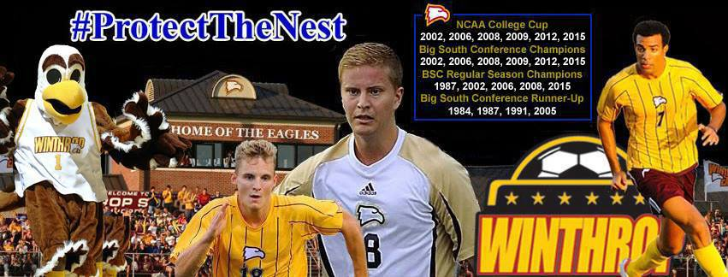
WINTHROP UNIVERSITY SOCCER COMPLEX
(One Of The Best In The Nation)
The Winthrop Soccer Complex (Eagle Field) is located on what is referred to as the Winthrop Farm Area, which is the home of the Eagle Athletic Department. The Stadium is located in a very scenic location across from the Winthrop Lake and at the entrance to the Winthrop Golf Course. The Winthrop Soccer Stadium has been host to several Discoveries Soccer Club events and area high school regional championship matches throughout the years. It has also been the home to the Charlotte Eagles (USL) professional team over the years on many occassions. In the summer of 2013, Eagle Field hosted the first MLS team in the upstate of South Carolina when the Chicago Fire came to town for the US Open Cup. The new USL Pro team the Charlotte Independence will be playing several games at Eagle Field in 2015. During the first phase which was completed in 1997 the playing area was enclosed, the bench areas were enhanced, and the old irrigation system was replaced with a new top-of-the-line Toro sprinkler system. In the second phase completed in the Spring of 1998 lights were added to allow for night matches and other events. The third phase which was completed in the summer of 2001 added permanent seating, both bleacher and stadium-style chair-back seats (Refer to BUY-A-SEAT-CAMPAIGN below), and a state-of-the-art press box. In this phase, a new state of the art sound system was installed and two new parking areas were added. In 2003 a message center with a new DAKTRONICS LCD scoreboard along with rotating triplex advertising panels were added. In 2005, a new field house was constructed. This facility is used by soccer and track which includes locker rooms, storage, public restrooms, concession area and a lounge area for players and club members for soccer. In the spring of 2008, 600 additional bench style seating with seat backs were added to the press box side of the field. The total seating capacity is now expanded to 1600. New dugouts from Pitch Equipment were also added to the bench areas along with new Pro Premier World Cup goals installed. In the summer of 2010 a new top of the line MUSCO lighting system was installed to replace the old lighting at Eagle Field. In the summer of 2013 we added our Walk of Champions brick walkway leading to the main stands.
The Field Dimensions are 118 yards X 75 yards. The surface is Tifway 419 hybrid Bermuda grass with Eagle Blend and Sun Star.
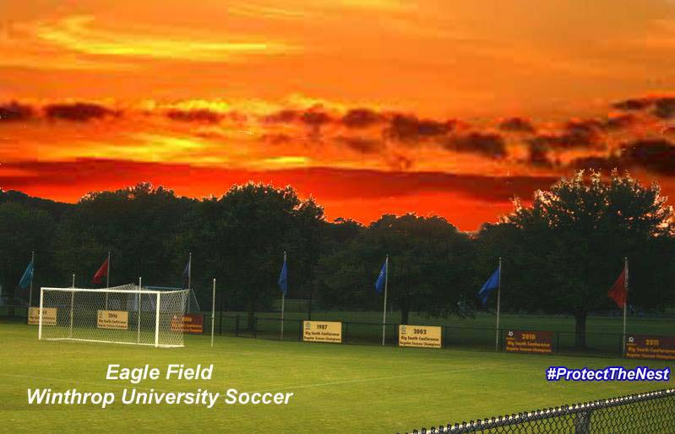
Winthrop Soccer Stadium Crowds Over 1000
2008 | Winthrop vs Clemson (Tie 0-0) | 2175
2015 | Charlotte Independence vs Richmond Kickers | 2155
2006 | Winthrop vs #3 Clemson (Loss 2-1) | 2010
1999 | Charlotte Eagles vs Wilmington Hammerheads | 1910
2001 | Charlotte Eagles vs Atlanta Silverbacks | 1820
2002 | Big South Conference Championship vs #10 Coastal Carolina (Win 1-0) | 1570
2013 | Chicago Fire vs Charlotte Eagles (3rd Round US Open Cup) | 1562
1998 | Winthrop vs #1 Clemson (Loss 2-1) | 1320
2012 | Winthrop vs #1 UNC (Loss 1-0) | 1203
2003 | Winthrop vs #12 North Carolina (Loss 3-2) | 1195
2007 | #30 Winthrop vs #35 Charlotte (Win 2-0) | 1170
2012 | Winthrop vs North Carolina-Greensboro (T 1-1) | 1085

WINTHROP SOCCER STADIUM SEATING CHART
Storage | Lounge-Upper Level  Concession-Lower Level | Rest Rooms | Locker/Team Rooms

General Admission Seating | Reserved Seating | General Admission Seating
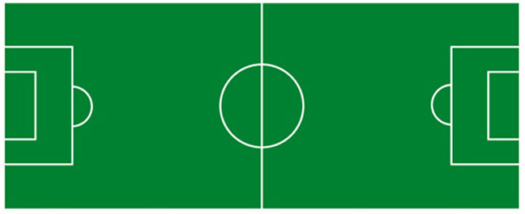
Home Bench | Press Box | Visitor Bench

General and Reserved Admission Seating | General and Reserved Admission Seating
STADIUM JOURNEY EVALUATION OF EAGLE FIELD

BUY-A-SEAT CAMPAIGN

SOCCER COMPLEX PHOTOS
From Our Drone Eagle I
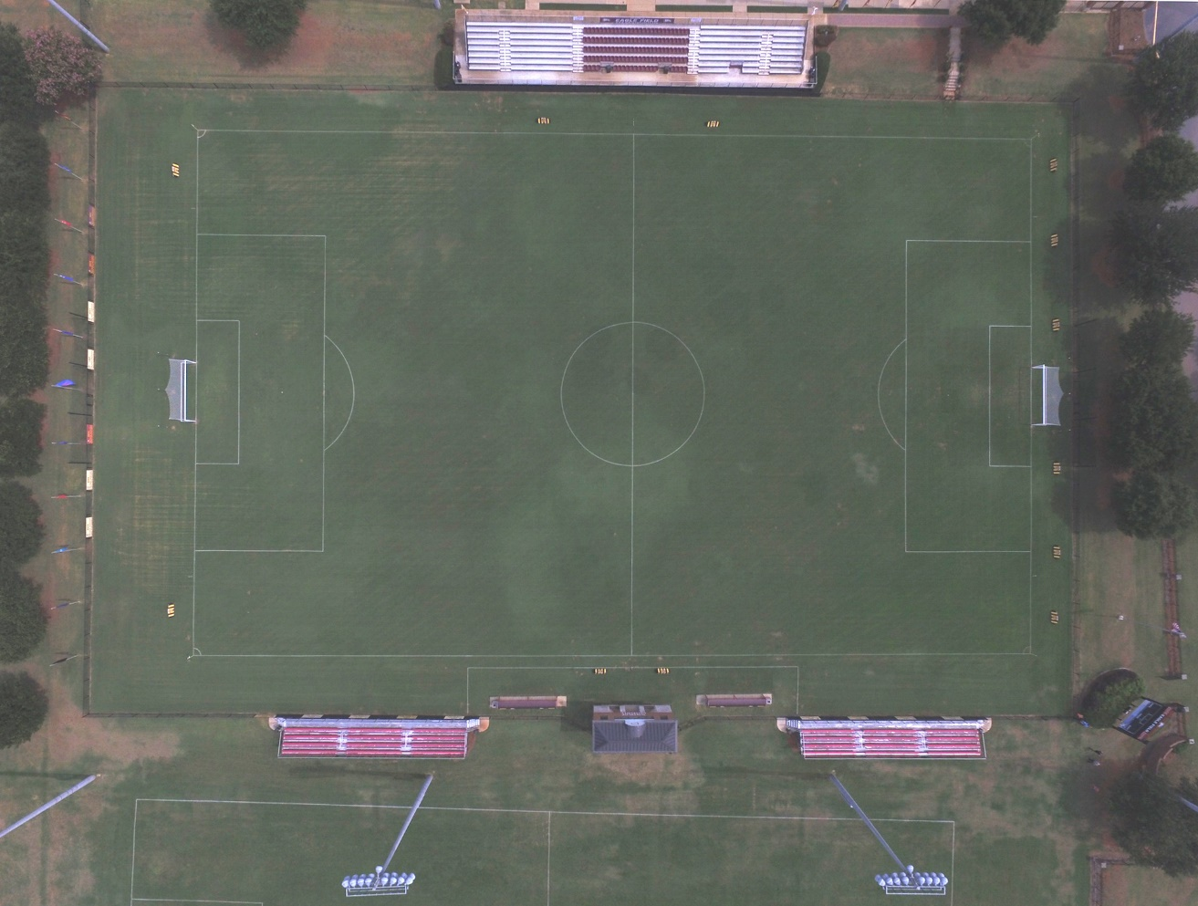
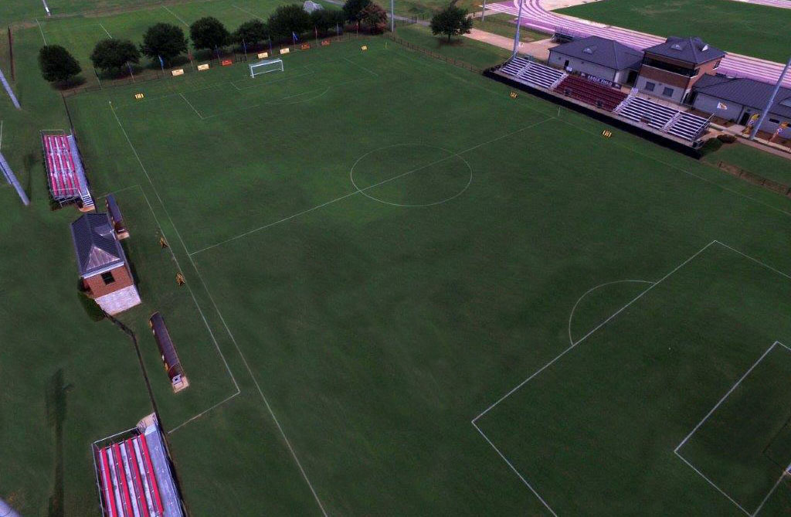
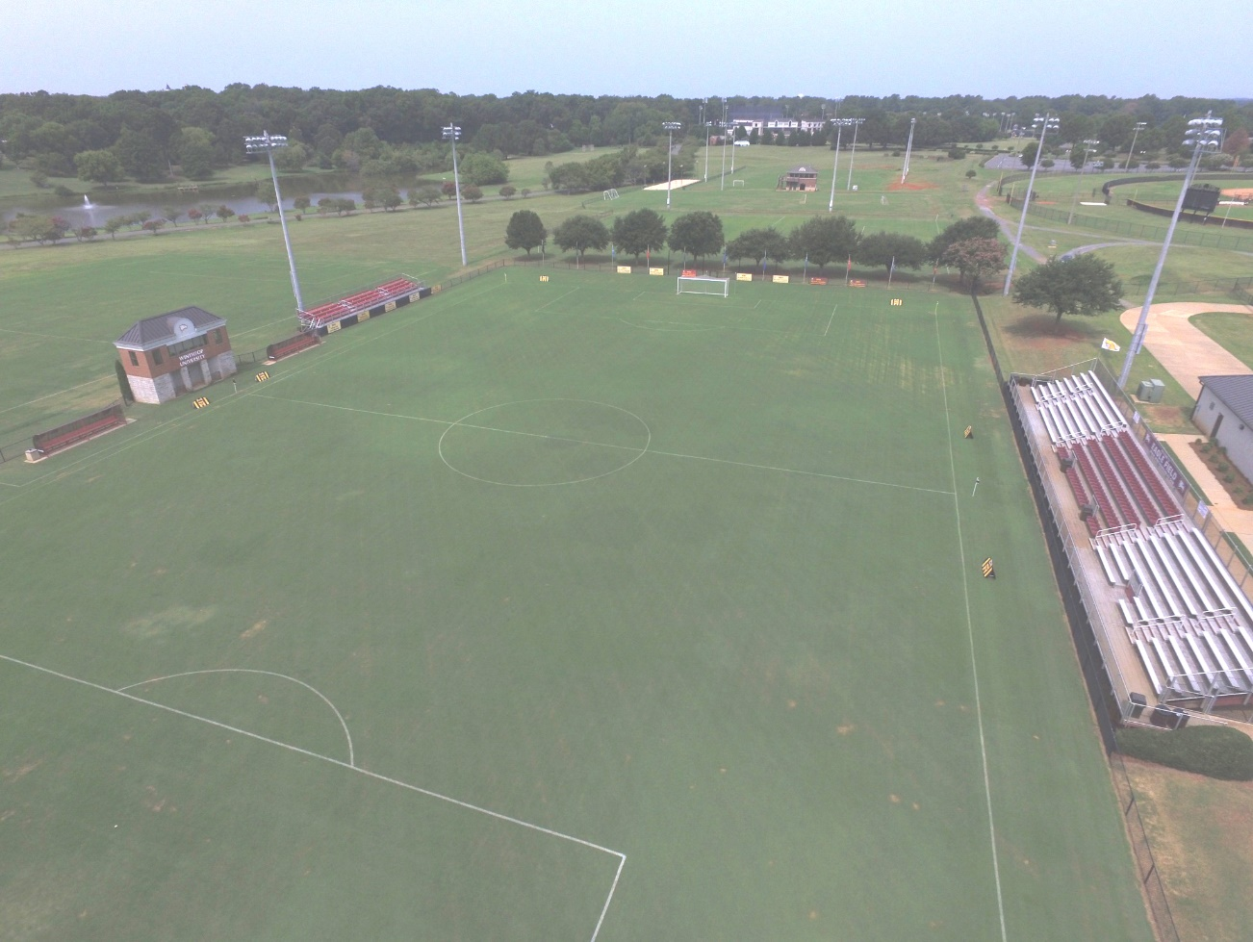
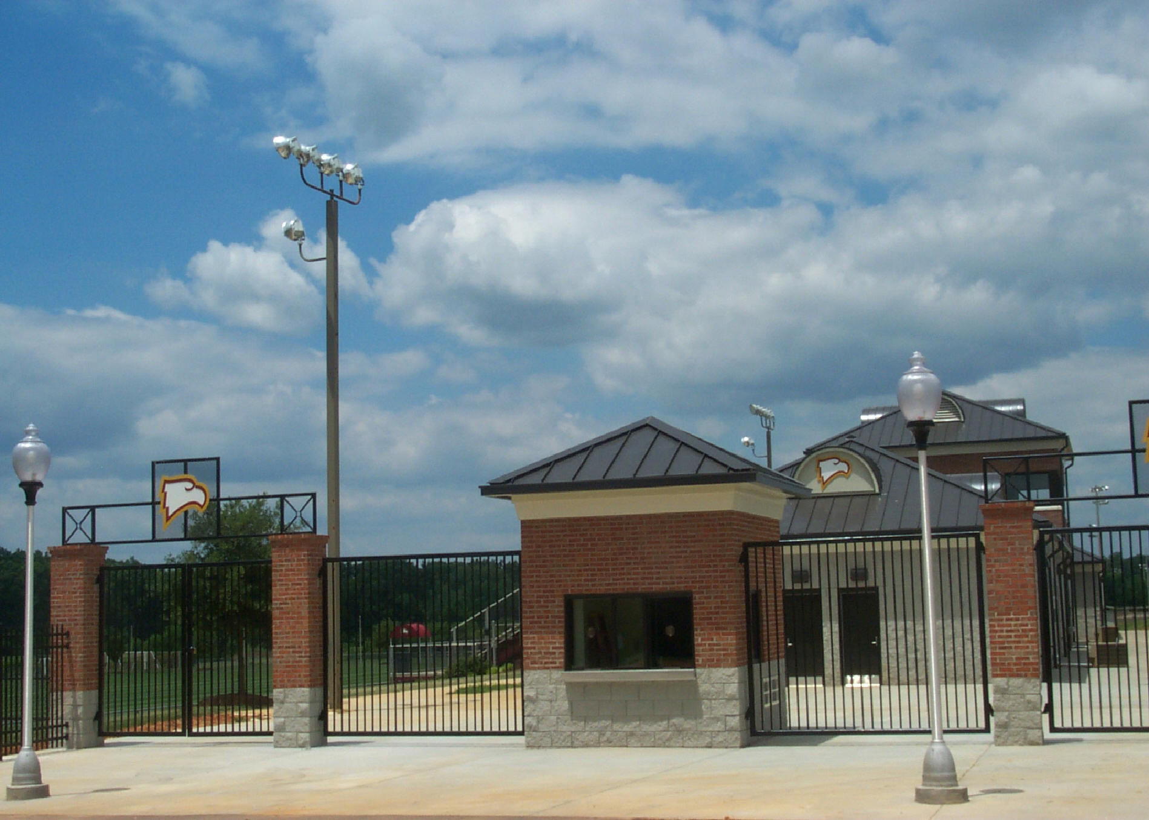
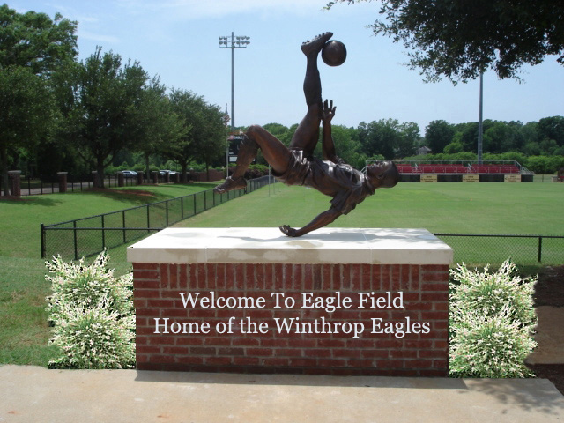
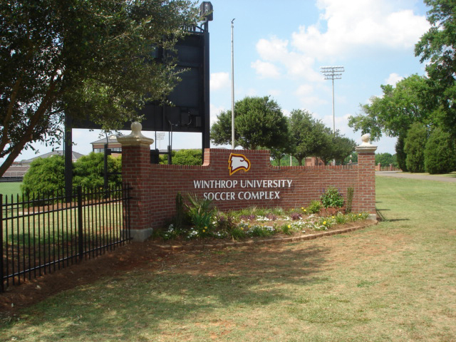
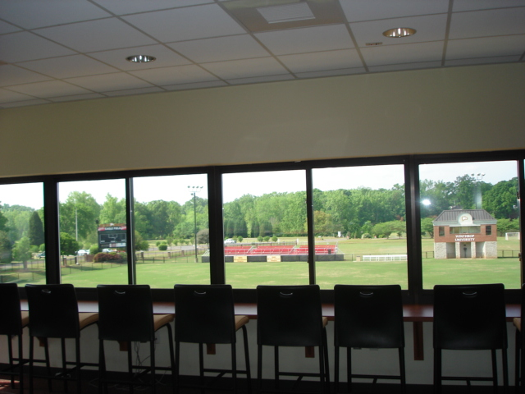
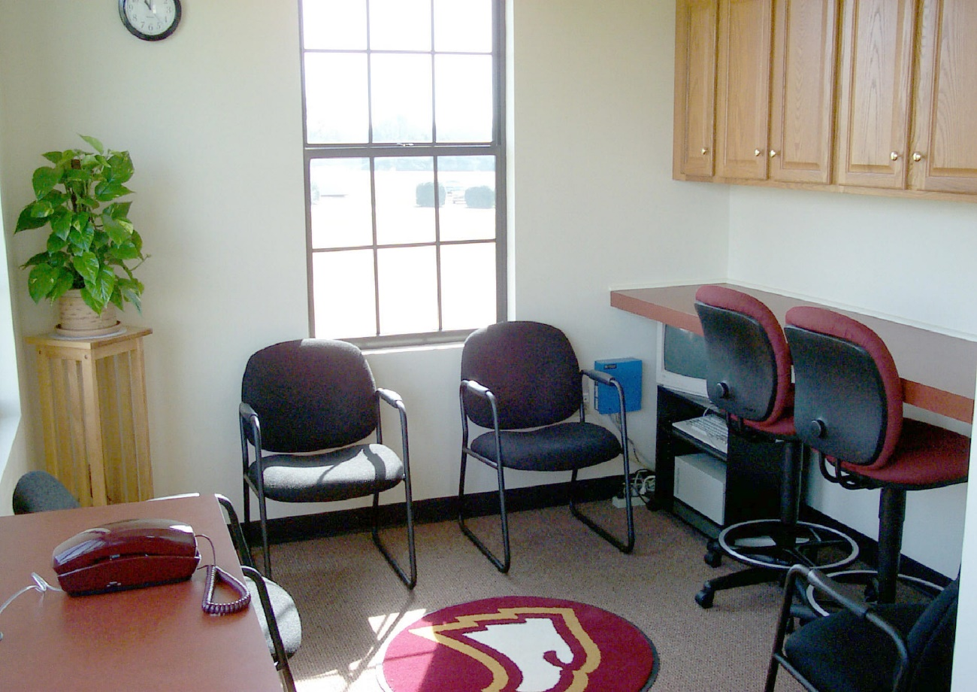
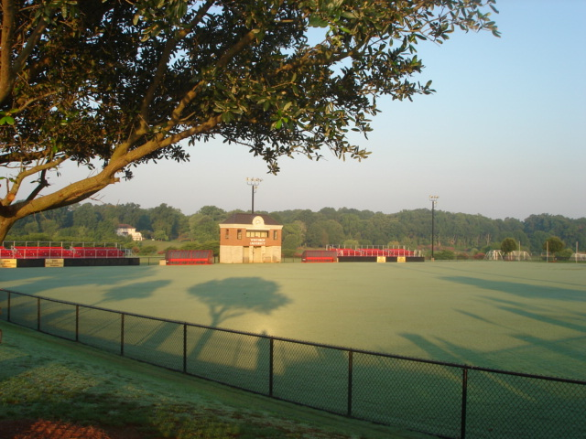
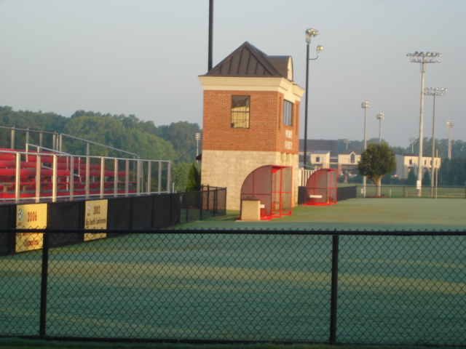
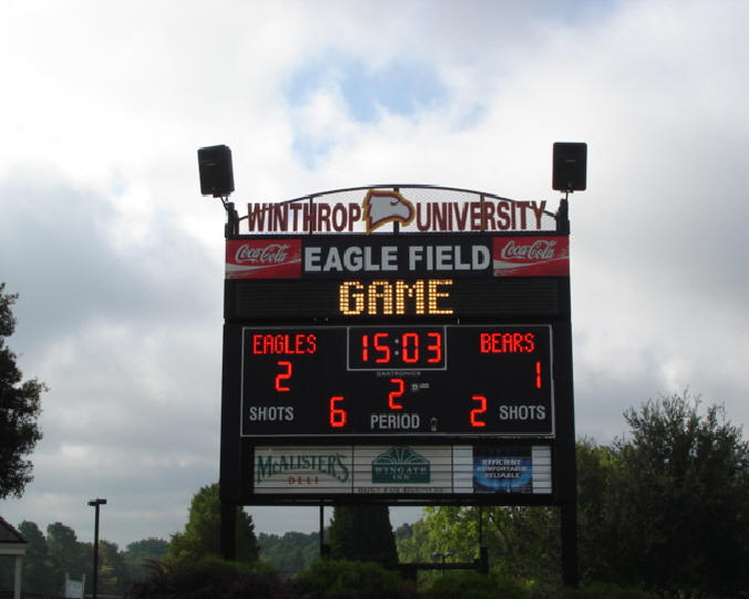
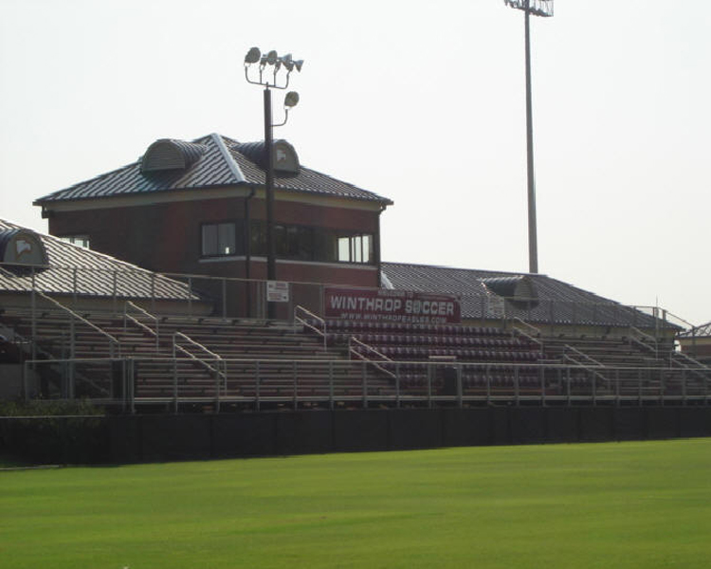
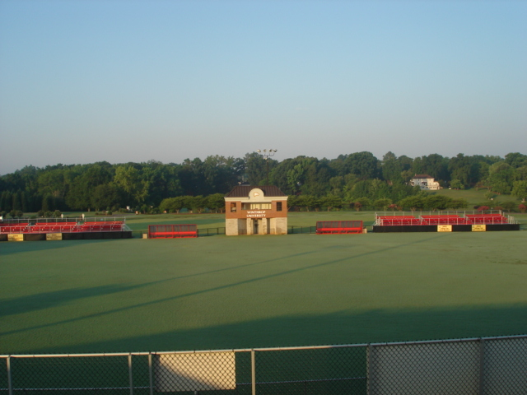
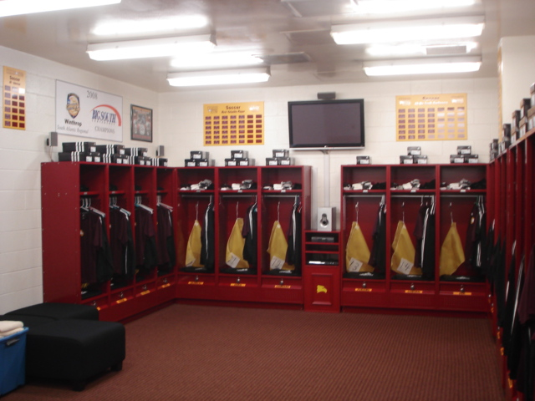
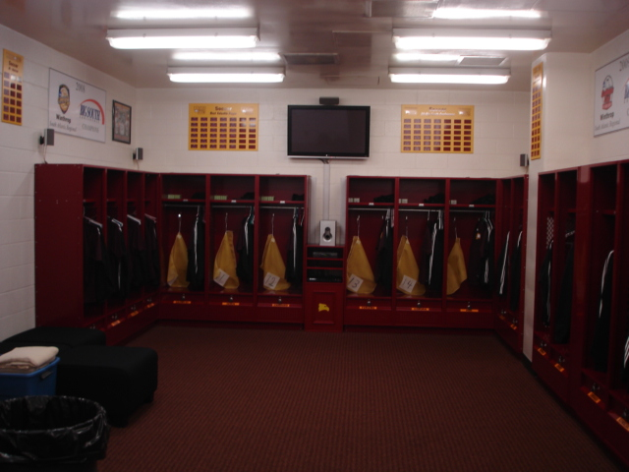
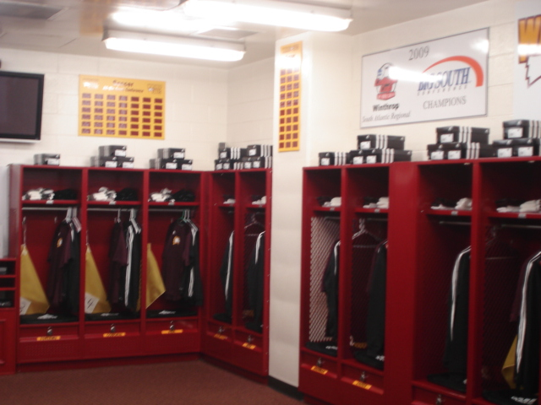
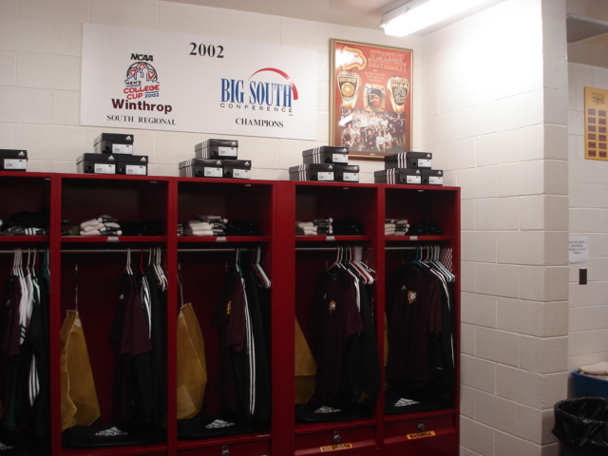
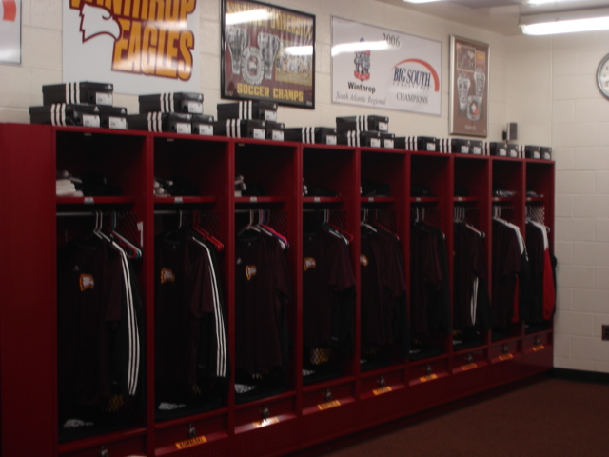
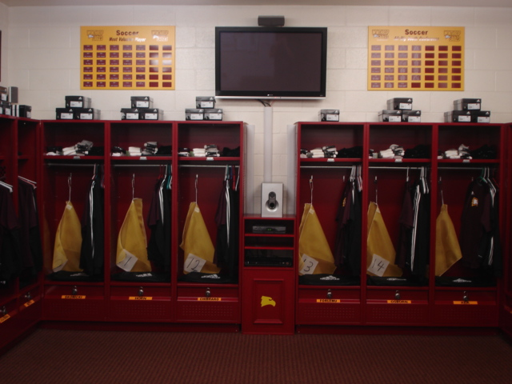
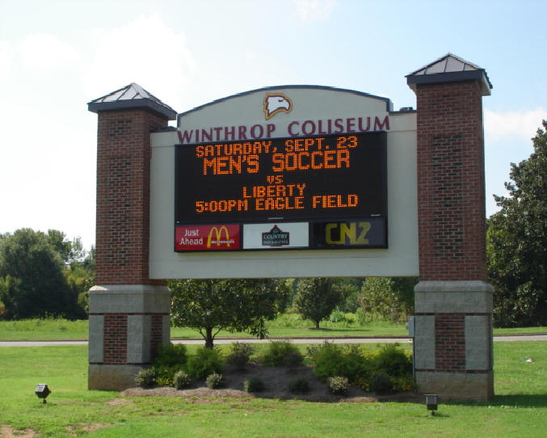
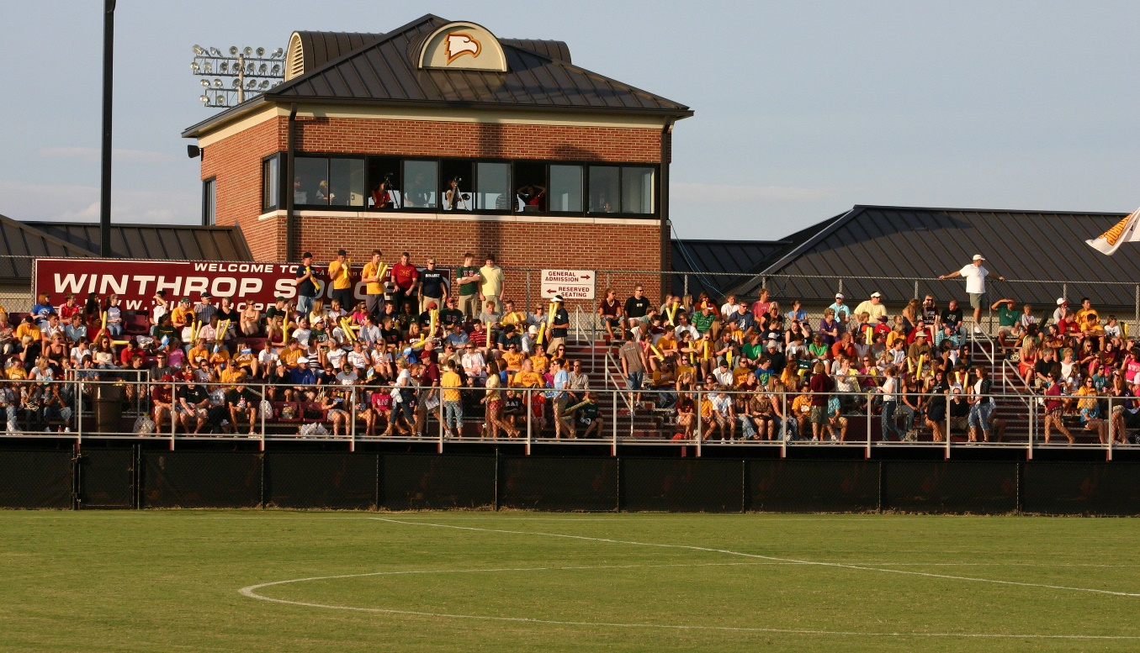
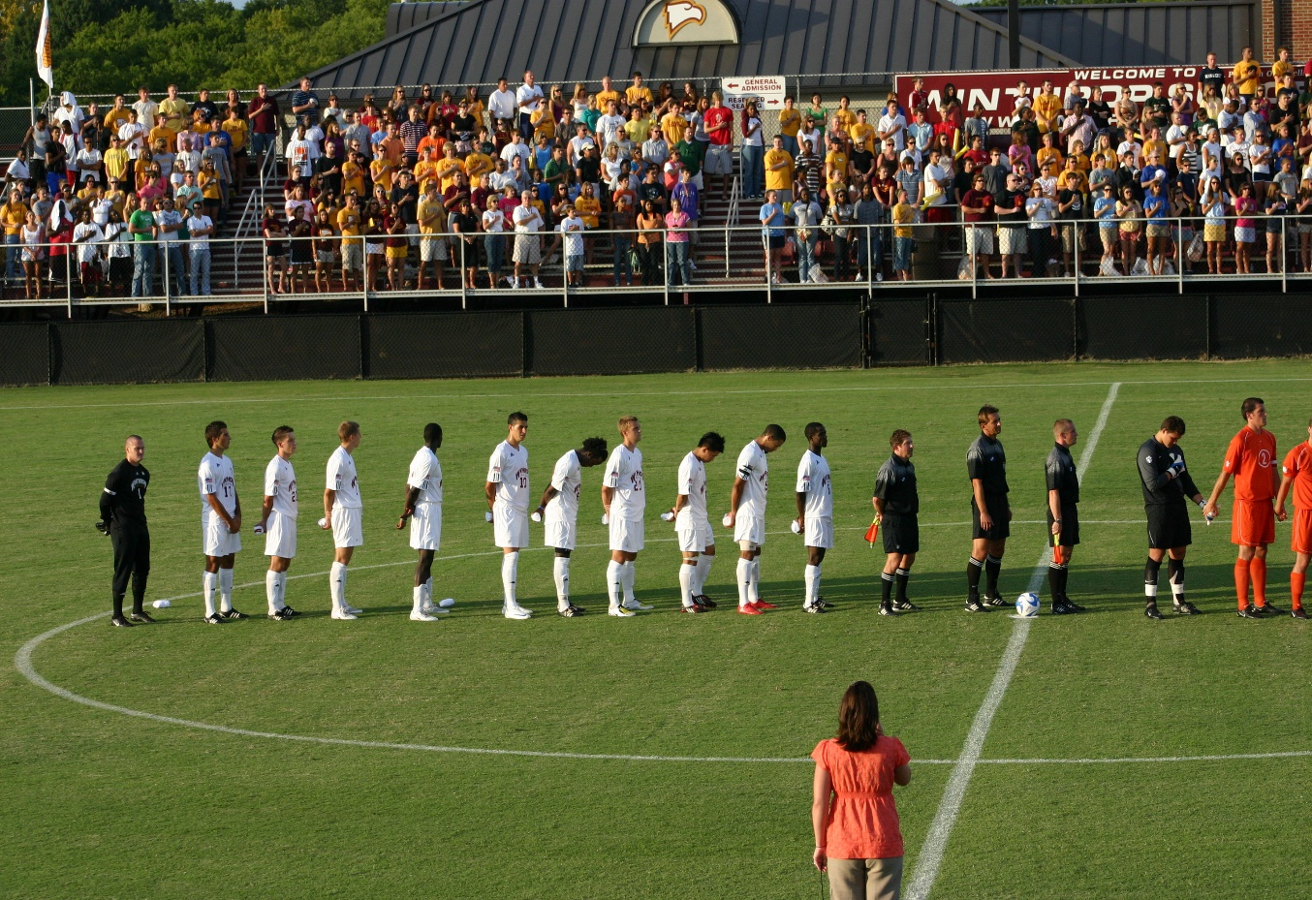
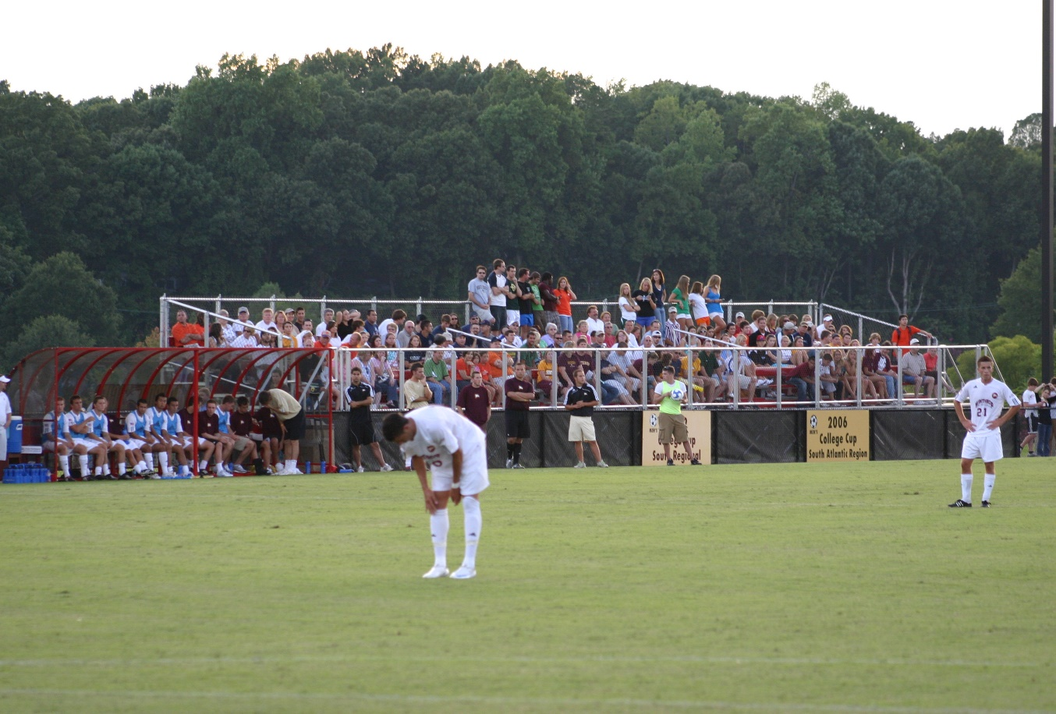
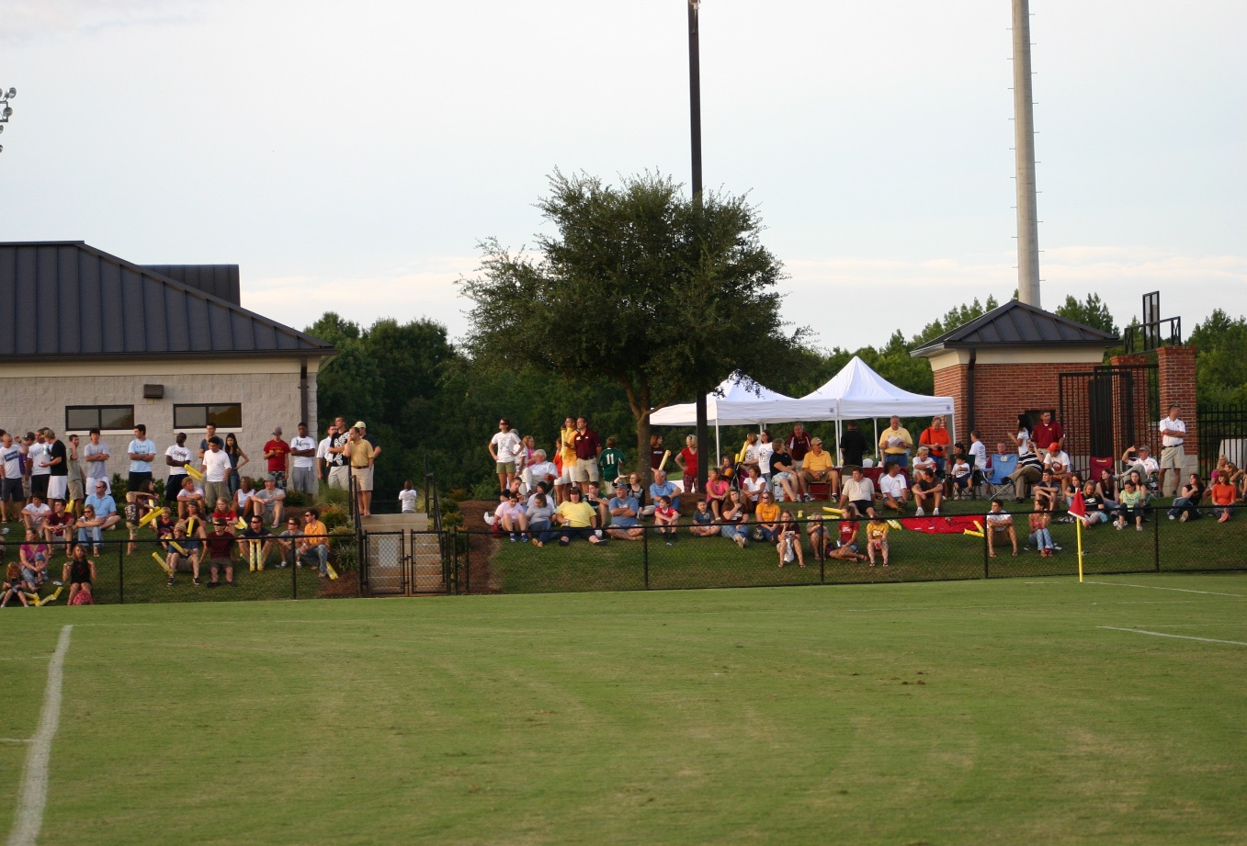
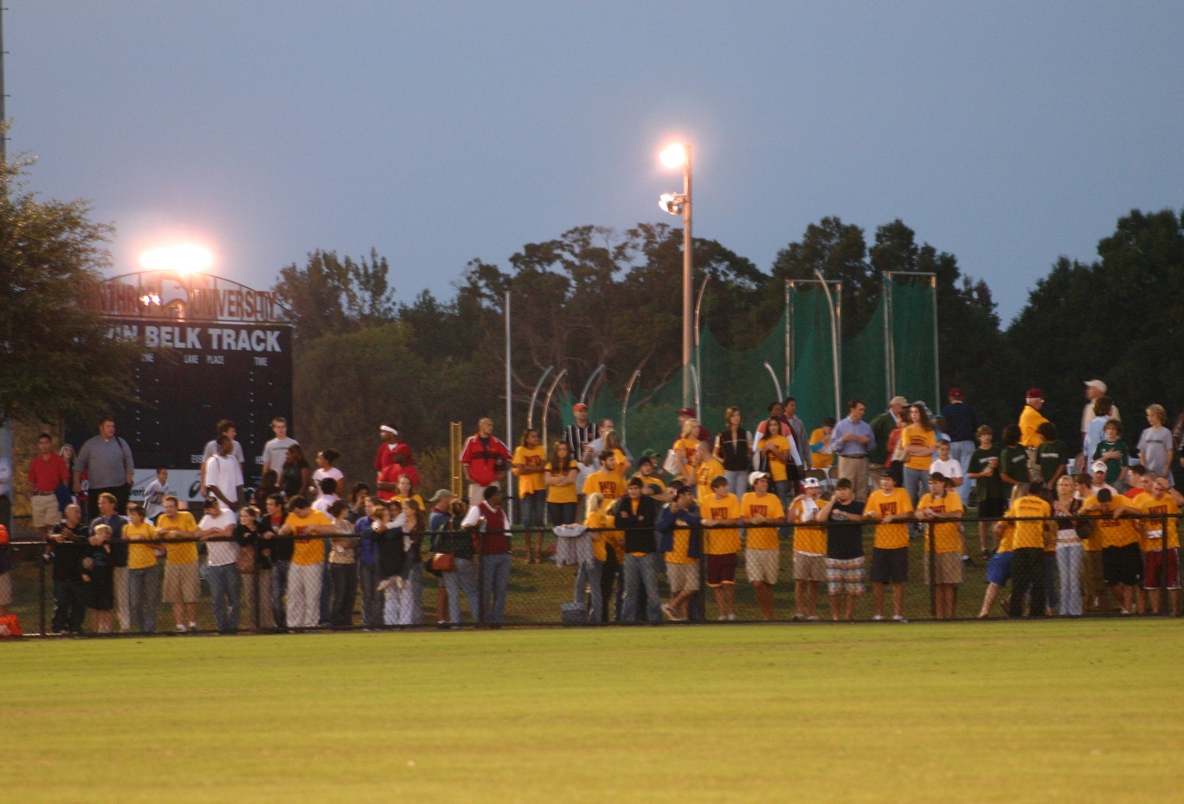
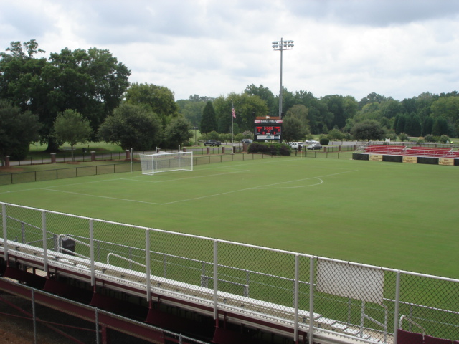
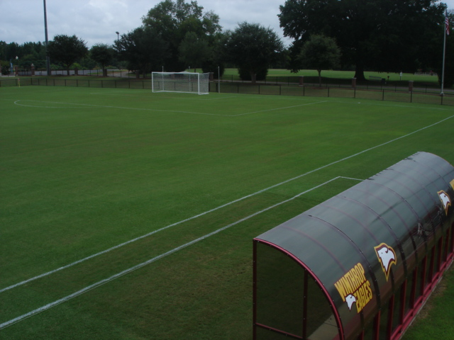
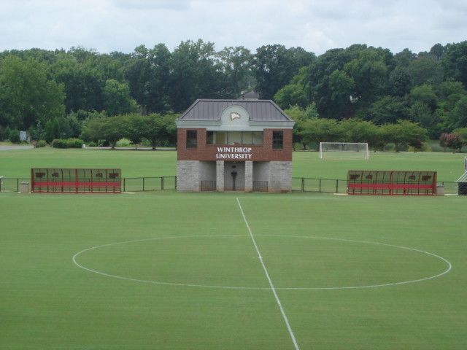
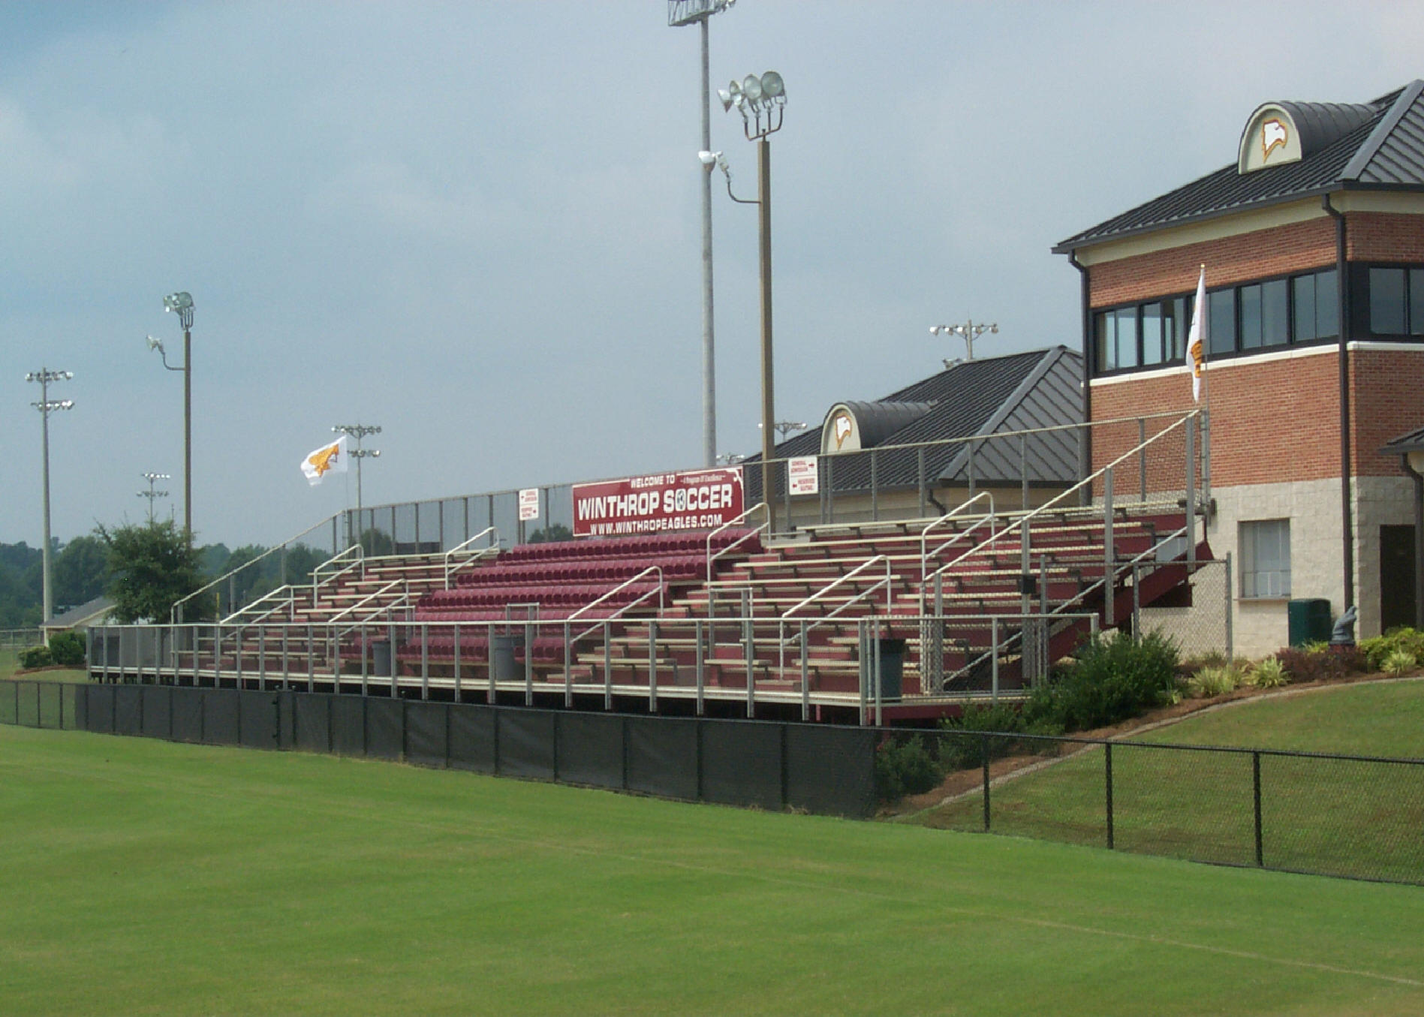
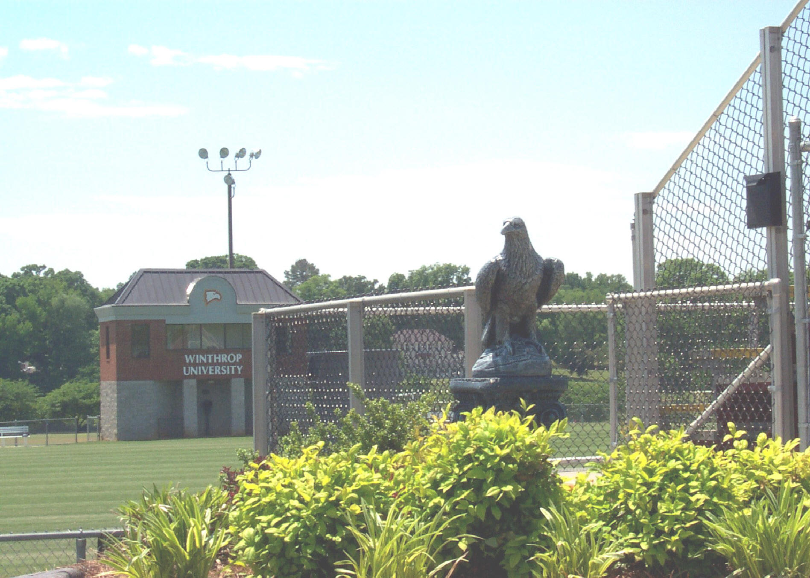
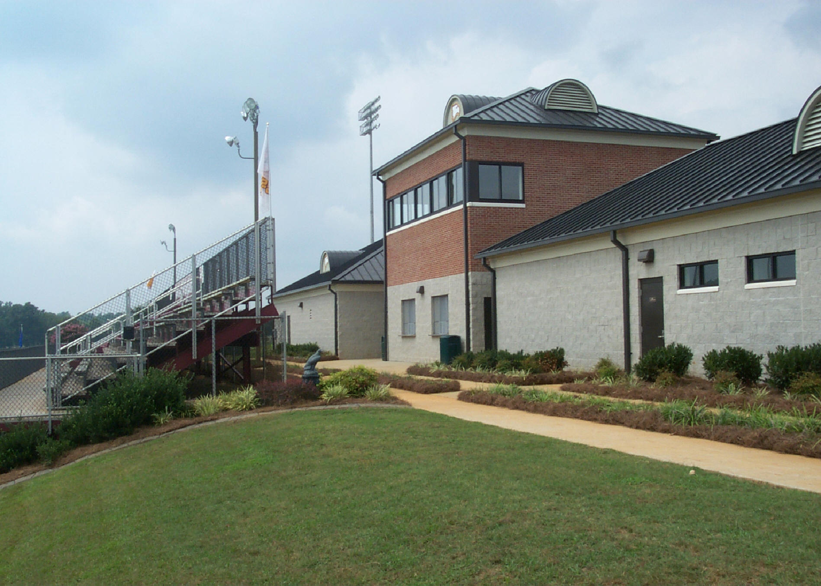
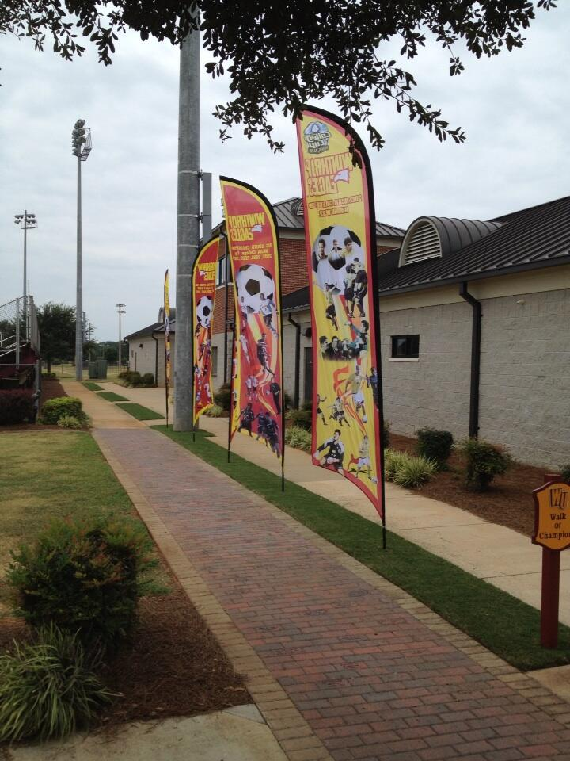
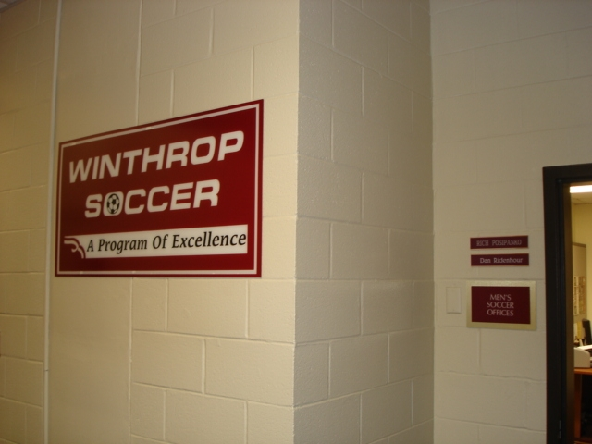
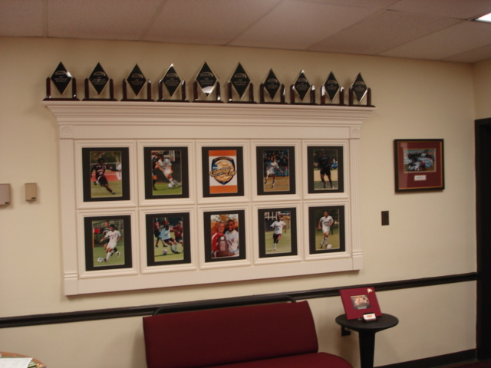
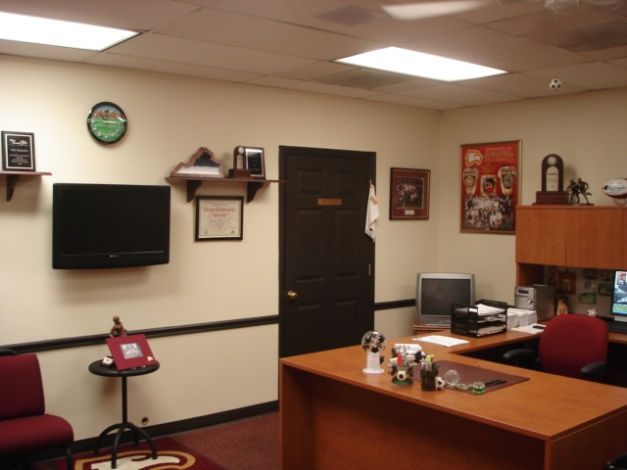
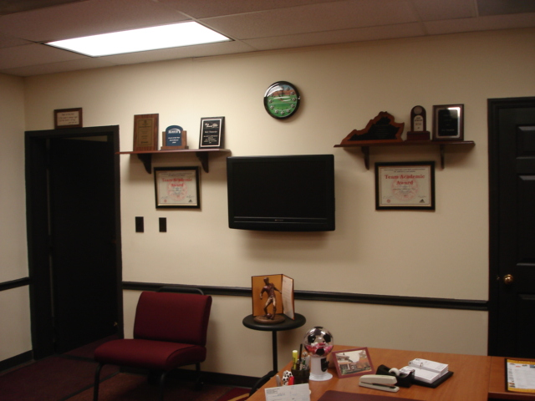
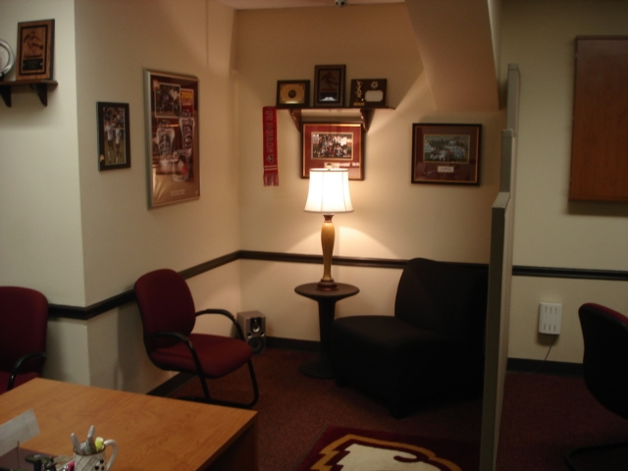
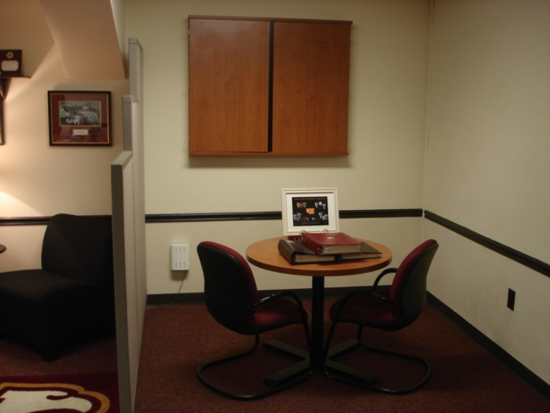
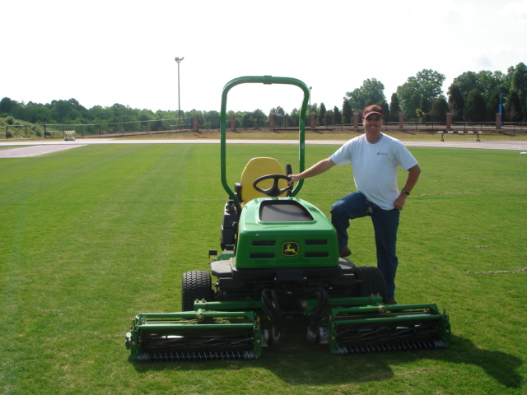
Kyle Stegall Does An Outstanding Job For Us. He Is In charge of the Soccer Facility and The Day to Day Maintenance

THANK YOU KYLE FOR ALL YOUR HARD WORK

