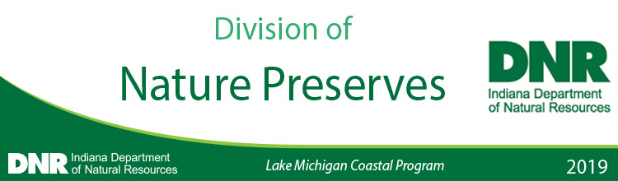

Reminder: 2020 Funding Priorities input ends May 15, 2019
The Indiana Department of Natural Resources Lake Michigan Coastal Program public input period on priorities for the 2020 Funding Cycle ends on May 15. Public input is crucial to the success of the LMCP Coastal Grants program.
Please remember to submit your suggested project priorities for the 2020 funding cycle to the Lake Michigan Coastal Program before the deadline. You may submit as many suggestions for any or all of the categories.
The LMCP Coastal Grants program awards funds to units of local government, regional and state agencies, educational institutions, and non-profit organizations.
The Coastal Program provides technical and financial assistance to coordinate efforts and support projects that protect and restore natural, cultural, and historical resources in Indiana’s Lake Michigan Coastal Area.
Eligible projects must fall within one of six categories: Public Access & Habitat Improvements, Land Acquisition, Planning & Coordination, Education & Outreach, Applied Research, and Emerging Issues.
For more information and to submit input, visit the LMCP Grants page.
To subscribe to LMCP Coastal Grants calendar event updates, visit the DNR Lake Michigan Coastal Program Calendar and click ‘subscribe’.
Thank you,
Sarah Nimetz
Grant Specialist, DNR Lake Michigan Coastal Program
snimetz@dnr.in.gov
219-250-5401