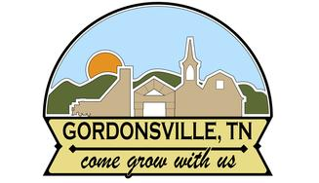
INVITATION TO BID
The Town of Gordonsville is requesting bids on a 32’ x 84’ shelter to be erected on an existing concrete slab. Bid specifications can be obtained via our website, www.townofgordonsville.com or by coming by City Hall at 63 E. Main Street, Gordonsville, TN 38563.
Prospective bidders may coordinate a site visit by contacting City Hall at 615-683-8282.
Sealed bids will be received at City Hall, 63 E. Main Street Gordonsville, TN 38563, until 10 a.m. CST, September 6, 2024, at which time they will be opened.

John Potts
Mayor

