SUNDAY | MONDAY | TUESDAY | WEDNESDAY | THURSDAY | FRIDAY | SATURDAY
 | 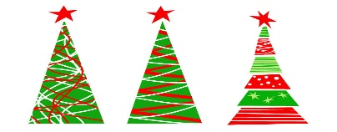  This Photo by Unknown Author is licensed under CC BY-SA | 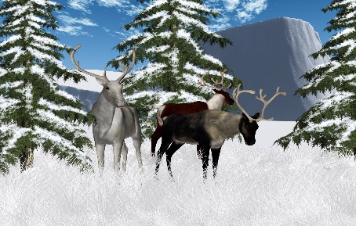 | 1 | 2 | 3 | 4
5 | 6  NO BUS SERVICE | 7  NO BUS SERVICE | 8 | 9 | 10 | 11
12 | 13 | 14  BOARD MTG @ 4PM | 15 | 16 | 17 | 18
19 | 20 | 21  BOOKMOBILE  2:30 – 3:30 | 22  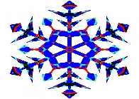  WINTER WONDERLAND | 23  HALF DAY  STUDENTS OUT @ 12:15  END OF 2ND QUARTER | 24 | 25
26 | 27 | WINTER  28 | BREAK  29 | 30 | 31

DECEMBER 2021
This Photo by Unknown Author is licensed under CC BY-NC

