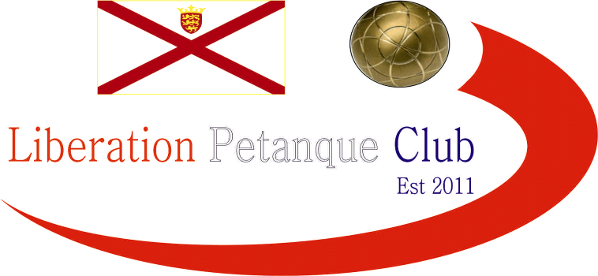

**2023**

**International Triples Open**

# A record 20 Triples teams took part in day 3 of our International Open weekend, almost double last years entries.

# Round one saw defending champions Matt Buesnel, Geoffroy Buffetrille and Laurent Pellaton take on Eliot, Paul and Roger from the England with a good start 13 – 4.

# Not quite a s good as Norwegian champions Benny, Eli & Gabriel who beat Leo, Michael & Virgina from Ireland 13 – 0!

# Gary, Wendy & Keith started off with a tight win 9 – 6 over England Veterans champions Adrian, Ian and Simon. Another match not making it to 13 as Andrew, Callum & Toby won 12 – 7 over Colin, Lesley & Paula.

# Julian, Eric playing with stand in Des beat Clive, Christine & Brian.

# Round two, saw another 13 – 0 score as Andrew, Callum & Toby hit top form to hand out a certificate to Andrew, Lorna & Stephen.

# Three matches didn’t make it to 13 with Gary, Wendy & Keith getting 9 points again, but unfortunately their opponents Geoffroy, Laurent & Matt scored 10 points. John, Pauline & David also won by one point 9 – 8 over Moira, Mike & Greg.

# Stuart, Chris & Carolyn won big 13 – 2 over Clive, Christine & Brian. With Eric, Julian & Des winning 13 – 4 and Myra, Carol & Julie winning 13 – 4.

# Round three, saw back to back 13 – 0 wins for Andrew, Callum & Toby, this time over John, Pauline & David.

# A huge match saw Benny, Eli & Gabriel play Des, Eric & Julian with the Norwegians taking the match 13 – 6.

# Three really close matches saw Leo, Mary & Virginia beat Alex, Cassie & Jean 13 – 12. Sandra, Grant & Clifton won 12 – 11 over Clive, Christine & Brian.

# Champions Laurent, Geoffroy & Matt lost their first match against Adrian, Ian & Simon 13 – 6.

# Big wins for Andrew, Lorna & Stephen. Mike Moira & Greg. Neil, Ross & James and Mary, Breda & Brian.

# Round four, Well after back to back 13 – 0 wins the next match was going to be tougher for Andrew, Callum & Toby as they played Benny, Eli & Gabriel this time losing 13 – 9 in a close match.

# Gar, Wendy & Keith yet again failed to reach 13 points in their match as the lost 9 – 8 to Des, Eric & Julian.

# Laurent, Geoffroy & Matt lost back to back matches this time to Pauline, John & David 13 – 6. Clive, Christine & Brian finally won their first match and in style 13 – 1 over Liz, Marietta &Mary.

# In the final Round to determine the top eight for the Main and the next eight teams for the plate with the bottom four teams missing out.

# Benny, Eli & Gabriel topped the rankings with a win over Andrew, Lorna & Stephen who finished sixth in the rankings.

# Andre, Callum & Toby lost the second successive match, this time to Adrian, Ian & Simon but still finished fourth with the latter finishing third.

# Second place went to Des, Eric & Julian who finished with four wins taking an 11-7 win over David, John & Pauline who still made it through in eighth place.

# Gary, Wendy & Keith 13 – 6 win over Myra, Carol & Julie saw them finish sixth and seventh went to Clifton, Sandra & Grant with a big 13 – 3 win over Mike, Moira & Greg.

# Champions Geoffroy, Laurent & Matt though missed out by the narrowest of margins after only beating Leo, Michael & Virginia 13 – 12 meaning their points difference of minus 3 to David, Pauline & johns +1.

# Final Swiss Rankings

# Inline image

# The Plate Competition

# Quarter Finals

# Wins all around for the top ranked teams in the quarter finals with the closest match between all Liberation players saw James Ross & Neil beat Alex, Cassie & Jean.

# Ranked 9th Geoffroy, Laurent & Matt 13 v 4 Mike, Moira & Greg Ranked 16th

# Ranked 10th Chris, Stuart & Carolyn 13 v 7 Clive, Christine & Brian Ranked 15th

# Ranked 11th Leo, Michael & Virginia 13 v 5 Colin, Lesley & Paula Ranked 14th

# Ranked 12th James, Neil & Ross 13 v 9 Alex, Cassie & Jean Ranked 13th

# The Plate Competition

# Semi Finals

# In the Semi-final local rivalry to place as Geoffroy, Laurent & Matt played James, Neil & Ross, with the latter taking the local bragging rights winning comfortably 13 – 4.

# A big win also for English team Stuart, Chris, & Carolyn 13 – 2 over Irish team Leo, Michael & Virginia.

# Ranked 9th Geoffroy, Laurent & Matt 4 v 13 James, Neil & Ross Ranked 12th

# Ranked 10th Chris, Stuart & Carolyn 13 v 2 Leo, Michael & Virginia Ranked 11th

# Geoffroy, Laurent & Matt took third place with a win over Leo, Michael & Virginia and the Plate winners finished in style with another big win 13 – 3 over James, Neil & Ross.

# 2023 – Plate - Winner – Stuart Brown, Carolyn Greenhalgh & Chris Turner

# 

# The Main Competition

# Quarter Finals

# Well not expecting these scores in the Quarter finals as Benny, Eli & Gabriel and Andrew, Callum & Toby both won their matches 13 – 0! A big win also for Des, Eric & Julian 13 – 4 over Clifton, Grant & Sandra but the one that got away was Andrew, Lorna & Stephen who should have won but threw away a great chance to beat Adrian, Ian & Simon but lost 10 – 9!

# Ranked 1st Benny, Eli & Gabriel 13 v 0 David, John & Pauline Ranked 8th

# Ranked 2nd Des, Eric & Julian 13 v 4 Clifton, Grant & Sandra Ranked 7th

# Ranked 3rd Adrian, Ian & Simon 10 v 9 Andrew, Lorna & Stephen Ranked 6th

# Ranked 4th Andrew, Callum & Toby 13 v 0 Gary, Wendy & Keith Ranked 5th

# The Main Competition

# Semi Finals

# Another big win for Benny, Eli & Gabriel with Gabriel shooting really well but disappointing from Andrew, Callum & Toby who just didn’t quite hit top gear. So the top two ranked teams made the final as Des, Eric & Julian set up a rematch against Benny, Eli & Gabriel whom they lost 13 – 6 to in Round 3.

# Ranked 1st Benny, Eli & Gabriel 13 v 1 Andrew, Callum & Toby Ranked 4th

# Ranked 2nd Des, Eric & Julian 13 v 7 Adrian, Ian & Simon Ranked 3rd

# Third place went to Andrew, Callum & Toby who got revenge over Adrian, Ian & Simon winning 13 – 6 after losing to them in Round 5, 13 – 8.

# The final wasn’t as close as hoped as Benny, Eli & Gabriel ended up conceding just three points and a total of four points in the knockout stages for a well-deserved title.

# 2023 – Main - Winner – Benny & Gabriel Bel-Lafkih & Eli Gjengstoe

# from Norway

# 

# Thanks to all those who helped, especially Dawn Buckley and Elaine Paisnel for umpiring on the day to make it another great competition.

# Club email address - [liberationpc@gmail.com](mailto:liberationpc@gmail.com)

# Club Website - [www.liberationpetanque.co.uk](http://www.liberationpetanque.co.uk)

# Kind Regards

# Toby Northern

# Chairman

# Liberation Petanque Club