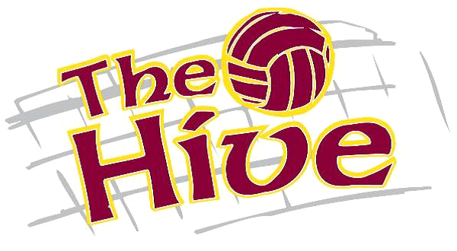

Image Emporium; Vendor for ordering required player jerseys & optional other apparel.
Note: A new player jersey is not required if you have one from the 2017/2018 season.
The link to order is;
https://www.shopimagemporium.com/collections/hive-volleyball/products/hive-volleyball-club-player-jersey

Winter 2019-Spring 2020 AAU Card Instructions:
In order to play AAU club volleyball, a valid & up to date AAU card is required.
Instructions on how to acquire an online AAU card;
- Website is https://aausports.org/Join-AAU
- Hit the “JOIN AAU” icon, red, upper right corner.
- Hit the “GET A MEMBERSHIP” icon & then “APPLY FOR YOUTH ATHLETE MEMBERSHIP” icon.
- Hit the “GET A MEMBERSHIP” green icon.
- Hit the “YOUTH MEMBERSHIP” green icon.
- Select your sport; Volleyball in the drop down. “ARE THEY A MEMBER OF A CLUB” Yes. “ENTER YOUR CLUB CODE” WYBB4Y for The Hive.
- Enter the balance of the information as requested.
- Process your payment (choose how many years that you want the AAU card good for).
- Print the receipt & the AAU card. The AAU card will be required to complete your child’s registration with The Hive as well as needing a copy at all tournaments.

