ASSISTANT DIRECTOR: DEANA DILLON

TELEPHONE: (614) 837-3020 / FAX: (614) 833-6471
HOURS: MON-THURS 8:30 a.m. - 4:30 p.m.
FRIDAYS 8:30 a.m. – 2:30 p.m.
WEB PAGE: http://pickeringtonseniorcenter.org
EMAIL: NLee@pickeringtonseniorcenter.com

A NOTE FROM NANCY

It’s that time of year again, time to pay your Senior Center dues for the year. If you’ve had a change of address or phone number, be sure to let our office know. Members who joined after October 1st and paid $6.25 for the balance of 2021, your dues of $13.00 are due by January 1st. If you turned 90 before January 1st, 2022 your membership is free. Any snowbirds who would like our Newsletter forwarded to you, just give us your address and we will do so. Remember to let us know when you return to your Ohio address.

$10.00 CLUB
Just a reminder that we have a donation called the $10.00 Club. You can donate any amount you would like. The money donated helps with the purchase of items that we need for the kitchen, office supplies, etc.

OUR PARKING LOT ENTRANCE & EXIT

Please be sure to follow the arrows designating the entrance and exit to our Center’s parking lot.

This has been done for everyone’s safety and to avoid accidents. We had a near collision in our parking lot this past month. Signs will be going up to further advise drivers of the correct entrance and exit. In the event of a fender bend, the driver not adhering to these arrows and signs will be responsible for the accident. As always, be sure to drive slowly and courteously while in our parking lot.

WEATHER DELAY OPENINGS and/or CLOSINGS

As we are now in the winter months, we want to remind everyone that our Center follows the Pickerington School District inclement weather schedule. This information will be posted on Channel 10.

MEMBERSHIP INCENTIVE PROGRAM

Any member who signs up four new members will receive a $25.00 gift Card. Tell the office to put your name on the form when you sign up a new member. All you need is four members!

We welcome Cecelia Kehres, Dana Miller, Nancy
Penrod, and Scott Stewart as new members to our Center this month and hope they will join us for some of our activities.

VOLUNTEER OF THE MONTH

Our Center would like to honor Marilyn Morgan as our volunteer for the month of December. She sets up for strength classes on Mondays and Wednesdays, she teaches line dancing on Wednesdays and Fitness Classes on Fridays. She is always available to help where needed. Marilyn will receive a $15.00 gift card. Enjoy your reserved parking space for the month of December. Thanks for all your help!

NOODLES

Our Pickerington Senior Center sold 975 bags of noodles in 2021 under the leadership of John Samborsky and Jeanne Carroll. The noodles sold at our Center, Craft Shows and the Lion’s Club Fish Fry.
NOODLE MAKING

We will resume noodle making in 2022. Dates to be announced shortly.

BLANKETS FOR THE HOMELESS

Seton Homeless Comfort Crew is collecting old bedding, curtains, material, etc., to make sleeping bags for the homeless. When the sleeping bags are finished they are given to the Holy Family Soup Kitchen who distributes them to the homeless.

BINGO
TUESDAY / JANUARY 25th

We will be playing Bingo on the 4th Tuesday of January. There will be no potluck this month. Please bring a dessert to share.

WEDNESDAY LUNCHEONS
We are pleased to announce that our monthly Wednesday luncheons are restarting. Our first luncheon will be held at 11:30 a.m. on Wednesday, February 2, 2022. The cost is $6.00 per person. MENU: Johnny Marzetti – Salad with assorted dressings – Garlic Bread – Dessert – Coffee & Iced Tea.

Tickets are available at our Center’s office. No tickets will be sold after Friday, January 28th.

FREE
MEMBERSHIP APPRECIATION LUNCHEON

Our Center will be holding our Annual Membership Appreciation Luncheon on Thursday, February 17, 2022 at noon. The Luncheon menu will be spaghetti and meatballs provided by Pizza Cottage. Musical entertainment will be provided by Erik Solomon. This luncheon is for members only, no guests may attend. You must sign up ahead. Remember, it’s free.

Tickets will be available for pick up starting Monday, January 17th. No tickets will be given out after the cut-off date of Monday, February 14th. If you have any questions, please call our Center.

If you pick up a ticket and later find out that you can’t attend, please return it to our office or give us a call, we have to pay for each person registered. Thank you.

WATERCOLOR CLASS
(Free to Members)
Every Monday from 1-3 p.m.

Join Jenene Warmbier for adventures in watercolor painting at our Center. Jenene is a great teacher. No previous training, or talent necessary, just the desire to express yourself with “Paints and Brushes.” You can stop in our office and get a list of supplies you will need for the class.

STRENGTH CLASS
(Free to Members)
MONDAYS and/or WEDNESDAYS / 10-11 a.m.

Come join us in our strength classes lead by Kelley Deibert. The focus is on building upper and lower body strength, stretching and improving your balance.

LINE DANCING – MONDAYS / 11:15-noon

Good news – Our line dancing classes will be starting up again this month with our talented instructor, Marilyn Morgan. The first session of 2022 will run from January 3rd through March 21st. Payment of $12.00 is due upon registration. For additional information you can contact Marilyn at mnm@columbus.rr.com

CORNHOLE
(Free to Members)
EVERY TUESDAY / 11 a.m.

We play Cornhole every Tuesday. On the last Tuesday of each month, we have a tournament with prizes for the winning team. The winning Team for November was Ruth Ann Garand and Richard Anderson. Come and join in on all the fun. If you don’t know how to play, Deana or Doug will be happy to teach you.

EUCHRE
EVERY WEDNESDAY / 12:30 p.m.

Come in, join your friends, and play some Euchre. We start playing at 12:30 p.m. The cost is only $2.25, which includes the games and the loner pot. Please be here at least 10 minutes ahead of time to Get signed up so we can start on time at 12:30.

CRAFT GROUP
(Free to Members)
EVERY WEDNESDAY / 10 a.m. – noon

The main purpose of our craft group is to offer fun activities for our seniors, but the group also raises money for our Center. They provide tray favors for two carry out meals which our Center provides for our shut-in members. The most important fundraising activity they participate in is our Breakfast with Santa, which is normally held on the first Saturday of December.

DUPLICATE BRIDGE - WEDNESDAYS / 9:30 a.m.
and
BRIDGE - THURSDAYS / 12:30 p.m.

We are looking for more members to play Bridge. Anyone interested in joining us, please call Deana at our Center and give her your name and phone number. The cost to play either Bridge or Duplicate Bridge is $1.00 per week.

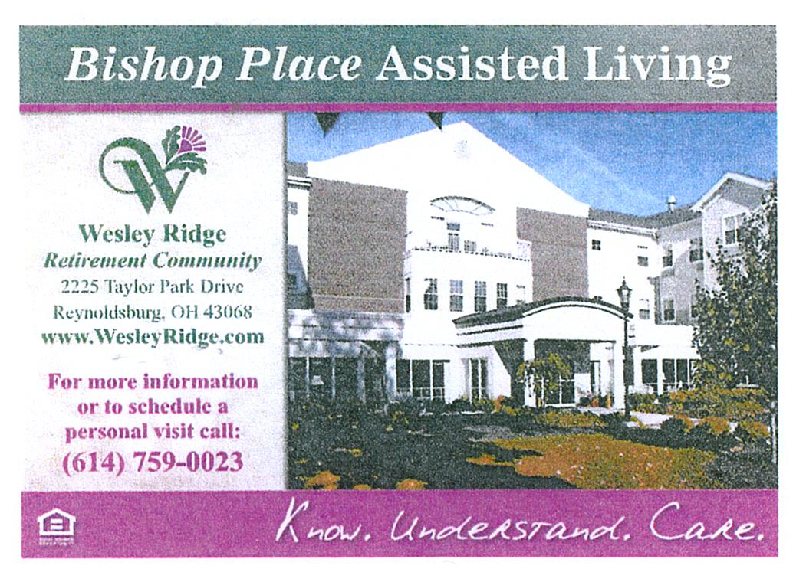

TITLE BOXING
(Free to Members)
THURSDAY / JANUARY 6th, 13th & 20th
Maria Manzo from Title Boxing will lead the class at our Center from 9:00 to 9:45 a.m. Sessions are around the Rock Steady Boxing curriculum which increases the neuroplasticity of the brain to help produce healthy brain cells. The exercises are designed to improve quality of life, have fun, and get results - all at the same time! You can purchase a bag and gloves for $25.00 at the class.

FRIDAY FITNESS CLASS
(Free to Members)
EVERY FRIDAY / 9:00 – 9:45 a.m.
Sign up starts at 8:30 a.m. This is a 45 minute Cardio Class. It’s a total workout. Come see the power you have and make great things happen for your health and well-being. We have plenty of room for you to move and groove to great music with our instructor Marilyn Morgan.

SOCIAL EUCHRE
(Free to Members)
EVERY FRIDAY / 11 a.m.

This is a slower paced Euchre game where we can meet and play cards non-competitively. If you like to play cards for fun, at a relaxed pace and you don’t mind teaching others when needed, then please join us. We welcome anyone who wants to
play cards.

GAME ROOM
(Free to Members)
Our Game Room is open all day, Monday through Friday. We have a shuffleboard table and a dart board. No need to call ahead, just come and enjoy.

OUR LIBRARY
(Free to Members)
We have videos, puzzles and a large selection of books for our members to choose from. Come check out our cozy library.
FOOD PANTRY FOR ANIMALS

If you know of anyone struggling financially to feed their pet companions, please have them call (614) 966-1777. Tricia Gerencser would like to thank everyone for the generous donations she has already received.

LIONS CLUB - RECYCLE FOR SIGHT

The Lions Club has a Recycle for Sight box in our Center’s library. You can donate your old eyeglasses there. The glasses are used in Third World Nations where eye care is practically non-existent. The glasses can’t be given away in the U.S. because it is illegal to give away a prescription that was meant for someone else.

COAT ROOM
Now that winter is here and we’re wearing our winter coats again, please remember to hang your coat on the rack in our library or on the coat rack by our back entrance Please don’t put then on the tables or on the floor. Thank you.

STAYING HEALTHY IN YOUR HOME
The Violet Township Fire Department, Truro Township and the City of Whitehall Division of Fire are collaborating with Mt. Carmel Health Systems to develop a Community Paramedic program to further improve the health and welfare of the communities. The program was launched in January of 2019. For more information you can contact Lt. Postage at (614) 778-5561 or by email at para@violet.oh.us

TRIPS FOR 2022

ISLANDS OF NEW ENGLAND
AUGUST 12 – 19, 2022

HIGHLIGHTS:
Providence, Newport, choice of options on tour, lobster dinner, Block Island, Cranberry Bog, Plymouth Rock, Cape Cod, Martha’s Vineyard, Provincetown, Hyannis, and Nantucket. Save $100 if booked before February 12th.

Cost: Single $4,049 - Double $3,249 - Triple $3,219. Flyer available in our office.
DAY 1 - Our tour opens in Providence, the capital
of Rhode Island.
DAY 2 - Providence - Newport
Day 3 - Providence - Block Island
Day 4 - Providence - Plymouth, Massachusetts –
Cape Cod
Day 5 - Cape Cod - Martha’s Vineyard
Day 6 - Cape Cod - Providence
Day 7 - Cape Cod – Hyannis - Nantucket
Day 8 - Cape Cod – Our Tour Ends

LACOMEDIA DINNER THEATRE – GODSPELL
THURSDAY, FEBRUARY 10th

Godspell is a perennial audience favorite, based on the gospel according to St. Matthew, telling the well-known parables with comedy, improvisation and theatre games. It features the international hit “Day by Day.” Godspell has a blend of songs, ranging from pop to vaudeville, it is both hilarious and moving, Godspell is a solid gold hit from the Off-Broadway season of 1971. Sign up starts on Monday, January 10, 2022. The cost per person is $63.00. Payment is due at sign up.

SNOOTY FOX
WEDNESDAY, MARCH 23rd

“An Upscale Thrift Store Shopping Adventure”

The motorcoach will leave our Center at 7:00 a.m. and head to the Cincinnati area for a shopping adventure full of great deals! We will visit several upscale clothing and furniture thrift shops, enjoy beverages, Danish, snacks, lunch, dessert and wine tasting along the way. There will be food selections at some stops but beverages at all of them. You will receive a 15% discount on your purchases and possibly 20% at some locations. Cash and major credit cards are accepted – no checks! This trip is always a blast! The price is $41.00 per person. Sign up starts on Monday, February 7, 2022.

UPCOMING TRIPS IN PLANNING STAGES

CASINO TRIPS

At this time the casino is not doing overnight bus trips to Wheeling Island, West Virginia. The situation is the same with regard to the casinos in Cincinnati.

SCIOTO DOWNS

They will allow busses, but they do no do not offer any incentives. As soon as they have incentives again we will schedule a trip.

LACOMEDIA DINNER THEATRE – THE MUSIC MAN
THURSDAY, APRIL 14th

Fast-talking traveling salesman, Harold Hill, cons the people of River City, Iowa, into buying instruments and uniforms for a boys’ band.

MACKINAC ISLAND, MICHIGAN

June 19-22, 2022
Further information to follow.

FROM DEANA 😊

REMEMBERING EVERYONE WITH
WARMEST WISHES ON THEIR BIRTHDAY!!

(1) Judith Beery, Emily Buck (Brown), Hedy Fleischer, Alice Hunter; (2) Myrtle Boggs, Edd Chinnock, Ann Funk, Joan Heft, Ken Prince; (3) Darcy Fortner, Lana Houston, Cindy Marn, Sharon Wagner; (4) Judith Lipp, Cecilia Roman, Michael Searfos; (5) Kathy Antoniak, Ursula Clark, Peggy George, Richard Roe; (6) Pastor Joseph Culp; (7) Nancy Sander, Dorothy Wilson; (8) Carole Crawford, Bev Forsen; (9) Geneva Schumacher;(10) Judy Fahner, Sherry McKinney, Lou Postage, James Schumacher; (11) Darlene Bouck, Shirley Carius, TSG John Gibbons, Barbara Hudyk; (12) Carol Ardrey, Wilma Osborne, Mavis Schultz; (13) Deb Czycalla, Evelyn Delong, Lois Peterson, Janet Wilcox; (14) Cecilia Berman, Serene Culp, Jim Moore, Sheree Schaffner; (15) Marva Pettit; (16) Dennis Ellerbeck, John Greedy, Michael Hudyk, Shirley Motsch, Charles Smith, Robert Smith;
(17) Bobbi Williams; (19) Bill Harvey, Hildred Perry, Carolyn Smith; (20) Wilma Arnett, Carol Magistrale, Dottie Nelson, Beth Oliver; (21) Patti Golladay, Marylou Tate, Jane Wilhelm; (22) Bob Munjas, Linda Price; (23) Deena Womack; (24) Jean Kuhn, Maria Taylor; (25) Elaine Redmond, Arlene Reel; (26) Bernita Ardrey, Judy Hemphill, Brenda Hirsch, Jane Runyon; (27) Eileen Dumire; (28) Darryl Baker, Mary Cloud, Frank Hirsch, Sarah Jackson; (29) Marilyn Elliott, Goldie Kincaid; (30) Mary Campbell, Janet Connell, Georgia Meadows, Lou Ann Wise; (31) Kyle Arthur, Nadine Hamilton, Betty Leinhauser.

CONGRATULATIONS

Betty Pruden on the birth of her
great-grandson, Tatum Nicolas

MEMBERS KNOWN ILL

Edgar Boggs:
Fell, broken hip, surgery Mt. Carmel East

Myrtle Boggs: Embassy of Pickerington Rehab

Dorothy Ford: Fell, brain bleed, home recovering

Linda Gerhardt: Eye surgery, doing better

Ray Knight: Home, doing better
Don McKitrick: Renal disease, home on dialysis
Mike Scudder: Hernia surgery, doing better
Gran Tuttle: Lung cancer
Pam Tuttle: Neuropathy
Gil Zalewski: Home, recuperating from surgery

IN LOVING MEMORY OF

Dorothy Bauman’s husband Marty
Pat Billingham
Jeanne Carroll’s nephew
Janet Douglas’ son Robert
Ann Harper’s son Tim Smith
Faith Hoek’s cousin Doug Deicke
Mary Hungerford
Dorloris (Dee) Leistikow
Sonnie Stewart’s sister Donna

Follow us on Facebook at:
Pickerington Senior Citizens Center

